AGENDA ITEM 6 – b – 9

Marketing & Communications Program
Melissa Franklin

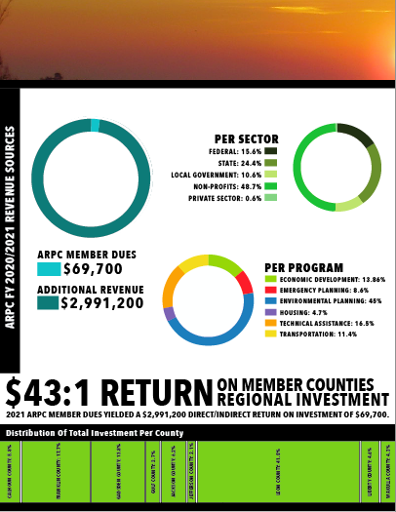
Media, Public Engagement, and General Communications
Staff are developing 2022 communications goals and strategies
ARPC, as well as the varied programs
within ARPC. A summary will be provided upon completion.
In preparation for the 850 Industrial Hemp 2022 Summit,
staff submitted an application for the “2022 Lemoyne Chain of Parks Festival”, and planning and development
of Informational materials/craft activities have begun. This year, the ARPC booth will be focused on the versatility and innovation of industrial hemp.
Staff compiled, designed and distributed the
ARPC 2020-2021 Annual Report!

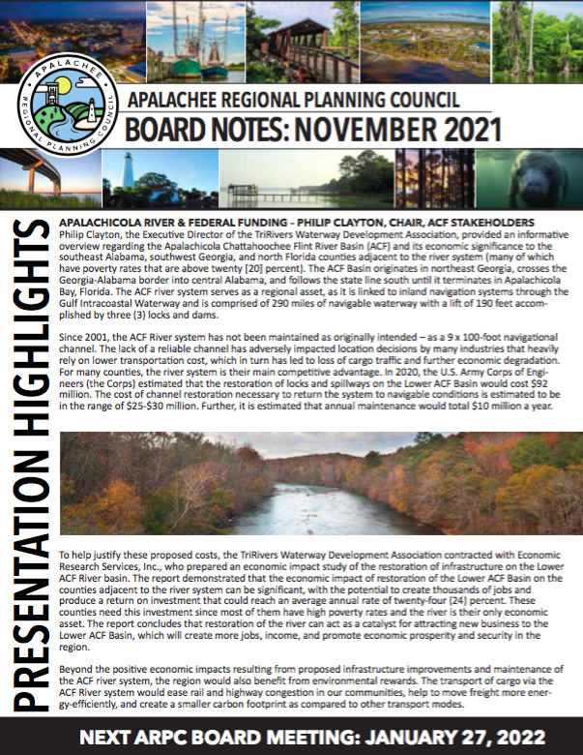
Online & Social Media Engagement
In November, ARPC staff developed and distributed the November Board Notes and continues to manage ARPC social media engagement, as well as website updates and document uploads. All websites (ARPC, BBHCC, and 850 Hemp) are monitored for updates on a weekly basis. In addition, ARPC staff provides general graphics and communications support throughout the organization’s numerous programs and projects, developing informative, professional, and eye-catching materials as needed.

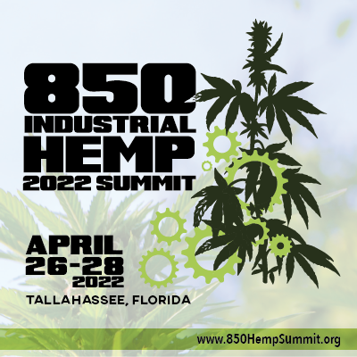
850 HEMP Summit 2022
Registration for the 850 Industrial Hemp 2022 Summit is now open! Registration, Sponsorship, and Vendor information can be found at www.850hempsummit.org!
Hemp is the only plant that can feed, house,
clothe, and heal! From farming to manufacturing, this extraordinary plant can strengthen the resiliency of our Region -- not only economically, but environmentally, as well! And through combined efforts, the Apalachee Region is in a prime position to emerge at the forefront of the industrial hemp industry. As such, the ARPC is excited to bring the second 850 Hemp Summit to the Region. The 850 Hemp Summit unites farmers, stakeholders, cultivation and production experts, economic development professionals, and policymakers to discuss the status, challenges, and opportunities for industrial hemp in the Apalachee Region.

Hemp Summit Planning
Staff are contacting potential speakers and developing the summit agenda. As of January 14th, 2022, the following speakers have been confirmed:
• Holly Bell, FDACS, Cannabis Director
• Steven Hall, FDACS, General Counsel
• Dr. Eric Rohrig, FDACS, Division of Plant Industry, Bureau Chief
• Dr. Zhou, FAMU, Associate Professor, College of Agriculture and Food Sciences (CAFS)
• Matthew Mizereck, FAMU, Hemp Planting Site Monitor, Industrial Hemp Research Pilot Program

Staff are diligently working to identify and confirm speakers for the Summit and continue to meet with various representatives within the hemp industry to ensure the most up to date and informative summit possible.
Topics to be featured at the summit include:
• State of the Hemp Industry (Industry Analysis, State & Regulatory Perspective, National Trades Association Perspective, Bio-Regional Perspective, Financial Perspective)
• Why Hemp!
• Farming & Genetics
• Market Opportunity in Northwest Florida (Fiber & Textiles; Oils, Grains, Food & Beverage)
• Hemp and Housing
• Hemp Challenges and Opportunities
• Future of Hemp in Florida

The versatility of hemp lends itself well to community partnerships, and ARPC staff is working diligently to maximize these opportunities. Potential collaborations with several local businesses and organizations are being discussed, and ARPC staff are committed to creating an event that is locally developed and ensures maximum investment in our Region. To build community interest, as well as credibility among potential speakers and vendors, various points of engagement leading up to the Summit are being utilized. The 850 Hemp Newsletter is distributed monthly, and additional resources are available at the 850 Hemp Summit website. Education regarding the history and benefits of hemp remains a top priority, and materials for an educational media campaign are complete and ready to launch. Staff created a Master Task List for summit planning, as well as a Speaker Contact spreadsheet for tracking staff communications with potential speakers.

The location for the summit Kick-Off Party (April 26th at Oyster City Brewing Company, Tallahassee) has been confirmed, and staff are developing ideas to showcase the versatility and innovation of industrial hemp (i.e., fashion show, makers space, artists, printers, etc.). Ideal promotional items have been identified, and a Media/Sponsor Kit is complete and in distribution.

