Apalachee

Local Emergency Planning Committee

Hazardous Materials Emergency Plan

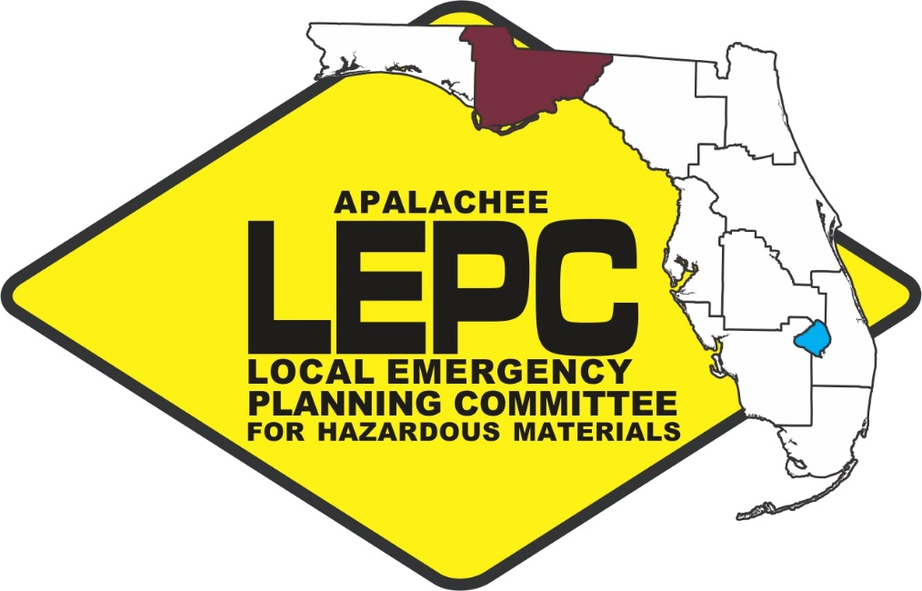

JUNE 2019

Prepared by:

The Apalachee Regional Planning Council

Serving: Calhoun, Franklin, Gadsden, Gulf, Jackson, Jefferson, Leon, Liberty and Wakulla Counties
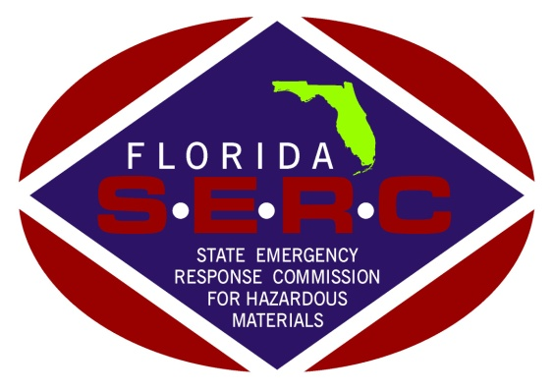

RESOLUTION

The Apalachee Local Emergency Planning Committee meeting in regular session this 24 day of June , 2019, in Tallahassee, Florida, considered the following:

WHEREAS, the enactment of the Emergency Planning and Community Right-To-Know Act of 1986 imposed upon Local Emergency Planning Committees (LEPCs) planning and preparedness requirements for response to emergencies involving the release of hazardous materials; and

WHEREAS, Apalachee LEPC's Hazardous Materials Emergency Plan has been reviewed and approved by the Florida State Emergency Response Commission for Hazardous Materials as meeting the criteria for such plans established by the Administrator, United States Environmental Protection Agency and the National Response Team; and

WHEREAS, this plan is intended to provide the framework for the development of detailed operating procedures by first response public safety agencies charged with the responsibility of protecting the public's health and safety from the discharge or release of extremely toxic chemicals.

NOW, THEREFORE, BE IT RESOLVED BY THE APALACHEE LEPC that the Apalachee LEPC Hazardous Materials Emergency Plan be hereby adopted.

SIGNED: ATTESTED BY

_______________________________
Kevin Peters Zachary Annett
Chairperson Staff

EXECUTIVE SUMMARY

Regional Description
The Apalachee LEPC is located in Northwest Florida at longitudes 83°50' to 85°40' West and latitudes 29°30' to 31°00' North. The nine-county region covers 5,855 square miles and extends from Jefferson County on the east to Jackson, Calhoun and Gulf Counties on the west. The landscape and topography of the Apalachee region is varied. The climate of the region is predominantly subtropical (mild, moist, and fairly uniform) with a minor split between coastal and inland areas. Rainfall in the region averages between 48 to 64 inches per year, with thunderstorms occurring on half of the summer days.

The Floridan Aquifer provides most of the potable water in the region. The region also has abundant surface water resources. These resources serve as habitat for fish and wildlife, provide recreational opportunities, serve as part of the transportation system and are central to the economies of some of the coastal counties in the region. Surface waters include: the Apalachicola River and Bay System; the Chipola, Ochlockonee, St. Marks, Aucilla, New, and Little Rivers; and the St. Joseph Bay in Gulf County, St. George Sound (an extension of the Apalachicola Bay) in Franklin County, and Oyster, Ochlockonee and Apalachee Bays in Wakulla County. Wildlife, both game and nongame, is abundant in the Apalachee region, due primarily to the heavily forested and rural nature of the area.

The 2014 population of the Apalachee region was estimated at 477,098 approximately 2.5% of the State's population (Bureau of Economic and Business Research, 2014). With the exception of Leon County (population – 281,292), the remaining eight counties in the district can generally be considered rural. Leon County’s high population with respect to the other Apalachee counties can be attributed to the economy created by the State Capital and the expanding university system.

The transportation network for the region is comprised primarily of two-lane highways connecting population centers. Interstate 10 traverses the northern portion of the region and provides the major east-west expressway. State highways constitute all the north-south transportation corridors in the western part of the region. In the eastern portions of the region, U.S. Highways 319, 27 and state and county roads provide for north-south movement. The region also has three railroads, four seaports and nine airports of differing sizes. Only one airport, the Tallahassee Regional Airport, serves jet traffic.

Organizational Structure
The Chairperson of each Board of County Commissioners has the responsibility for overall hazardous materials planning in his/her county of jurisdiction. The local emergency manager, or his/her designee, is in charge of the direction of the response activities to implement the decisions of the County Commissions.

Throughout Apalachee, local firefighters (if adequately trained to a minimum of Operations or Level 2 training) will generally be the designated responders to a hazardous materials incident. Agency response does not transfer the liability from the owner, shipper, carrier or responsible party. Mutual Aid agreements will be implemented, if necessary, for areas where responders are not adequately trained.

Law enforcement, governmental agencies and other public and private organizations will support the response activities in areas such as warning, evacuation, and public information. Specific responsibilities are described in Chapter 2 of the Apalachee LEPC Hazardous Materials Emergency Plan.

Notification
If an amount equal to or greater than the reportable quantity (RQ) as defined by EPCRA is released from a fixed facility, notification to the SERC and the LEPC must be made by contacting the State Warning Point/State Watch Office at (850) 413-9911 or (800) 320-0519. The notification must be made by the facility representative within 15 minutes. In addition to the above notification, CERCLA spills must be reported to the National Response Center at (800) 424-8802. If the spill is transportation related, Section 304 notification can be made by calling 911 or, in the event a 911 system is not available, calling the operator to contact emergency assistance. Information to be included in the facility's initial and follow-up messages is identified in Figure 4-2. Figure 4-1 lists the warning point for each county in Apalachee in the event of a hazardous materials emergency.

Activation
Local response organizations will be notified of the emergency by the county warning point, at the direction of the officer on duty at the warning point. Contacts for each type of emergency (Potential, Limited and Full) can be seen in Figure 4-3. Primary and alternate contacts for each emergency response organization and up to date phone numbers are maintained by the local emergency management office. The following procedures should be followed to activate local personnel and the EOC, as necessary:

Potential Emergency Condition
- Description - A "potential emergency condition" is defined as one in which the threat of a release can be controlled by the first response agencies and does not require evacuation of other than the involved structure or the immediate outdoor area. The incident is confined to a small area and does not pose an immediate threat to life or property.

- Notification - Upon receipt of notification from a facility operator that a potential emergency condition exists, the involved Warning Point will notify the appropriate emergency personnel as listed in Figure 4-3.

- Activation - Activation of emergency response personnel beyond the first response agencies (fire department, emergency medical services, police department, etc.) and partial EOC staff is not anticipated for this level of emergency. The Emergency Management Director will monitor the situation, coordinate local response activities, and be prepared to take further action, if necessary, to protect the public.

Notification of Limited Emergency Condition
  - Description - A "limited emergency condition" is defined as an incident involving a greater hazard or larger area than a potential emergency and which poses a potential threat to life and/or property and may require a limited evacuation of the surrounding area.

  - Notification - Upon notification of a limited emergency condition from the facility owner or operator, the involved Warning Point will notify the appropriate emergency personnel (see Figure 4-3):

  - Activation - Upon notification, the Emergency Management Director and appropriate staff will report to the incident command post to facilitate the rapid deployment of emergency response personnel, if needed. If the situation warrants, the county Emergency Management Director will activate the County EOC.

Notification of Full Emergency Condition
  - Description - A full emergency situation is defined as an incident involving a severe hazard or large area which poses an extreme threat to life and/or property and will probably require a large scale evacuation, or an incident requiring the expertise or resources of county, state, federal and/or private agencies.

  - Notification - Upon receipt of notification of full emergency conditions from the owner or operator of the facility, the involved Warning Point will notify the emergency personnel identified in Figure 4-3.

  - Activation - The County Emergency Management Director and staff will activate the EOC and assist in the notification process. Rumor control telephone numbers will be activated. Designated emergency personnel will report to the EOC and other emergency response personnel may be directed to take appropriate emergency actions.

Public Notification
If it is necessary to advise the public of the release, the local Emergency Management office will activate the Emergency Broadcast System for the area affected by the release. Broadcast media resources, including the EBS stations, are listed in Figure 4-4. Communication with the media should be achieved through the designated Public Information Officer(s). Sample media releases are found in Chapter 6 of the plan.

Communications
It is imperative that all personnel involved in the response activities be aware of the communications systems available to the jurisdiction. Local communications systems can be found in figure 5-1.

Initial Response
The response by personnel first on the scene must be guided by following proper standard operating procedures.

Protective Measures
Persons within the vulnerable zone estimated in the plan may have to be evacuated. Evacuation procedures are described in Chapter 10 of the plan. Evacuation routes are also found in the analyses of each facility. In cases where a toxic cloud may pose an immediate threat or where evacuation is not recommended, the sheltering in place procedures should be followed. No one should be allowed to reenter the evacuated area until the area is cleared.

All responders should wear adequate (depending on the chemical and specific characteristics of the incident) personal protective equipment. All responders must also keep records of exposure.

Training
All responders to hazardous materials incidents must be adequately trained. The Apalachee LEPC, in coordination with the SERC, will provide training for responders within Apalachee. It is the responsibility of each facility and response agency to ensure that personnel involved in response activities are adequately trained.

TABLE OF CONTENTS

SECTION |  | PAGE
 | Executive Summary……………………………………………………………………………….. | ES-1
 | Introduction………………………………………………………………………………………….. | Intro-1
 | Acronyms………………………………………………………………………………………………. | Intro-2
 | Definitions…………………………………………………………………………………………….. | Intro-4
 | Record of Plan Revisions……………………………………………………………………….. | Intro-8
 | Distribution List…………………………………………………………………………………….. | Intro-9
 | RRT/NRT-1 Cross Reference………………………………………………………………….. | Intro-11
1.0 | OVERVIEW AND PURPOSE
1.1 | Responsibility for Planning Effort………………………………………………………….. | I-1
1.2 | Emergency Planning Bases……………………………………………………………………. | I-2
1.2.1 | Geographic Description………………………………………………………………………… | I-2
1.2.2 | Hydrological Resources…………………………………………………………………………. | I-3
1.2.3 | Ecological Description…………………………………………………………………………… | I-3
1.2.4 | Demographics………………………………………………………………………………………. | I-6
1.2.5 | Housing………………………………………………………………………………………………… | I-7
1.2.6 | Transportation……………………………………………………………………………………… | I-7
1.2.7 | Health Care Facilities…………………………………………………………………………….. | I-9
1.2.8 | Educational Facilities…………………………………………………………………………….. | I-9
1.2.9 | Agriculture……………………………………………………………………………………………. | I-9
1.2.10 | Other Critical Variables Impacting Response…………………………………………. | I-10
1.3 | Hazards Analysis……………………………………………………………………………………. | I-10
1.3.1 | Methodology and Assumptions……………………………………………………………. | I-12
1.4 | Supporting Plans…………………………………………………………………………………… | I-13
1.5 | Mutual Aid Agreements………………………………………………………………………… | I-14
1.6 | Authorities and References…………………………………………………………………… | I-14
2.0 | EMERGENCY RESPONSE ORGANIZATIONS AND  RESPONSIBILITIES
2.1 | General………………………………………………………………………………………….……… | II-1
2.2 | Local Government Organizations and Responsibilities……………………..…….. | II-1
2.2.1 | Chairperson of the Local Boards of County Commissioners……..…………… | II-1
2.2.2 | County Administrator……………………………………………………………………………… | II-1
2.2.3 | Emergency Management Director………………………………………………………… | II-1
2.2.4 | Sheriffs and Municipal Law Enforcement……………………………………………… | II-2
2.2.5 | County, Municipal and Volunteer Fire Departments………………..…………… | II-2
2.2.6 | County Health Departments……………………………………………………….………… | II-3
2.2.7 | Local Public Works or Road and Bridge Departments………………….………… | II-4
2.2.8 | School Administration…………………………………………………………………..………. | II-4
2.2.9 | Community Transportation Coordinators (CTCs)……………..…………………… | II-4
SECTION |  | PAGE
2.2.10 | Hospitals…………………………………………………………….…………………………………. | II-4
2.2.11 | Local Emergency Medical Services……………………….……………………………... | II-5
2.2.12 | Other County and Municipal Agencies…………………………….………………….. | II-5
2.3 | State Government Organizations and Responsibilities……………….……….. | II-5
2.3.1 | Governor. …………………………………………………………………………………………... | II-5
2.3.2 | Attorney General…………………………………………………………………..……………… | II-5
2.3.3 | Florida Division of Emergency Management (FDEM)……………..……………. | II-6
2.3.4 | Florida Department of Environmental Protection (FDEP)…………..………… | II-6
2.3.5 | Florida Department of Transportation (FDOT)………………………….…………. | II-7
2.3.6 | Florida Department of Law Enforcement (FDLE)…………………………………. | II-8
2.3.7 | Florida Department of Highway Safety & Motor Vehicles (FDHSMV)…… | II-9
2.3.8 | Florida Game and Fresh Water Fish Commission (FWC)…………….………… | II-9
2.3.9 | Florida Department of Military Affairs (FDMA)…………………………………….. | II-10
2.3.10 | Florida Department of Health (FDOH)…………………………………………………. | II-10
2.3.11 | Florida Department of Agriculture and Consumer Services (FDACS)……. | II-10
2.3.12 | Florida Department of Financial Services (FDFS)…….…………………………... | II-11
2.3.13 | ESF 10: Environmental Protection……………………………………….……………… | II-11
2.4 | Federal Government Organizations and Responsibilities …………….………. | II-11
2.4.1 | Federal Emergency Management Agency (FEMA)……………….……………... | II-11
2.4.2 | U.S. Coast Guard (USCG)………………………………………………………………………. | II-11
2.4.3 | U.S. Environmental Protection Agency (EPA)……………………..……………….. | II-12
2.4.4 | U.S. Department of Transportation (U.S. DOT)……………….…………………… | II-12
2.4.5 | Regional Response Team (RRT)……………………………………….…………………… | II-12
2.4.6 | National Weather Service……………………………….…………………………………… | II-12
2.5 | Facility Owners/Operators……………………………………………..……………………. | II-12
2.6 | Volunteer Organizations………………………………….…………………………………… | II-13
2.6.1 | American Red Cross……………………………………..……………………………………... | II-13
2.6.2 | Emergency Alert System (EAS)………………………..…………………………………… | II-13
2.6.3 | Florida Wing, Civil Air Patrol (CAP)………………………………………….…………… | II-13
2.6.4 | Amateur Radio Emergency Services (ARES)……………………..………………….. | II-14
2.6.5 | Other Local Volunteer Organizations…………………………………………………… | II-14
3.0 | DIRECTION AND CONTROL
3.1. | General………………………………………………………………………………..……………... | III-1
3.2 | The Local Emergency Planning Committee/LEPC Role…………….…………... | III-1
3.3 | Local Government Role…………………………………………………….…………………. | III-1
3.3.1 | On-Scene Command………………………………………………..………………………….. | III-2
3.3.2 | Emergency Operations Center (EOC)…………………………………………………… | III-3
3.4 | State Government Role……………………………………………………………………….. | III-3
3.5 | Federal Government Role…………………………..……………………………………….. | III-3

SECTION |  | PAGE
4.0 | NOTIFICATION AND ACTIVATION
4.1 | General……………………………………………………………..………………………………... | IV-1
4.2 | Warning Points…………………………………………….……………………………………... | IV-1
4.3 | Notification and Activation……………………………..…………………………………… | IV-2
4.3.1 | Notification of Potential Emergency Conditions…………..……………………... | IV-7
4.3.2 | Notification of Limited Emergency Conditions……………………………………. | IV-8
4.3.3 | Notification of Full Emergency Conditions…………………………………………... | IV-11
4.4 | Notification to the Public………………………………………………..…………………... | IV-11
5.0 | EMERGENCY COMMUNICATIONS
5.1 | General………………………………………………………………………………………………... | V-1
5.2 | Coordination of Emergency Communications……………………………………... | V-1
5.3 | Communications Systems…………………………………………………………………….. | V-2
6.0 | PUBLIC INFORMATION AND EDUCATION
6.1 | General………………………………………………………..……………………………………... | VI-1
6.2 | Public Information Officers………………………..………………………………………... | VI-2
6.2.1 | Local Public Information Officer…………………..……………………………………... | VI-2
6.2.2 | State Public Information Officer……………………..…………………………………… | VI-3
6.2.3 | Federal Public Information Officer…………………….………………………………… | VI-3
6.2.4 | Facility Public Information Officer……………………..………………………………… | VI-3
6.3 | Emergency News Facilities…………………………………………………………………… | VI-3
6.3.1 | Emergency Operations Center………….……………….………………………………... | VI-4
6.3.2 | DEM Press Room……………………………………………….………………………………... | VI-4
6.4 | Coordination of Media Release…………………………..……………………………….. | VI-4
6.5 | Rumor Control……………………………………………………………………………………… | VI-5
6.6 | Public Education………………………………..………………………………………………… | VI-5
6.7 | Post Emergency Operations………………………..………………………………………... | VI-5
6.8 | Public Access……………………………………………………..…………………………………. | VI-6
6.9 | Public Outreach……………………………………………………………………………………. | VI-6
7.0 | EMERGENCY FACILITIES AND EQUIPMENT
7.1 | General………………………………………………………………………………………………... | VII-1
7.2 | Emergency Response Facilities and Personnel…………………………………….. | VII-1
7.2.1 | Emergency Operations Center……………………….…………………………………... | VII-1
7.2.2 | On-Scene Command Post………………………………………….………………………... | VII-2
7.3 | Equipment and Resources…………………………………….…………………………….. | VII-2
7.3.1 | Equipment………………………………………………………………………………………….. | VII-2
7.3.2 | Laboratory Analytical Support……………………..……………………………………... | VII-4
7.3.3 | Other Technical Support……………………………………………………………………… | VII-4

SECTION |  | PAGE
8.0 | ACCIDENT ASSESSMENT
8.1 | General…………………………………………………….………………………………………….. | VIII-1
8.2 | Initial Assessment……………………………………..………………………………………... | VIII-1
8.3 | Assessment and Monitoring………………………………………………………………... | VIII-1
8.3.1 | Resources and Capabilities…………………………..………………………………………. | VIII-1
8.3.2 | Activation of Field Teams…………………………………………………………………….. | VIII-2
8.3.3 | Coordination of Assessment and Monitoring Activities…………..…………… | VIII-2
8.3.4 | Additional Assessment and Monitoring Support…………………….…………... | VIII-3
9.0 | EXPOSURE CONTROL FOR EMERGENCY WORKERS
9.1 | General………………………………………………………………….……………………………... | IX-1
9.2 | Exposure Monitoring……………………………………………………….………………….. | IX-1
9.2.1 | EPA Levels of Protection……………………………………………………………………... | IX-2
9.2.2 | Exposure Records…………………………………………………………………………………. | IX-4
9.3 | Authorization of Exposure in Excess of Protective Action  Guidelines………………………………………………………………………………………… | IX-4
9.4 | Decontamination of Individuals and Equipment………………………………….. | IX-4
9.5 | Site Decontamination………………………………………………………………………….. | IX-5
10.0 | PROTECTION ACTIONS
10.1 | General………………………………………………………………………………………………... | X-1
10.2 | Vulnerable Zones………………………………………………………………………………... | X-1
10.3 | Levels of Concern……………………………………………….……………………………….. | X-1
10.4 | Evacuation……………………………………………………….………………………………….. | X-2
10.4.1 | Evacuation Routes………………………………………..…………………………………….. | X-2
10.4.2 | Evacuation of General Public………………………….……………………………………. | X-2
10.4.3 | Evacuation for Special Needs……………………………………………………………….. | X-3
10.4.4 | Schools………………………………………………………………………………………………... | X-3
10.4.5 | Medical Facilities…………………………………………….…………………………………... | X-3
10.4.6 | Incarceration Facilities…………………………………….…………………………………... | X-3
10.5 | Reception and Care……………………………………………………………………………… | X-3
10.6 | Sheltering-In-Place ……………………………………………………………………………. | X-4
10.7 | Temporary Housing………………………………………..…………………………………… | X-4
10.7.1 | General……………………………………………………………..………………………………... | X-4
11.0 | MEDICAL AND PUBLIC HEALTH SUPPORT
11.1 | General………………………………………………………………………………………………... | XI-1
11.2 | Medical Support……………………………………………………………………………………. | XI-1
11.2.1 | Hospitals and Ambulance Services..………………………………..……………………. | XI-1
11.2.2 | Provision for Emergency Mental Health Care..…………………………….………. | XI-2

SECTION |  | PAGE
12.0 | RECOVERY AND RE-ENTRY
12.1 | General………………………………………………………………………………………………... | XII-1
12.2 | Recovery………………………………………………………………………………………………. | XII-1
12.2.1 | Environmental Analysis………………………………..………………………………………. | XII-1
12.2.2 | Containment and Cleanup…………………………..……………………………………….. | XII-1
12.2.3 | Documentation and Follow-up…………………….……………………………………... | XII-7
12.3 | Re-entry……………………………………………………………………………………………….. | XII-7
13.0 | EXERCISES
13.1 | General………………………………………………………………………………………………... | XIII-1
13.2 | Exercises………………………………………………………………………………………………. | XIII-1
13.2.1 | Full Scale Exercise………………………………………..………………………………………. | XIII-1
13.2.2 | Functional Exercise………………………………………..……………………………………… | XIII-1
13.2.3 | Tabletop Exercise………………………………………………………………………………... | XIII-2
13.2.4 | Scheduling and Scenario Development……………………………………………….. | XIII-2
13.2.5 | Critique and Reports…………………………………………………………………………... | XIII-3
13.3 | Drills……………………………………………………………………..……………………………... | XIII-2
13.3.1 | Communications Drills…………………………..…………………………………………….. | XIII-3
13.3.2 | Medical Drills………………………………………………….……………………………………. | XIII-3
13.3.3 | Chemical Monitoring Drills………………………..………………………………………... | XIII-3
14.0 | TRAINING
14.1 | General………………………………………………………………………………………………... | XIV-1
14.2 | Annual and Refresher Training…………………………………………………………….. | XIV-1
14.3 | Schedule and Availability of Training…………………………………………………... | XIV-2
Appendix A | List of Extremely Hazardous Substances (EHSs) and the Data for  the Hazards Analyses………….………………………………………………………………… | A-1
Appendix B  Appendix C | Hazards Analyses…………………………………………………..……………………………...  2016 Commodity Flow Study…………………………………………………………………. | B-1  C-1
Appendix D | Media Release Forms…………………………………………………………………………… | D-1
LIST OF TABLES AND FIGURES

FIGURE | TITLE | PAGE
Figure 1-1 | Aquifer Sensitivity…………………………………………………….…….. | I-4
Figure 1-2 | Hydrology of the District…………………………………………………. | I-5
Figure 1-3 | Regional Transportation Network…………………………………... | I-8
Figure 1-4 | Hazards Analysis Information Summary…………………………. | I-17 thru I-24
Figure 1-5 | Hazards Analysis Summary Maps…………………………………... | I-25 thru I-33
Figure 3-1 | Example Executive Order……………………………………………….. | III-4
Figure 4-1 | Warning Points in Apalachee………………………….………………... | IV-2
Figure 4-2 | SARA – Title III Section 304 Reporting Form……………….…… | IV-5
Figure 4-3 | Emergency Contact List Regional Summary………………..….. | IV-9
Figure 4-4 | Radio and Television Stations…………………………………………. | IV-12
Figure 5-1 | Local Communications Systems…………………..…………………. | V-3
Figure 6-1 | Public Information Officers……………………………….……………. | VI-2
Figure 6-2  thru 6-8 | Sample Media Release……………………………….…………………… | VI-7 thru VI-13
Figure 6-9 | Local Emergency Planning Committees………………………….. | VI-14
Figure 7-1 | Emergency Operations Centers in Apalachee………….………... | VII-2
Figure 7-2 | Private Contractors’ Laboratory and Analytical  Capabilities……………………………………………………..…………. | VII-7
Figure 9-1 | Hazardous Materials Exposure Form……………..……………….. | IX-6
Figure 11-1 | Apalachee Emergency Medical Facilities……………..……………. | XI-3
Figure 12-1 | Removal Actions…………………………………….………………………. | XII-3
Figure 12-2 | Remedial Actions……………………………….…………………………… | XII-6
Figure 14-1 | Training for Emergency Personnel……………………..…………… | XIV-2

INTRODUCTION

The Apalachee Hazardous Materials Emergency Plan contains general information regarding the procedures to be used in the response to a hazardous materials incident within the Apalachee region. It also notes the parties that are involved in the response to a hazardous materials emergency and the roles they will play in the response actions. This regional plan compiles information included in the local response plans and allows a general overview of the status of the District.

The regional plan contains a summary of local fixed facility information (Figure 1-4) that includes the facility name, State Emergency Response Commission (SERC) number, City and County. Maps of the facilities for each county within the District (Figure 1-5) are also included in the plan. The consolidated information will be valuable to those entities which may be assisting in the response to incidents outside their jurisdiction. Used in conjunction with each county’s Hazard Analysis (HA), the tables and maps provide a better idea of potential problems with critical facilities and can be used by the local governments in the development of polices to mitigate the risk from hazardous materials incidents. The summaries and maps will also be useful in the outreach activities of the Apalachee LEPC.

ACRONYMS

ARES Amateur Radio Emergency Services
BCC Board of County Commissioners
BEBR Bureau of Economic and Business Research
CAP Civil Air Patrol
CAS Chemical Abstract Service
CBTR Center for Biomedical & Toxicological Research and Hazardous Waste
Management at FSU
CEC Community Emergency Coordinator
CERCLA Comprehensive Environmental Response, Compensation and Liability Act
CHEMTREC Chemical Transportation Emergency Center
CHRIS Chemical Hazard Response Information System
CPE Chlorinated Polyethylene
CPG Citizens Protection Guide
CTC Community Transportation Coordinator
CUTR Center for Urban Transportation Research
DACS Department of Agriculture & Consumer Services
DEM Florida Division of Emergency Management
DEP Florida Department of Environmental Protection
DHHS U.S. Department of Health and Human Services
DHS Department of Homeland Security
DHSMV Department of Highway Safety & Motor Vehicles
DOH Department of Health
DOI Department of Insurance
DOT (U.S. or Florida) Department of Transportation
EAS Emergency Alert System
EHS Extremely Hazardous Substance
EOC Emergency Operations Center
EPA U.S. Environmental Protection Agency
EPCRA Emergency Planning & Community Right to Know Act
EPI Emergency Public Information
FDMA Florida Department of Military Affairs
FWC Florida Fish and Wildlife Conservation Commission
FEMA Federal Emergency Management Agency
GAR Governor's Authorized Representative
HEAR Hospital/Emergency Ambulance Radio
HMTF Hazardous Materials Task Force
HSEEP Homeland Security Exercise and Evaluation Program
HYSPLIT Hybrid Single Particle Lagrangian Integrated Trajectory
IDLH Immediately Dangerous to Life and Health
JIC Joint Information Center
JIS Joint Information System
LEPC Local Emergency Planning Committee
LOC Level of Concern
MSA Metropolitan Statistical Area
MSDS Material Safety Data Sheet
NAWAS National Warning System
NIMS National Incident Management System
NIOSH National Institute for Occupational Safety and Health
NOAA National Oceanic and Atmospheric Administration
NRC National Response Center
NRP National Response Plan
NRT-1 Hazardous Materials Emergency Planning Guide, National Response Team
NWS National Weather Service
OHM-TADS Oil and Hazardous Materials Technical Assistance Data Systems
OSHA Occupational Safety and Health Administration
PEL Permissible Exposure Limit
PIO Public Information Officer
RCRA Resource Conservation & Recovery Act
REL Recommended Exposure Limit
RERA Regional Emergency Response Advisor
RDSTF Regional Domestic Security Task Force
RHMERP Regional Hazardous Materials Emergency Response Plan
RPC Regional Planning Council
RQ Reportable Quantity
RRT Regional Response Team
SARA Superfund Amendments and Reauthorization Act
SCBA Self-Contained Breathing Apparatus
SEOC State Emergency Operations Center
SERC State Emergency Response Commission
STEL Short Term Exposure Limit
SWP State Warning Point
SWO State Watch Office
TPQ Threshold Planning Quantity
USCG United States Coast Guard
VOC Volatile Organic Compound
DEFINITIONS

Acute - severe but of short duration. Acute health effects are those that occur immediately after exposure to hazardous chemicals.

Ambient - surrounding. Ambient temperatures are temperatures of the surrounding area (e.g., air or water).

Avoidance - to eliminate a hazard through measures such as relocation, prohibition of construction within an area susceptible to danger, or by other means.

Construction practices - codes, standards, and specifications governing repairs, alterations, or new construction of a facility or structure.

Disaster - an emergency situation requiring a response that exceeds the physical and organizational capabilities of a unit of local government.

Disaster proofing - modifications to damaged facilities which would prevent or substantially reduce future damage to a facility.

Disposal - the removal of waste material to a site or facility that is specifically designed and permitted to receive such wastes.

Drill - a supervised instruction period aimed at developing testing and monitoring technical skills necessary to perform emergency response operations.

Education and training - as referred to in this plan shall include all instrumental activities and facilities which are necessary to inform and train individuals to fulfill emergency responsibility in the event of a disaster and the post-disaster emergency; education and training shall encompass higher education, technical and vocational education and training, and general education for children, youths and adults.

Emergency - any accidental, natural, man caused, or wartime emergency or threat thereof.

Emergency situation - an incident or event resulting from a natural or man-made hazard that affects people and their activities in a negative manner.

Exercise - a simulated accident or release set up to test emergency response methods and for use as a training tool.

Extremely Hazardous Substances (EHSs) - a list of chemicals identified by EPA on the basis of toxicity, and listed under Title III of SARA.

Facility - defined for Section 302 of Title III of SARA as all buildings, equipment, structures, and other stationary items which are located on a single site or on contiguous or adjacent sites and which are owned or operated by the same person (or by any person which controls, is controlled by, or under common control with, such person). For purposes of emergency release notification, the term includes motor vehicles, rolling stock, and aircraft.

Facility Emergency Coordinator - facility representative for each facility with an extremely hazardous substance (EHS) in a quantity exceeding its threshold planning quantity (TPQ), who participates in the emergency planning process.

Full Emergency Condition - an incident involving a severe hazard or large area which poses an extreme threat to life and/or property and will probably require a large scale evacuation, or an incident requiring the expertise or resources of county, State, Federal or private agencies.

Hazard - any natural or man-made source of danger or element or risk.

Hazardous material - any substance or material in a quantity or form which may be harmful to humans, animals, crops, water systems, or other elements of the environment if accidentally released. Hazardous materials include: explosives, gases (compressed, liquefied, or dissolved), flammable and combustible liquids, flammable solids or substances, oxidizing substances, poisonous and infectious substances, radioactive materials, and corrosives.

Immediately Dangerous to Life and Health (IDLH) - the maximum level to which a healthy worker can be exposed for 30 minutes and escape without suffering irreversible health effects or escape-impairing symptoms.

Incident Commander - the predesignated local, State, or Federal official responsible for the coordination of a hazardous materials response action, as outlined in the pertinent emergency response plan.

Law Enforcement Service - composed of all law enforcement organizations, their personnel, facilities and resources at county/city level. Upon request, qualified commissioned personnel from state and federal agencies may be utilized.

Level of Concern (LOC) - the concentration of an extremely hazardous substance (EHS) in the air above which there may be serious irreversible health effects or death as a result of a single exposure for a relatively short period of time.

Limited Emergency Condition - an incident involving a greater hazard or larger area which poses a potential threat to life and/or property and which may require a limited evacuation of the surrounding area.

Local Emergency Planning Committee (LEPC) - a committee appointed by the State Emergency Response Commission (SERC), as required by Title III of SARA, to formulate a comprehensive emergency plan for its district.

Material Safety Data Sheet (MSDS) - a compilation of information required under the OSHA Hazard Communication Standard on the identity of hazardous chemicals, health and physical hazards, exposure limits, and precautions. Section 311 of Title III of SARA requires facilities to submit MSDSs under certain conditions.

Mitigate - to alleviate the effects of an emergency and of future emergencies in the affected areas, including reduction or avoidance.

Non-structural measures - preventive measures which do not modify the hazard itself. These measures include zoning for purposes compatible with prudent management of floodplains and other hazard areas, and restrictions on construction, repairs or alterations of facilities within specified areas. Preventive restrictions regulate the high danger areas such as parks, farms, and recreation areas. Corrective restrictions include: disaster proofing; acquisition; insurance; and removal of nonconforming uses.

Potential Emergency Condition - an incident or threat of a release which can be controlled by the first response agencies and does not require evacuation of other than the involved structure or the immediate outdoor area. The incident is confined to a small area and does not pose an immediate threat to life or property.

Public information - as referred to in this plan, public information shall include all personnel and facilities, public and private, normally engaged in the collection, preparation and dissemination of news and information; public information shall encompass press services, radio and television services and other information services such as public address systems, posters, billboards and messengers.

Reduction - act of diminishing the size, amount and extent of damage resulting from a disaster or expected to result from future emergencies.

Remedial actions - actions consistent with a permanent remedy which are necessary to prevent or minimize the release of hazardous materials so that they do not spread or cause substantial danger to public health and safety, or to the environment.

Reportable Quantity (RQ) - The quantity of a hazardous substance that triggers reporting under CERCLA; if a substance is released in a quantity that exceeds its RQ, the release must be reported to the National Response Center (NRC), as well as to the State Emergency Response Commission (SERC) and the community emergency coordinator for areas likely to be affected by the release.

Short Term Exposure Limit (STEL) - a 15-minute time-weighted average exposure which should not be exceeded at any time during a work day even if the eight-hour time-weighted average is within the TLV.

State Emergency Response Commission (SERC) - Commission appointed by each State governor according to the requirements of Title III of SARA; duties of the commission include designating emergency planning districts, appointing Local Emergency Planning Committees (LEPCs), supervising and coordinating the activities of planning committees, reviewing emergency plans, receiving chemical release notifications, and establishing procedures for receiving and processing requests from the public for information.

Structural alternatives - modification of the hazard itself through engineering methods.

Threshold Limit Value (TLV) - airborne concentrations of substances and represent conditions under which it is believed that nearly all workers may be repeatedly exposed day after day without adverse effect.

Threshold Planning Quantity (TPQ) - a quantity designated for each chemical on the list of extremely hazardous substances (EHSs) that triggers notification by facilities of the State Emergency Response Commission (SERC) that such facilities are subject to emergency planning under Title III of SARA.

Vulnerable zone - an area over which the airborne concentration of a chemical involved in an accidental release could reach the level of concern (LOC).

Warning - as referred to in this plan, applies to the necessary functions and facilities needed to rapidly and effectively warn County and municipality officials, and the populace of an impending disaster, either man-made or natural.

RECORD OF REVISIONS

Revision # | Date of Revision | Revision Entered By | Date Entered

DISTRIBUTION LIST

Copy # | Agency/Contact | Date | Amendment | Received

RRT/NRT-1 Cross Reference
RRT Criterion | NRT-Criterion | Apalachee  Hazardous Materials Emergency Plan | Page
1.1 | A(1) | Figure 4-2 | IV-5
2.1 | A(2) | Resolution | FRONT
2.2 | A(2)
2.3 | A(2)
3.1 | A(3) | Section 1.5-1.6 | I-14
3.2 | A(3) | Section 1.5 | I-14
4.1 | A(4) | Table of Contents | TOC-1
5.1 | A(5) | Definitions/Acronyms | INTRO 2-7
6.1 | A(6) | Section 1.3.1 | I-12
6.2 | A(5) | Figures 1-4,5 | I-16
6.3 | A(5) | Figures 1-4,5 | I-16
6.4 | A(5) | Figures 1-4,5 | I-16
6.5 | A(5) | Section 8.2 | VIII-1
6.6 | A(6)
6.6.1 | A(6) | Figures 1-4,5 | I-16
6.6.2 | A(6) | Figures 1-4,5 | I-16
6.6.3 | A(6) | Figures 1-4,5 | I-16
6.7 | A(6) | Section 1.2 | 1-2
6.8 | A(6) | Section 1.2 | 1-2
6.9 | A(6) |  | `
6.10 | A(6) | Section 1.2 | 1-2
7.1 |  | Section 2.2 | II-1
7.2 | A(7)(b) | Section 2.2 | II-1
7.3 | A(7)(b)
7.4 | A(7)(C)
7.5 | A(7)(C)
7.6 | A(7)(b) | Section 2.2 | II-1
7.7 | A(7)(b) | Sections 3.3 and 3.4 | III-2,3
7.8 | A(7)(c) | Sections 3.3 and 3.4 | III-2,3
7.9 | A(2) | Section 1.5 | I-14
7.10 | A(7)(c)
7.11 | A(7)(C)
7.12 | A(7)(C)
8.1 | A(8)(a) | Section 1.0 | I-1

RRT/NRT-1 Cross Reference
RRT Criterion | NRT-Criterion | Apalachee  Hazardous Materials Emergency Plan | Page
8.2 | A(8)(b) | Section 1.1 | I-1
9.1 | A(a) | Section 1.1 | I-1
10.1 |  | Section 4.3 | IV-2
10.2 | B | Figure 4-3 | IV-9
10.2.1 | B | Figure 4-3 | IV-9
10.2.2 | C(1)
10.2.3 | C(1) | Section 7.3.3 | VII-6
10.2.4 | C(1) | Section 4.2 | IV-1
10.2.5 | C(1) | Figure 4-3 | IV-7
10.2.6 | C(1) | Figure 4-3 | IV-9
10.2.7 | C(1)
10.2.8 | C(1)
11.1 | B | Section 4.2 | IV-1
11.2 | C(1) | Section 4.3 | IV-2
11.3 | C(1) | Section 4.3 | IV-2
11.4 | C(1)
11.5 | C(1)
11.6 | C(1) | Section 4.2 | IV-1
11.7 | B | Section 4.2 | IV-1
11.8 | B | Section 4.3 | IV-2
11.9 | B
11.10 | C(1) | Section 4.3 | IV-2
11.11 | C(1) | Section 4.2 | IV-1
12.1
12.2 | C(2) | Section 3.3 | III-2
12.3 | C(2) | Section 2.1 | II-1
12.4 | C(2) | Section 2.2 | II-1
12.5 | C(2) | Section 3.3.1 | III-2
12.6 | C(2) | Section 3.0 | III-1
12.7 | C(2) | Section 3.3.2 | III-3
12.8 | C(2) | Section 4.3 | IV-2
12.9 | C(2) | Section 4.3 | IV-2
12.10 | C(2) | Section 4.3 | IV-2
13.1 | C(3) | Sections 5.2 and 5.3 | V-1

RRT/NRT-1 Cross Reference
RRT Criterion | NRT-Criterion | Apalachee  Hazardous Materials Emergency Plan | Page
19.8 | C(9)(a)
19.9 | C(5) | Section 6.6 | VI-5
20.1
20.2 | C(9)(b) | Section 10.4 | X-2
20.3 | C(9)(b)
20.4 | C(9)(b)
20.5 | C(9)(b)
20.6 | C(9)(b) | Section 10.4.3 | X-3
20.7 | C(9)(b)
20.8 | C(13)
20.9 | C(13) | Section 10.4 | X-2
20.10 | C(11) | Section 10.4 | X-2
20.11 | C(11) | Section 10.4 | X-2
20.12 | C(11) | Section 12.3 | XII-7
20.13 | C(9)(b) | Section 10.4 | X-2
21.1 | C(10) | Section 2.2.5 | II-3
21.2 | C(10)
21.3 | C(10) | Section 3.2 | III-1
21.4 | C(6)
21.5 | C(6)
22.1 | C(11) | Section 2.2.4 | II-2
22.3 | C(11) | Section 3.2 | III-1
22.3 | C(11)
23.1 | C(12) | Section 8.3 | VII-2
23.2 | C(12) | Section 8.3.3 | VII-2
23.3 | C(12) | Section 8.3.3 | VIII-2
24.1 | C(13) | Sections 2.2, 2.3, and 2.6 | II-1
24.2 | C(13) | Sections 2.2, 2.3, and 2.6 | II-1
25.1 | C(14) | Section 2.2.7 | II-4
25.2 | C(14) | Section 3.2 | III-1
26.1 | D(1) | Section 12.2.2 | XII-1
26.2 | D(1) | Section 12.2.2 | XII-1
26.3 | D(1) | Section 12.2.2 | XII-1
26.4 | D(2) | Section 12.2.2 | XII-1
26.5 | D(2) | Section 12.2.2 | XII-1
26.6 | D(2)
26.7 | D(2) | Section 12.2.2 | XII-1

RRT/NRT-1 Cross Reference
RRT Criterion | NRT-Criterion | Apalachee  Hazardous Materials Emergency Plan | Page
26.8 | D(2)
26.9 | D(2)
26.10 | D(2)
27.1 | E | Section 12.2.3 | XII-6
27.2 | E | Section 12.2.3 | XII-6
27.3 | E | Section 2.2.3 | II-1
28.1 | F(1) | Section 13.2.4 | XIII-2
28.2 | F(1) | Section 13.2 | XIII-1
28.3 | F(1) | Section 13.2 | XIII-1
28.4 | F(1) | Section 13.2.4 | XIII-2
28.5 | F(2) | Section 13.2.5 | XIII-2
28.6 | F(2) | Section 13.2.4 | XII-2
29.1 |  | Section 14.3 | XIV-2
29.2 |  | Figure 14-1 | XIV-2
29.3 |  | Section 14.3 | XIV-2
29.4

1.0 PLAN OVERVIEW AND PURPOSE

1.1 Responsibility for the Planning Effort

The enactment of the Emergency Planning and Community Right-To-Know Act (EPCRA) of 1986 imposed upon state and local governments additional planning and preparedness requirements for emergencies involving the release of hazardous materials. To comply with these requirements, the State of Florida designated ten (10) Local Emergency Planning Committees (LEPCs). The LEPCs share the boundaries of the State's Planning Districts and are staffed by the Regional Planning Councils (RPCs). This document has been prepared to coordinate preparedness and response efforts from an emergency caused by release of hazardous materials from those facilities that are subject to the requirements of EPCRA.

The Apalachee LEPC Hazardous Materials Emergency Plan was developed based upon guidance criteria provided by the National Response Team (Hazardous Materials Emergency Planning Guide/NRT-1) and by the State Emergency Response Commission (SERC) for Hazardous Materials in concurrence with EPCRA and the Florida Hazardous Materials Emergency Response and Community Right-to-Know Act of 1988, (Chapter 252, Part II F.S., Chapter 9G-14, F.A.C.). The plan provides emergency response personnel with guidance for effectively managing resources in response to emergencies involving hazardous materials. The plan is based upon certain assumptions, resources, and capabilities which may be subject to frequent change. These potential changes and incident specific circumstances may require deviation in the implementation of this plan in order to protect the health and safety of residents near each facility. This plan addresses the range of potential emergency situations and the appropriate measures to be implemented to minimize exposure through inhalation, ingestion, or other routes of direct exposure.

The portions of this plan which address local emergency response capabilities have been approved by the local agencies in charge of emergency preparedness in each of the District's counties, with input from designated emergency contacts of those agencies with hazardous materials emergency responsibilities. The site-specific portions of the plan were developed based upon input from affected facility owners and operators.

The LEPC has overall responsibility for the development of this plan and for assuring the SERC and the counties within the District that prompt and effective protective measure can and will be taken in the event of an emergency involving the release of hazardous materials.

The plan is reviewed and updated annually. Plan revisions reflect changes in implementation procedures, improvements in emergency preparedness capabilities and deficiencies identified in drills and exercises.

A copy of this plan and any subsequent revision will be distributed to the SERC and offered to the local emergency managers within the District and to LEPC members. Each copy will be numbered and the LEPC will maintain a control log of plan recipients. Each recipient will be responsible for maintaining a record of plan revisions and is encouraged to make copies available to appropriate response personnel. Each local emergency response organization is also encouraged to use the information contained in this plan to develop their respective response plans and implementing procedures.

1.2 Emergency Planning Bases

1.2.1 Geographic Description

The jurisdiction of the Apalachee LEPC corresponds to that of the Apalachee Regional Planning Council. This region is located in the Florida panhandle at longitudes 83o50' to 85o40' West and latitudes 29o30' to 31o00' North. The nine-county region covers 5,855 square miles and extends from Jefferson County on the east to Jackson, Calhoun and Gulf Counties on the west. The region extends north to the Alabama and Georgia state lines and south to the Gulf of Mexico, and covers 10.8% of the state's land area.

Approximately 76% of the region's land is forested, 21% open fields or croplands, and the remaining 3% built up into urban areas and small communities. As of 2000, U.S. Geological Survey (USGS) classified wetlands covered 25%, or 938,625 acres of this region.

The landscape and topography of the Apalachee region is varied. There are three major physiographic areas: the Northern Highlands, the Marianna Lowlands, and the Coastal Lowlands. The Northern Highlands are the areas of greatest relief in the state (greatest vertical distance between the lowest and highest points in a given area). The Marianna Lowlands range in elevation from near sea level to 245 feet and have many springs and caverns. The Coastal Lowlands cover much of the southern half of the Apalachee region and consist primarily of flat plains that gently slope toward the coast. Elevations within these areas range from sea level to 100 feet and drainage is characteristically poor.

The climate of the region is predominantly subtropical (mild, moist, and fairly uniform) with a minor split between coastal and inland areas. The average annual temperature for the region is approximately 68o Fahrenheit. The average summer and winter temperatures are within the low to mid 80's and the low to mid 50's, respectively.
The growing season ranges from 260 days inland to 280 days along the coast, with an average of 75 to 125 days of frost inland and 50 to 75 days of frost along the coast. Rainfall in the Region averages between 48 to 64 inches per year, with thunderstorms occurring on half of the summer days. There are two peak rainfall periods for this region, early spring and summer, and two low rainfall periods, fall and late spring.

High winds are infrequent, of short duration and are usually associated with strong cold fronts in late winter and early spring. The likelihood of hurricane occurrence in the coastal areas of the region is once every three years. The most recent hurricane to affect the Apalachee region occurred in 2016. Climate in the region usually aids with the dispersion and dilution of airborne-released chemicals. However, climate within the region varies slightly among coastal vs. inland counties and is affected seasonally.

1.2.2 Hydrological Resources

The Floridian Aquifer provides most of the potable water for the region. Protection from contamination, especially in areas where the aquifer is close to the surface or not adequately protected by a clay confinement layer, is an issue that will affect hazardous materials emergency response and cleanup. Figure 1-1 provides a general view of the aquifers in the region.

The Apalachee region has abundant surface water resources. These resources serve as habitat for fish and wildlife, provide recreational opportunities, serve as part of the transportation system and are central to the economies of some of the coastal counties in the region. Figure 1-2 displays the hydrological resources of the region. The Apalachicola River, with an average flow of 22.4 thousand cubic feet per second or roughly 16 billion gallons of water per day at its mouth, is the largest river in the region. The river flows into the Apalachicola Bay, one of the most productive estuaries in the State. Other rivers of the region are the Chipola, Ochlockonee, St. Marks, Aucilla, New, and Little Rivers, as well as their many feeder creeks and streams. Other bays and estuaries include the St. Joseph Bay in Gulf County, St. George Sound (an extension of Apalachicola Bay) in Franklin County, and Oyster, Ochlockonee and Apalachee Bays in Wakulla County. All the bays and estuaries in the region are low energy systems with varying marine flora and fauna. Sea grass beds are predominant across the region.

1.2.3 Ecological Description

The United States Department of Agriculture, through the Soil Conservation Service, has designated twenty-six ecological communities in the State of Florida. Fifteen of these are apparent in the Apalachee region. These fifteen communities can be categorized broadly into five, distinct vegetative areas: coastal scrub and pine, pine flatwoods, longleaf pines, mixed hardwood and pine, and hardwood forests.

INSERT FIGURE 1-1
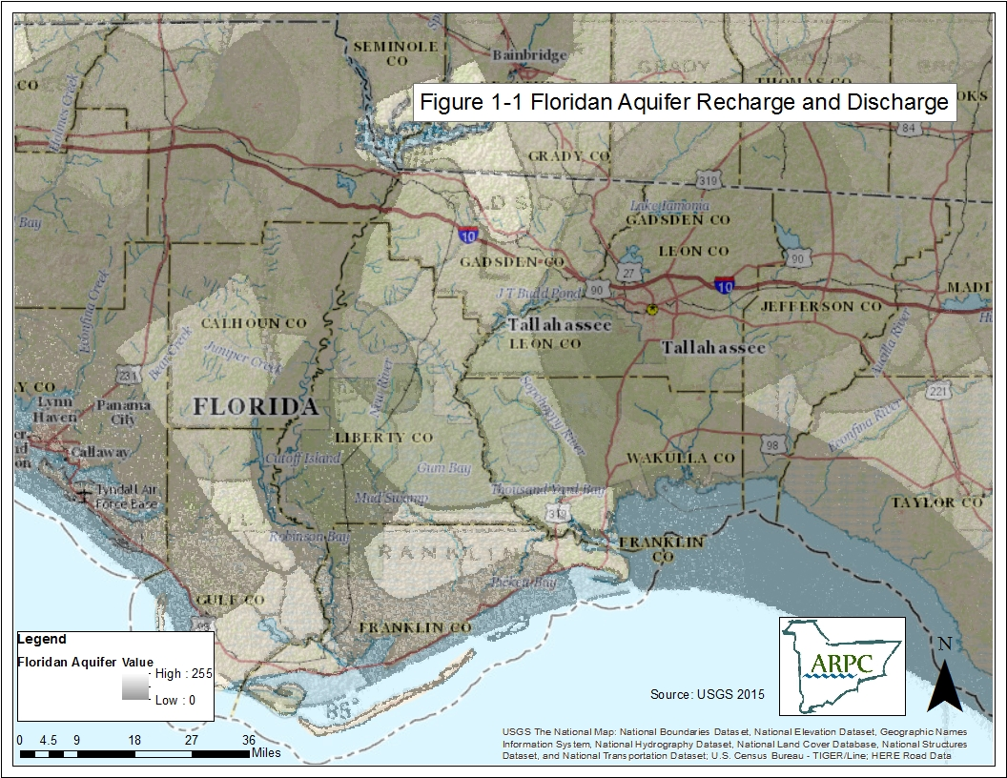

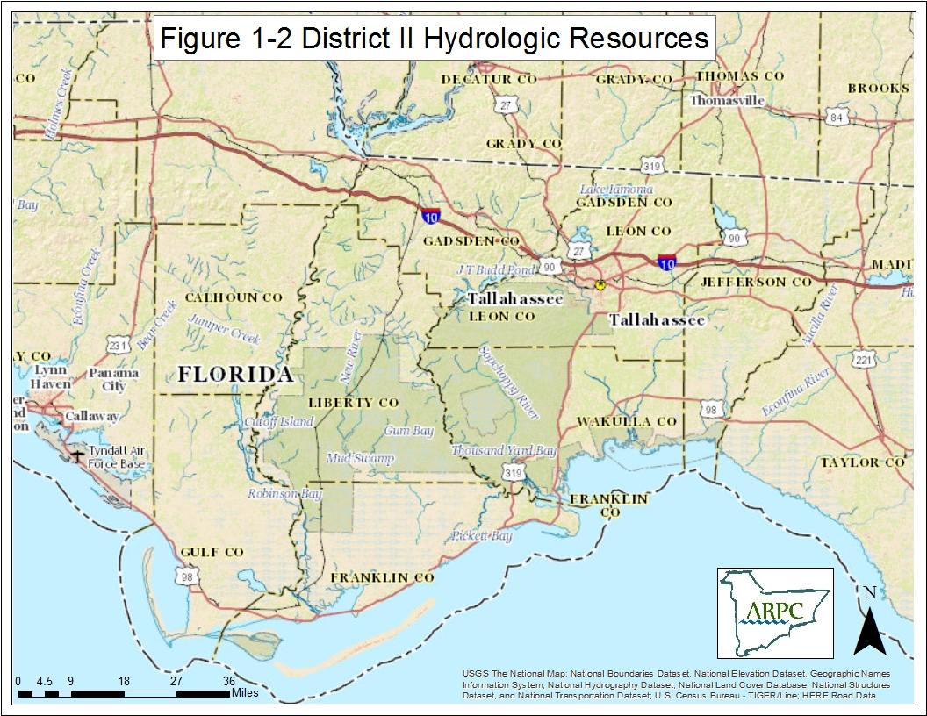

INSERT FIGURE 1-2

The southern portion of the region is primarily pine flatwoods and longleaf pine forest, interspersed along river basins by hardwood forests. The northern or uplands area of the region is characterized by forests of mixed hardwoods and pines with hardwoods along river basins.

Wildlife, both game and nongame, is abundant in the Apalachee region, due primarily to the heavily forested and rural nature of the area. Many species of birds are found in the area: predatory birds, songbirds, and waterfowl. Several species of migratory birds are present at various times of the year in certain locations. The rivers and lakes in the area contain large numbers and many species of fish, including several endangered species (e.g. the Atlantic Sturgeon). The bays and estuaries contain many species of fin and shellfish, as well. Many endangered and threatened species exist in the region: the red-cockaded woodpecker, the southeastern kestrel, and the Torreya tree are examples.

Wetlands cover more than 25% of the region's land area and constitute an important natural resource. Wildlife of many species rely on these areas for habitat and cover. In addition, these areas serve a vital function in the hydrologic cycle by acting as a buffer zone for flood waters, recharging and discharging the aquifer, and filtering debris and pollutants from run-off. Five of the ten largest first magnitude springs in the state are in the Apalachee region. They are important local recreational and aesthetic resources. Some are open to the public, many are privately owned. The Apalachee region is home to many state parks and recreation areas; the Apalachee National Forest, the largest national forest in the state; two national wildlife refuges and aquatic preserves; and over 80 historic and archaeological sites.

1.2.4. Demographics

The 2013 estimated population of the Apalachee region was estimated at 477,098 approximately 2.5% of the State's population (Bureau of Economic and Business Research, 2013). This population reflects a 2.0% increase since 2014, approximately half of the State of Florida’s rate of increase. With the exception of Leon County (population – 281,292 the remaining eight counties in the district can generally be considered rural. Leon County’s population with respect the other Apalachee counties can be attributed to the economy created by the State Capital and the expanding university system.

The overall density of the region was estimated at 81.4 persons per square mile in 2014 by the Bureau of Economic and Business Research. If Leon County is excluded in the calculations, the average density for the region is 38.9 persons per square mile.

The demographic makeup of the population is a factor that affects the response to hazardous materials emergencies. There are certain population groups that are, for planning purposes, considered special needs populations. According to 2013 U.S. Census data, residents age 65 and above account for approximately 12.8% of the total population of the Apalachee region, or 56,031 individuals. It was estimated in 2013 through the United States Census that there are approximately 31,572 persons with a disability (age 16+) living within the region. In addition, 30,057 residents in the region speak a language other than English at home (U.S. Census 2009-2013 American Community Survey 5-Year Estimates). These special needs population groups may require special considerations during an emergency event.

1.2.5 Housing

It is estimated 2009-2013 American Community Survey 5-Year Estimates, there are 211,055 total households in the Apalachee region, occupied or vacant. Furthermore, mobile homes constituted about 16.4% of the housing inventory of the region. The region also had an estimated 68,731 rental units (licensed lodgings: hotel, motel, transient/nontransient apartments, transient/nontransient rooming houses and vacation rental condominiums).

1.2.6 Transportation

The transportation network for the region is composed primarily of two lane highways connecting population centers. Interstate 10 traverses the northern portion of the region and provides an east-west expressway. US 90 and US 98 provides additional yet less significant east-west traffic volume across the region. State highways constitute all the north-south transportation corridors in the western part of the region. In the eastern portions of the region, U.S. Highway 319, 27 and state and county roads provide for north-south movement. Figure 1-3 depicts the road network of the Apalachee region.

There are three railroads that serve the region. CSX Transportation is the largest with annual freight volumes between 5-15 million gross ton/miles/year. The Bay Line Railroad operates from Dothan, Alabama, to Panama City, Florida, with a branch line between Campbellton and Graceville. The Apalachicola Northern Railway is 96-mile short line freight railroad running between Port St. Joe and Chattahoochee that interchanges with CSX Transportation.

Four sea ports are located in the region, Port St. Joe in Gulf County, Apalachicola and Carrabelle in Franklin County, and St. Marks in Wakulla County. Although none of these are major ports, each is locally significant. Port St. Joe is region’s only deep water port. In addition, there are river ports along the Apalachicola River in Blountstown and in Jackson County.

Nine airports of varying size and development exist in the region, the largest of which is located in Tallahassee. Six of the nine have paved runways and three are unpaved. The only airport served by major jet airliners is Tallahassee, although commuter and charter airlines can serve other airports.

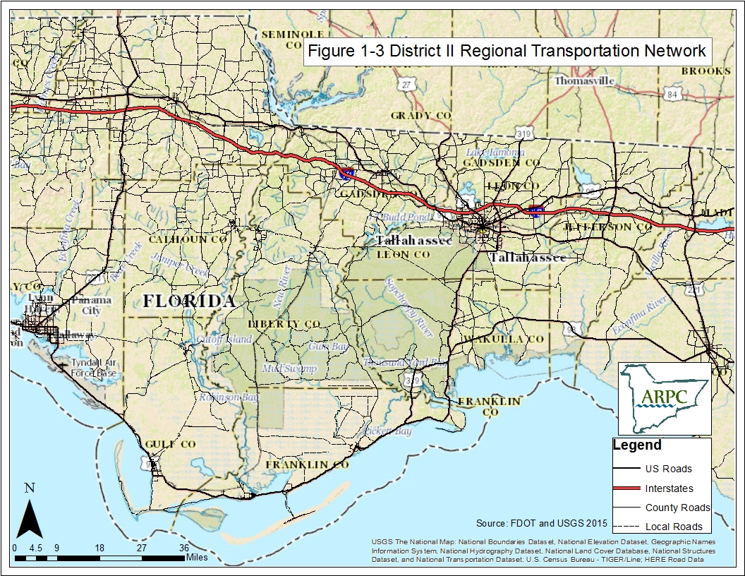
INSERT FIGURE 1-3

1.2.7 Health Care Facilities

Health care facilities within the region are concentrated in the population centers. There are general hospitals located in Calhoun, Franklin, Gadsden and Gulf Counties. Two general hospitals are located in Jackson (Marianna and Graceville) and Leon (Tallahassee) Counties. There are also five psychiatric institutions in the region. Ninety-six percent of the physician's offices are in Leon, Gadsden, and Jackson Counties. Notably, 80% of the physician's offices are in Leon County.

1.2.8 Educational Facilities

There are 106 public elementary and secondary schools in the region and 49 private schools. In 2012-2013, 59,381 students were enrolled in public schools and 5,896 were enrolled in private schools (Florida Department of Education). Regional post-secondary education facilities include one vocational-technical center, two junior colleges, and two state universities. Florida State University, Florida A & M University, Tallahassee Community College, and Lively Vocational-Technical Center are all located at Tallahassee. Chipola Junior College is located at Marianna.

1.2.9 Agriculture

For eight of the nine counties in the Apalachee region, agriculture and silviculture are important sectors of the economy. Most of the crops depend on the application of pesticides, herbicides and fertilizers. There are approximately 13 major crops, not including silviculture, grown to produce income. Each of the major crops has specific organisms that historically are associated with that crop and chemicals that are intended to deal with the pests.

There are numerous chemicals used for agriculture stored at several locations in the region. The quantity of chemicals in these stores varies according to the crop requirements, the time of year, and the expected threat to the crop. Some stores or warehouses in the region store multiple hazardous substances, some of which may be above the Threshold Planning Quantity (TPQ) and some of which may be below the TPQ.

Agricultural chemicals which are stored in amounts below the TPQ fall outside the purview of the hazardous materials program. However, they may still represent a threat to firefighting personnel. Training regarding the potential threat from these chemicals during a fire should be provided to local firefighting units. Also, since the probability of a release may increase during certain parts of the year depending on the crops, agricultural activities must be included in the evaluation of the risk from hazardous materials and in education and preparedness efforts.

1.2.10 Other Critical Variables Impacting Response

Critical variables impacting emergency response are factors that will affect emergency response but, because of their nature (e.g. may not be permanent, may affect only a certain time or area) are considered separately.

There are certain activities that draw large numbers of people to an area at the same time. Response activities for any incident involving the affected areas during these periods of time must take the event attendees into consideration. Some examples of these activities in the region include:

Event Location/Month
Goat Day Blountstown, October
Apalachicola Seafood Festival Apalachicola, November
Quincy Festival Quincy, October
Tupelo Festival Wewahitchka, April
Watermelon Festival Monticello, June
Springtime Tallahassee Tallahassee, March/April
Tallahassee Leon County Civic Center Tallahassee, events as scheduled
Winter Festival of Lights Tallahassee, December
College football games FAMU/FSU, Sept. – Dec.
Blue Crab Festival Panacea, May

During morning and afternoon rush hour, traffic becomes congested in the centers of population in the District. Response operations during these hours must consider traffic congestion as a factor. The following areas experience some degree of rush hour congestion: Blountstown, Chattahoochee, Marianna, Quincy and Tallahassee (including roads in Wakulla County leading to Leon County).

Other road conditions such as road construction and long and narrow bridges may affect evacuations. Calhoun, Liberty and Gadsden Counties must take into consideration the bridges over the Apalachicola River on State Road 20 and US Highway 90, respectively. Franklin County must also consider the bridges along US 98.

1.3 Hazards Analysis

A clear understanding of the types of hazards that may affect the community and the risks they pose is essential for comprehensive planning. To gain this understanding, each district LEPC conducts a site-specific hazard analysis for potential airborne releases of extremely hazardous substances (EHSs) as required by EPCRA, based on individual county reports and information submitted by the facility. The hazards analyses serves as the basis for developing and revising the emergency plans that are mandatory under EPCRA.

The hazards analyses included in this section of the plan are designed to consider the potential acute health hazards within Apalachee (specifically those facilities which have notified the SERC pursuant to state and federal requirements) and to identify which hazards are hazards of high priority which should be addressed in the emergency response planning process. The hazards analyses is updated annually as additional facilities come into compliance and as new facilities subject to the requirements of EPCRA begin operating in the county.

The hazards analyses included in the plan consists of the following three components:

- Hazards Identification - provides specific information on situations that have potential for causing injury to life or damage to property. The hazards identification includes information concerning the following:

    - Identity of stored chemicals;

    - Location of facilities that use, produce, process, or store designated hazardous materials;

    - Type and design features of chemical containers or vessels;

    - Quantities of material that could be involved in an airborne release; and

    - Nature of the hazard (e.g., airborne toxic vapors, fire, explosion, large quantities stored or processed, special handling conditions) most likely to accompany hazardous materials spills or releases.

The list of extremely hazardous substances (EHSs) and data used for the hazards analyses can be found in the SERC’s How to Comply Handbook available upon request or online at www.floridadisaster.org/hazmat/index.htm.

- Fixed Facilities Vulnerability Analysis - identifies areas in the community that may be affected or exposed, individuals in the community who may be subject to injury or death from certain specific projected release scenarios for designated hazardous materials, and facilities, property, or areas in the local environment that may be susceptible to damage should a hazardous materials release occur. A vulnerability analysis provides information describing:

    - Extent of the vulnerable zones (i.e., an estimation of the area that may be affected in a significant way as a result of a spill or release of a known quantity of a specific chemical under defined conditions);

    - Facility population (maximum number of personnel on site at any time;

    - Critical facilities within each vulnerable zone such as schools, day cares, public safety facilities and hospitals; and

    - An estimate of the total exposed population within each vulnerable zone (facility population + general population + critical facilities).

- Fixed Facility Risk Analysis - is an assessment of the probability (likelihood) of an accidental release of a hazardous material and the actual consequences that may occur, based on the estimated vulnerable zones. The risk analysis is a judgment of probability and severity of consequences based on the history of previous incidents, local experience, and the best available current technological information. The risk analysis provides an estimation of the:

    - Probability of an accidental release based on the history of previous incidents and current conditions & controls at the facility, or the possibility of simultaneous emergency incidents;

    - Severity of human injury or death that may occur, the number of possible injuries and deaths, and the associated high-risk groups;

    - Severity of consequences on specific critical facilities;

1.3.1 Methodology and Assumptions

The plan contains a summary of local fixed facility information (Figure 1-4) that includes the facility name, address, city and county. For each facility, information on the specific chemical (or chemicals) present, the reported quantity (if in excess of the Threshold Planning Quantity) and other selected information was used to estimate the vulnerability zone. Appendices A and B contain the detailed Extremely Hazardous Substances (EHS) and Hazards Analyses data for Apalachee. The following assumptions were used in the calculation of the vulnerable zones:

    - Quantity released: maximum quantity that could be released from largest vessel or interconnected vessels.

    - Rate of release to air: total quantity of gas, solid as a powder, or solid in solution, assumed to be released in 10 minutes; for liquids and molten solids, the rate is based on the rate of evaporation and rate of volatilization, respectively.

    - Temperature: not applicable to gases or solids as powders or in solution; for liquids, dependent on whether they are used at ambient temperature or near their boiling points; for molten solids, at their melting point.

    - Meteorological conditions: wind speed of 1.5 meters per second (3.4 miles per hour); F atmospheric stability (stable, slow tendency to move);

    - Topographic conditions: obstructed terrain for urban and rural areas; flat, level, unobstructed terrain for wide-open fields;.

    - Level of concern: one-tenth of the National Institute for Occupational Safety and Health's "Immediately Dangerous to Life and Health" level.

Response activities assume the owners/operators of facilities will notify the state and local governments of an emergency with sufficient time to implement the warning and protective actions.

The plan also assumes that the funding mechanisms included in EPCRA and the Florida Hazardous Materials legislation are designed to provide sufficient funding to state and local governments to assure compliance with federal, state and local chemical emergency preparedness requirements.

1.4 Supporting Plans

The following federal, state, local and facility emergency plans are available to support the implementation of the Apalachee Hazardous Materials Emergency Plan:

- Florida Coastal Pollutant Spill Plan;

- Florida Mutual Aid Plan;

- Comprehensive Emergency Management Plans (CEMP) for Calhoun, Franklin, Gadsden, Gulf, Jackson, Jefferson, Leon, Liberty and Wakulla Counties;

- State Comprehensive Emergency Management Plan;

- National Incident Management System (NIMS);

- National Response Framework; and

- National Oil and Hazardous Substances Pollution Contingency Plan.

1.5 Mutual Aid Agreements

These agreements should include: conditions, rules and standards governing any mutual aid; provisions for immunity from liability, and waiver of claims and indemnification from third party claims; notification of persons authorized to request or invoke mutual aid; compensation consideration; and procedures for the direction and control of personnel and units rendering aid. All counties within the Apalachee region are members of the Statewide Mutual Aid Agreement.

An interlocal agreement by certain members of the Big Bend Regional partnership was executed on September 8, 2008. The agreement sets the terms by which local parties will provide assistance to one another in connection with a fire or other emergency services as defined by 252.34 Florida Statutes. Parties to the agreement include Tallahassee, Leon County, Gadsden County, Quincy, Gretna and Midway.

1.6 Authorities and References

The preparation of the Apalachee LEPC Regional Hazardous Materials Plan was authorized pursuant to EPCRA; other related State and Federal legislation includes:

  - State Emergency Management Act, Chapter 252, Florida Statutes;

  - Resource Conservation and Recovery Act (RCRA), PL 94-580;

  - Comprehensive Environmental Response, Compensation, and Liability Act (CERCLA; Superfund);

  - Gubernatorial Executive Order 80-29, "Disaster Preparedness";

  - Gubernatorial Executive Order 12-23, State Emergency Response Commission Membership;

  - Hazardous Materials, Rule 27P-14, Florida Administrative Code

The following General and Technical References were used in the development of this plan and/or can be used as reference in the implementation of hazardous materials emergency preparedness activities:

    - CHRIS: Manual I, A Condensed Guide to Chemical Hazards. Washington D.C.: U.S. Coast Guard, USCG Publication M.16465.11A, 1985.

    - CHRIS: Manual II, Hazardous Chemical Data. Washington D.C.: U.S. Coast Guard, USCG Publication M.16465.12A, 1984.

    - Community Awareness and Emergency Response Program Handbook. Chemical Manufacturers Association.

    - Community Emergency Response Exercise Program Training. Chemical Manufacturers Association.

    - Community Teamwork. U.S. Department of Transportation.

    - U.S. DOT Emergency Response Guidebook. Washington, D.C.: U.S. Department of Transportation, Pipeline and Hazardous Materials Safety Administration, 2012.

    - Florida Incident Field Operations Guide. State of Florida: Division of Forestry, FDLE, DCA, DOH, DEP, State Fire Marshall, Sheriffs Association, Fire Chiefs Association, March 2006.

    - Florida Statistical Abstract. Gainesville, FL: University Presses of Florida, 2013.

    - Guide for Development of State and Local Emergency Operations Plans (CPG 1-8). Federal Emergency Management Agency.

    - Guidelines for the Selection of Chemical Protective Clothing, Second Edition. Cincinnati, Ohio: American Conference of Governmental Industrial Hygienists, Inc., 1985.

    - Hazardous Materials Emergency Planning Guide. Washington, D.C.: National Response Team, NRT-1, 1987.

    - Occupational Safety and Health Guidance Manual for Hazardous Waste Site Activities. Washington, D.C.: National Institute of Occupational Safety and Health, DHHS Publication No. 85-115, 1985.

    - The Physical Capabilities and Economics of the Apalachicola River Navigational Channel. Tallahassee, FL: Steve Leitman, Research for the Northwest Florida Water Management District.

    - Pocket Guide to Chemical Hazards. Washington, D.C.: National Institute of Occupational Safety and Health, DHHS Publication No. 90-117, 1990.

    - Site Emergency Response Planning. Chemical Manufacturers Association.

    - Technical Guidance for Hazard Analysis – Emergency Planning for Extremely Hazardous Substances. Washington D.C.: EPA, FEMA, U.S. DOT, 1987.

Figure 1-4: Apalachee LEPC Fixed Facilities (Chemicals, quantities and properties available in the County Hazards Analysis and CAMEO database)

County | Facility Name | Facility Address | City
CALHOUN | ALTHA FARMERS COOPERATIVE - ALTHA | 15543 NORTHEAST MOUNT OLIVE CEMETARY ROAD | ALTHA
CALHOUN | FAIRPOINT COMMUNICATIONS | 17273 MAIN STREET | BLOUNTSTOWN
CALHOUN | LEVEL 3 COMMUNICATIONS, INC | 14549 SR 20 WEST | CLARKSVILLE
FRANKLIN | ALLIGATOR POINT WATER - NEW WATER PLANT | 1MILE NORTH OF US 98, 1/8 MILE WEST OF STATE ROAD 370 | ALLIGATOR POINT
FRANKLIN | ALLIGATOR POINT WATER - OLD WATER PLANT | STATE ROAD 370 - 1 MILE SOUTH US HIGHWAY 98 | ALLIGATOR POINT
FRANKLIN | CITY OF APALACHICOLA - WTP | 29 CHAPMAN ROAD | APALACHICOLA
FRANKLIN | CITY OF APALACHICOLA - WWTP | 991 WEST HIGHWAY 98 | APALACHICOLA
FRANKLIN | EASTPOINT WATER AND SEWER DISTRICT - WELL 1 | BEGONIA STREET | EASTPOINT
FRANKLIN | EASTPOINT WATER AND SEWER DISTRICT - WWTP | 117 GILBERT STREET | EASTPOINT
FRANKLIN | WATER MANAGEMENT SERVICES, INC. - SAINT GEORGE ISLAND UTILITY | 139 GULF BEACH DRIVE WEST | SAINT GEORGE ISLAND
GADSDEN | BELLSOUTH - 31540 | 111 1st STREET SOUTHEAST | HAVANA
GADSDEN | CITY OF CHATTAHOOCHEE - WTP | 115 LINCOLN DRIVE | CHATTAHOOCHEE
GADSDEN | CITY OF CHATTAHOOCHEE - WWTP | 211 PALM STREET | CHATTAHOOCHEE
GADSDEN | CITY OF GRETNA - WELL 3 | WILLIAMS STREET | GRETNA
GADSDEN | CITY OF GRETNA - WELL 4 AND WATER PLANT | MEMORIAL BLUE STAR HIGHWAY | HAVANA
GADSDEN | CITY OF GRETNA - WWTP | 325 PARK STREET | GRETNA
GADSDEN | CITY OF QUINCY - BLUE STAR HIGHWAY WELLFIELD | 6215 MEMORIAL BLUE STAR HIGHWAY | QUINCY
GADSDEN | CITY OF QUINCY - WELL 4 | 723 SOUTH STEWART STREET | QUINCY
GADSDEN | CITY OF QUINCY WTP | 915 NORTH ADAMS STREET | QUINCY
GADSDEN | CITY OF QUINCY WWTP | 300 NORTH G F AND A DRIVE | QUINCY
GADSDEN | DAVIS SUPPLY-QUINCY | 25058 BLUE STAR HIGHWAY | QUINCY
GADSDEN | DEPARTMENT OF CHILDREN AND FAMILIES - FLORIDA STATE HOSPITAL | US HIGHWAY 90 EAST | CHATTAHOOCHEE
GADSDEN | FLORIDA GAS TRANSMISSION - C / S 14 QUINCY | 3690 HOSFORD HIGHWAY | QUINCY
GADSDEN | GARGIULO - BTG HARBIN FARM 2 | HARBIN ROAD | HAVANA
GADSDEN | PROGRESS ENERGY – QUINCY SUBSTATION | 904 N. ADAMS ST | QUINCY
GADSDEN | QUINCY FARMS | 190 MANNIE GUNN | QUINCY
GADSDEN | SPECIALTY CHEMICAL | 1633 HIGH BRIDGE ROAD - UNIT B | QUINCY
GADSDEN | SUPERVALU - QUINCY DISTRIBUTION---21160 | 1400 WEST GADSDEN STREET | QUINCY
GADSDEN | SUPERVALU - QUINCY DISTRIBUTION---21161 | 1797 PAT THOMAS PARKWAY | QUINCY
GADSDEN | TALQUIN ELECTRIC - GADSDEN EAST WELL (10/90) | 1205 COMMERCE BLVD | MIDWAY
GADSDEN | TALQUIN ELECTRIC - GADSDEN WWTP | 30270 BLUE STAR HIGHWAY | MIDWAY
GADSDEN | TALQUIN ELECTRIC - JAMIESON ROAD WELL | 15 ROGER LEWIS LANE | HAVANA
GADSDEN | TALQUIN ELECTRIC - OAK GROVE WELL | 8170 BLUE STAR HWY (HWY 90) | QUINCY
GADSDEN | TALQUIN ELECTRIC - OCHLOCKONEE WELL #1 | 85 CHOCTAW DRIVE | HAVANA
GADSDEN | TALQUIN ELECTRIC - OCHLOCKONEE WELL #2 | 315 MOCCASIN CIRCLE | HAVANA
GADSDEN | TALQUIN ELECTRIC - SCOTTSTOWN WELL | 3595 ATTAPULGUS HIGHWAY | QUINCY
GADSDEN | TALQUIN ELECTRIC - SHILOH WELL | 296 SHILOH ROAD | QUINCY
GADSDEN | TALQUIN ELECTRIC - ST. HEBRON WELL | 1205 PT MILLIGAN ROAD | QUINCY
GADSDEN | TALQUIN ELECTRIC - ST. JOHNS WELL | 4600 OLD BAINBRIDGE HWY | QUINCY
GADSDEN | TALQUIN ELECTRIC - WETUMPKA WELL | 5570 OLD FEDERAL ROAD | QUINCY
GADSDEN | TOWN OF HAVANA - WELL 1 AND 2 | 108 5 AVENUE EAST | HAVANA
GADSDEN | TOWN OF HAVANA - WELL 3 | 217 5 STREET SOUTHWEST | HAVANA
GADSDEN | TOWN OF HAVANA - WELL 4 | US HIGHWAY 27 ACROSS FROM COASTAL LUMBER | HAVANA
GADSDEN | TOWN OF HAVANA - WWTP | 110 14 AVENUE EAST | HAVANA
GULF | CITY OF WEWAHITCHKA - WTP | 402 EAST LAKE GROVE ROAD | WEWAHITCHKA
GULF | CITY OF WEWAHITCHKA - WWTP | 200 SYCAMORE AVENUE | WEWAHITCHKA
GULF | DEPARTMENT OF CORRECTIONS - GULF CORRECTIONAL FACILITY | 500 IKE STEELE ROAD | WEWAHITCHKA
GULF | DEPARTMENT OF CORRECTIONS - GULF FORESTRY CAMP | 3222 DOC Whitfield Road | White City
GULF | FAIRPOINT COMMUNICATIONS - PORT SAINT JOE | 502 CECIL G COSTIN SENIOR BOULEVARD | PORT SAINT JOE
GULF | GENERAL CHEMICAL - PORT SAINT JOE | 281 CHEMICAL DRIVE | PORT SAINT JOE
GULF | LIGHTHOUSE UTILITIES - 16 INCH WELL | 7521 COUNTY ROAD 30C | PORT SAINT JOE
GULF | LIGHTHOUSE UTILITIES - 6 INCH WELL | 5610 COUNTY ROAD 30C | PORT SAINT JOE
GULF | RAFFIELDS FISHERIES | 1624 GROUPER AVENUE | PORT SAINT JOE
GULF | WOODS FISHERIES | 464 ANGEL FISH STREET | PORT SAINT JOE
JACKSON | ALTHA FARMERS COOPERATIVE – MARIANNA | 2981 SOUTH PENNSYLVANIA AVENUE | MARIANNA
JACKSON | BELLSOUTH - 31536 | 5370 CLIFF STREET | GRACEVILLE
JACKSON | CAMPBELLTON FARM SERVICE | 5255 US HIGHWAY 231 SOUTH | CAMPBELLTON
JACKSON | CITY OF COTTONDALE – WWTP | 2680 FRONT STREET | COTTONDALE
JACKSON | CITY OF GRACEVILLE – WWTP | 865 6TH AVENUE | GRACEVILLE
JACKSON | CITY OF MARIANNA – SUNLAND TRAINING CENTER WELL 4 | 3725 HIGHWAY 71 NORTH | MARIANNA
JACKSON | CITY OF MARIANNA – SUNLAND TRAINING CNTR WELL 1 | 3659 HIGHWAY 71 NORTH | MARIANNA
JACKSON | CITY OF MARIANNA – WELL 1 | 4098 LAFAYETTE STREET | MARIANNA
JACKSON | CITY OF MARIANNA – WELL 5 | 2900 NOLAND STREET | MARIANNA
JACKSON | CITY OF MARIANNA – WELL 6 | CORNER OF 9 AVENUE AND 4 STREET | MARIANNA
JACKSON | CITY OF MARIANNA – WELL 7 | 3949 FAMILY DOLLAR PARKWAY | MARIANNA
JACKSON | CITY OF MARIANNA – WWTP | 2832 DAVEY STREEET | MARIANNA
JACKSON | DEPARTMENT OF CORRECTIONS - APALACHEE WEST UNIT | 52 WEST UNIT DRIVE | SNEADS
JACKSON | DEPARTMENT OF CORRECTIONS - JACKSON CORRECTIONAL INST | 5563 TENTH STREET | MALONE
JACKSON | EMBARQ – MARIANNA / CENTRAL OFFICE | 4387 LAFAYETTE STREET | MARIANNA
JACKSON | FAMILY DOLLAR - MARIANNA DISTRIBUTION CENTER | 3949 FAMILY DOLLAR PARKWAY | MARIANNA
JACKSON | GOLDEN PEANUT | 5155 PEANUT STREET | GREENWOOD
JACKSON | GULF POWER - SCHOLZ POWER PLANT | 1460 GULF POWER ROAD | SNEADS
JACKSON | L MCARTHUR | 5199 8TH AVENUE | MALONE
JACKSON | SOUTHERN STATES COOPERATIVE - MARIANNA | 2971 PIERCE STREET | MARIANNA
JACKSON | TOWN OF GRAND RIDGE - WELL 1 | 6918 HALL STREET | GRAND RIDGE
JACKSON | TOWN OF GRAND RIDGE - WELL 2 | 6913 PARK STREET | GRAND RIDGE
JACKSON | TOWN OF GRAND RIDGE - WELL 3 | 7108 PROVIDENCE CHURCH ROAD | GRAND RIDGE
JACKSON | TOWN OF SNEADS - WWTP | 1890 HAM POND ROAD | SNEADS
JEFFERSON | CENTURYLINK - MONTICELLO / CENTRAL OFFICE | 285 WEST WALNUT STREET | MONTICELLO
JEFFERSON | CITY OF MONTICELLO - WWTP | 1220 MAMIE SCOTT DRIVE | MONTICELLO
JEFFERSON | CITY OF MONTICELLO WATER SYSTEM WELL 1 | 200 EAST YORK STREET - NORTH CHERRY STREET | MONTICELLO
JEFFERSON | CITY OF MONTICELLO WATER SYSTEM WELL 2 | 700 EAST PEARL STREET | MONTICELLO
JEFFERSON | CITY OF MONTICELLO WATER SYSTEM WELL 3 | US HIGHWAY 19 SOUTH - WELL | MONTICELLO
JEFFERSON | CITY OF MONTICELLO WATER SYSTEM WELL 4 | 173 INDUSTRIAL PARK DRIVE | MONTICELLO
JEFFERSON | DEPARTMENT OF CORRECTIONS - JEFFERSON CORRECTIONAL INST | 1050 BIG JOE ROAD | MONTICELLO
JEFFERSON | DUMONT COMPANY - MONTICELLO | 33 TWO LONG KEEN ROAD | MONTICELLO
JEFFERSON | LEVEL 3 COMMUNICATIONS – LAMOUNT | 5473 EAST CAPPS HIGHWAY | LAMONT
JEFFERSON | MCI – MONTFL (VERIZON) | 15 TECUMSEH ROAD | MONTICELLO
JEFFERSON | VERIZON – DRFTFL (FORMERLY MCI) | CR 158 EAST | DRIFTON
JEFFERSON | WAUKEENAH FERTILIZER AND FARM SUPPLY | 9643 WAUKEENAH HIGHWAY | MONTICELLO
LEON | AT&T - FLF760 | 110 EAST CAROLINA STREET/327 N. ADAMS | TALLAHASSEE
LEON | CENTURYLINK - TALLAHASSEE / 385 CENTRAL OFFICE | 124 WILLIS ROAD | TALLAHASSEE
LEON | CENTURYLINK - TALLAHASSEE / 562 CENTRAL OFFICE | 3968 PERKINS ROAD | TALLAHASSEE
LEON | CENTURYLINK - TALLAHASSEE / 576 CENTRAL OFFICE | 706 MABRY STREET | TALLAHASSEE
LEON | CENTURYLINK - TALLAHASSEE / 644 FSU SHAW BLDG CO | CALL AND DEWEY STREETS | TALLAHASSEE
LEON | CENTURYLINK - TALLAHASSEE / 877 CENTRAL OFFICE | 1337 BLAIRSTONE ROAD | TALLAHASSEE
LEON | CENTURYLINK - TALLAHASSEE / 893 CENTRAL OFFICE | 5000 THOMASVILLE ROAD | TALLAHASSEE
LEON | CENTURYLINK - TALLAHASSEE / CALHOUN STREET BLDG | 132 NORTH CALHOUN STREET | TALLAHASSEE
LEON | CITY OF TALLAHASSEE - HOPKINS GENERATING STATION | 1125 GEDDIE ROAD - COUNTY ROAD 1585 | TALLAHASSEE
LEON | CITY OF TALLAHASSEE - THOMAS P SMITH WATER RECLAMATION FACILITY | 3805 SPRINGHILL ROAD | TALLAHASSEE
LEON | CITY OF TALLAHASSEE - WELL 02 AND WELL 04 | 1110 NORTH GILCHRIST STREET | TALLAHASSEE
LEON | CITY OF TALLAHASSEE - WELL 03 | 914 MEYERS PARK DRIVE | TALLAHASSEE
LEON | CITY OF TALLAHASSEE - WELL 05 | 600 NORTH WOODWARD AVENUE | TALLAHASSEE
LEON | CITY OF TALLAHASSEE - WELL 06 | 540 WEST FOURTH AVENUE | TALLAHASSEE
LEON | CITY OF TALLAHASSEE - WELL 07 | 410 WEST FOURTH AVENUE | TALLAHASSEE
LEON | CITY OF TALLAHASSEE - WELL 08 | 405 EAST BRADFORD ROAD | TALLAHASSEE
LEON | CITY OF TALLAHASSEE - WELL 09 | 225 WEST VIRGINIA STREET | TALLAHASSEE
LEON | CITY OF TALLAHASSEE - WELL 10 | 1224 HODGES DRIVE | TALLAHASSEE
LEON | CITY OF TALLAHASSEE - WELL 11 | 119 RIDGELAND ROAD | TALLAHASSEE
LEON | CITY OF TALLAHASSEE - WELL 12 | 2114 SOUTH COUNTRY CLUB DRIVE | TALLAHASSEE
LEON | CITY OF TALLAHASSEE - WELL 13 | 1401 ARKANSAS STREET | TALLAHASSEE
LEON | CITY OF TALLAHASSEE - WELL 15 | 400 SOUTH LIPONA ROAD | TALLAHASSEE
LEON | CITY OF TALLAHASSEE - WELL 16 | 2789 RAYMOND DIEHL ROAD | TALLAHASSEE
LEON | CITY OF TALLAHASSEE - WELL 17 | 2201 APALACHEE PARKWAY | TALLAHASSEE
LEON | CITY OF TALLAHASSEE - WELL 18 | 2320 ROYAL OAKS DRIVE | TALLAHASSEE
LEON | CITY OF TALLAHASSEE - WELL 19 | 3701 FRED GEORGE ROAD | TALLAHASSEE
LEON | CITY OF TALLAHASSEE - WELL 21 | 6512 1/2 EAST MAHAN DRIVE | TALLAHASSEE
LEON | CITY OF TALLAHASSEE - WELL 22 | 4845 LIMOGES DRIVE | TALLAHASSEE
LEON | CITY OF TALLAHASSEE - WELL 23 | 1968 MISSION ROAD | TALLAHASSEE
LEON | CITY OF TALLAHASSEE - WELL 25 | 703 SPANISH MOSS DRIVE | TALLAHASSEE
LEON | CITY OF TALLAHASSEE - WELL 26 | 2640 OLD BAINBRIDGE ROAD | TALLAHASSEE
LEON | CITY OF TALLAHASSEE - WELL 27 | 1343 EAST ORANGE AVENUE | TALLAHASSEE
LEON | CITY OF TALLAHASSEE - WELL 28 | 1950 MERCHANTS ROW | TALLAHASSEE
LEON | CITY OF TALLAHASSEE - WELL 29 | 7587 BRADFORDVILLE ROAD | TALLAHASSEE
LEON | CITY OF TALLAHASSEE - WELL 33 | 1861 BROWNING ROAD | WOODVILLE
LEON | Coca-Cola Refreshments USA, Inc. - TALLAHASSEE | 2050 MARYLAND CIRCLE | TALLAHASSEE
LEON | COMCAST OF THE SOUTH, INC. - TALLAHASSEE | 3760 HARTSFIELD ROAD | TALLAHASSEE
LEON | CONE DISTRIBUTING – TALLAHASSEE | 3214 W. THARPE STREET | TALLAHASSEE
LEON | COSTCO WHOLESALE - STORE 1026 | 4067 LAGNIAPPE WAY | TALLAHASSEE
LEON | DOC – FEDERAL CORRECTIONAL INSTITUTION - TALLAHASSEE | 501 CAPITAL CIRCLE NORTHEAST | TALLAHASSEE
LEON | FLORIDA STATE UNIVERSITY - NHMFL | 1800 EAST PAUL DIRAC DRIVE | TALLAHASSEE
LEON | GENERAL DYNAMICS LAND SYSTEMS | 2930 COMMONWEALTH BOULEVARD | TALLAHASSEE
LEON | GOLDEN EAGLE GOLF AND COUNTRY CLUB | 3700 GOLDEN EAGLE DRIVE | TALLAHASSEE
LEON | INTERSTATE BATTERY SYSTEM OF TALLAHASSEE | 2543 WEST TENNESSEE STREET | TALLAHASSEE
LEON | LEVEL 3 COMMUNICATIONS – TALLAHASSEE HUT 1&3 | 5693 BLOUNTSTOWN HIGHWAY | TALLAHASSEE
LEON | LEVEL 3 COMMUNICATIONS - TALLAHASSEE | 2075 MARYLAND CIRCLE | TALLAHASSEE
LEON | LEVEL 3 COMMUNICATIONS – TALLAHASSEE FLA2 | 4930 GUM ROAD | TALLAHASSEE
LEON | LEVEL 3 COMMUNICATIONS - TALLAHASSEE HUT | 813 GAY STREET | TALLAHASSEE
LEON | LEVEL 3 COMMUNICATIONS - TALLAHASSEE POP | 1346-C SOUTH ADAMS STREET | TALLAHASSEE
LEON | LEVEL 3 COMMUNICATIONS - TALLAHASSEE-3 | 619 MABRY STREET | TALLAHASSEE
LEON | LEVEL 3 COMMUNICATIONS - TLHSFL1W | 1416 SOUTH ADAMS STREET | TALLAHASSEE
LEON | PEDDIE CHEMICAL | 730 BLOUNTSTOWN HIGHWAY | TALLAHASSEE
LEON | PICK N PULL - TALLAHASSEE | 3900 WOODVILLE HIGHWAY | TALLAHASSEE
LEON | QWEST - TALLAHASSEE POP | 601 STONE VALLEY WAY | TALLAHASSEE
LEON | QWEST - TALLAHASSEE T1 | 603 WEST GAINES STREET | TALLAHASSEE
LEON | ROWE UTILITIES - BREWSTER SUBDIVISION | 4420 BREWSTER ROAD | TALLAHASSEE
LEON | ROWE UTILITIES - BUCK LAKE ESTATES | 2092 DRAKE DRIVE | TALLAHASSEE
LEON | ROWE UTILITIES - MEADOW HILLS SUBDIVISION | 4927 VERNON ROAD | TALLAHASSEE
LEON | ROWE UTILITIES - NORTH LAKE MEADOWS | 7283 NOLA COURT | TALLAHASSEE
LEON | ROWE UTILITIES - PLANTATION ESTATES | 7795 MAHAN DRIVE | TALLAHASSEE
LEON | ROWE UTILITIES - SEDGEFIELD SUBDIVISION | 1311 LANDSDOWNE ROAD | TALLAHASSEE
LEON | SAMS CLUB - STORE 8120 | 3122 DICK WILSON BOULEVARD | TALLAHASSEE
LEON | SEARS ROEBUCK AUTO CENTER - 6225 | 1500 APPALACHEE PARKWAY | TALLAHASSEE
LEON | SOUTHWOOD GOLF CLUB - CART STORAGE BLDG | 3752 GROVE PARK DRIVE | TALLAHASSEE
LEON | Talquin Electric - Baker Well | 8400 PROCTOR ROAD | TALLAHASSEE
LEON | Talquin Electric - Bradfordville Well | 6982 LAWTON CHILES LANE | TALLAHASSEE
LEON | Talquin Electric - Harwood Well | 3425 OLD BAINBRIDGE ROAD | TALLAHASSEE
LEON | Talquin Electric – Heartwood Hills Well | 1630 BAUM ROAD | TALLAHASSEE
LEON | Talquin Electric - Homestead Ridge Well | 3333 ALMANAC ROAD | TALLAHASSEE
LEON | Talquin Electric - Killearn Lakes Well #1 | 8020 DEERLAKE EAST | TALLAHASSEE
LEON | Talquin Electric - Killearn Lakes Well #2 | 9201 DEERLAKE EAST | TALLAHASSEE
LEON | Talquin Electric - Killearn Lakes Well #3 | 9820 WATERS MEET DRIVE | TALLAHASSEE
LEON | Talquin Electric - Killearn Lakes WWTP | 9201 DEERLAKE NORTH | TALLAHASSEE
LEON | Talquin Electric - Lake Jackson Systems T4 Well | 4808 PORTAL DRIVE | TALLAHASSEE
LEON | Talquin Electric - Lake Jackson Well | 5020 STONLER ROAD | TALLAHASSEE
LEON | Talquin Electric - Lake Jackson WWTP | 5999 TOWER ROAD | TALLAHASSEE
LEON | Talquin Electric - Lakewood Village Well | 5020 STONELER ROAD | TALLAHASSEE
LEON | Talquin Electric - Meadows Wells #1 and #2 (Lake Heritage) | 3438 LOUVINIA | TALLAHASSEE
LEON | Talquin Electric - Meadows WWTP | 8207 APALACHEE PARKWAY | TALLAHASSEE
LEON | Talquin Electric - Miccosukee Well | 8763 BILLINGSLEY ROAD | TALLAHASSEE
LEON | Talquin Electric - Oakfair Farms Well | 2426 LAKEFAIR DRIVE | TALLAHASSEE
LEON | Talquin Electric - Ochlockonee Interconnect Well | 5290 CAPITAL CIRCLE N.W. | TALLAHASSEE
LEON | Talquin Electric - Pineridge Wells #1 and #2 | 5500 WESTVIEW LANE | TALLAHASSEE
LEON | Talquin Electric - Sandstone WWTP | 242 MAIGE ROAD | TALLAHASSEE
LEON | Talquin Electric - Southern Pines Well | 2333 WILDFLOWER ROAD | TALLAHASSEE
LEON | Talquin Electric - Stonegate Well | 3001 WINDY HILL LANE | TALLAHASSEE
LEON | Talquin Electric - T-4 Well | 4808 PORTAL DRIVE | TALLAHASSEE
LEON | Talquin Electric - Towers Well #2 | 6301 SUE PAGE DRIVE | TALLAHASSEE
LEON | Talquin Electric - Whispering Pines Well #2 | 322 POST OAK DRIVE | TALLAHASSEE
LEON | THE HOME DEPOT – STORE 0254 | 3200 NE CAPITAL CIRCLE | TALLAHASSEE
LEON | UNISOURCE WORLDWIDE - TALLAHASSEE | 3166 HARTSFIELD ROAD | TALLAHASSEE
LEON | UNITED STATES POSTAL - TALLAHASSEE P&DF | 2800 SOUTH ADAMS STREET | TALLAHASSEE
LEON | VERIZON COMMUNICATIONS - TALSFL | 101 NORTH MONROE STREET - SUITE 950 | TALLAHASSEE
LEON | VERIZON COMMUNICATIONS - TLFRFL | 3303 WEEMS ROAD AT CSX RAILROAD TRACKS | TALLAHASSEE
LEON | VERIZON WIRELESS – FSU STADIUM | 100 CAMPBELL STADIUM | TALLAHASSEE
LEON | VERIZON WIRELESS – SOUTH MONROE MTSO | 1851 SOUTH MONROE STREET | TALLAHASSEE
LEON | W C T V CHANNEL 6 - TALLAHASSEE | 1801 HALSTEAD BOULEVARD | TALLAHASSEE
LIBERTY | CITY OF BRISTOL - WELL 8 | 260 MICHAUX ROAD | BRISTOL
LIBERTY | CITY OF BRISTOL - WELL 9 | 518 SOUTH FREEMAN ROAD | BRISTOL
LIBERTY | DEPARTMENT OF CORRECTIONS - LIBERTY CORRECTIONAL INST | 11064 NORTHWEST DEMPSEY BARRON ROAD | BRISTOL
LIBERTY | LEVEL 3 COMMUNICATIONS – HOSFORD | 20798 N.E. SR 20 | HOSFORD
LIBERTY | LIBERTY COUNTY - ESTIFFANULGA WATER SYSTEM | 21129 N.W. C.R. 333 Landing Rd. | BRISTOL
LIBERTY | LIBERTY COUNTY - HOSFORD WATER SYSTEM | 21436 N.E. Woodman St. | HOSFORD
LIBERTY | LIBERTY COUNTY - LAKE MYSTIC WATER SYSTEM | 16534 N.W. Lake Mystic Well's Rd. | BRISTOL
LIBERTY | LIBERTY COUNTY - ROCK BLUFF WATER SYSTEM | 5780 NORTHWEST COUNTY ROAD 270 | BRISTOL
LIBERTY | LIBERTY COUNTY - SUMATRA WATER SYSTEM | 44903 S.W. C.R. 379 | SUMATRA
LIBERTY | LIBERTY COUNTY - TELOGIA WATER SYSTEM | 18113 N.E. Arnold Kelly Rd. | TELOGIA
LIBERTY | TELOGIA POWER LLC | 20082 TELOGIA POWER ROAD | TELOGIA
WAKULLA | CITY OF SAINT MARKS - WWTP | 131 MOCK STREET | SAINT MARKS
WAKULLA | CITY OF SOPCHOPPY - WELL 1 | 35 BYRD ST - CITY HALL | SOPCHOPPY
WAKULLA | CITY OF SOPCHOPPY - WELL 2 | 686 SOPCHOPPY HIGHWAY - OTTER CREEK | SOPCHOPPY
WAKULLA | CITY OF SOPCHOPPY - WELL 3 | 148 WILDWOOD DRIVE - WILDWOOD ACRES | CRAWFORDVILLE
WAKULLA | CITY OF SOPCHOPPY - WELL 4 | 4671 CRAWFORDVILLE HIGHWAY - WAKULLA MANOR | SOPCHOPPY
WAKULLA | CITY OF SOPCHOPPY - WELL 5 | 41 HIGH DRIVE | CRAWFORDVILLE
WAKULLA | CITY OF SOPCHOPPY - WELL 6 | 69 FONTAINE CIRCLE - NORTH CRAWFORDVILLE | CRAWFORDVILLE
WAKULLA | CITY OF SOPCHOPPY- WELL 7 | 10 HARVEY PITTMAN | CRAWFORDVILLE
WAKULLA | CITY OF TALLAHASSEE - PURDOM GENERATING STATION | 667 PORT LEON DRIVE | SAINT MARKS
WAKULLA | CSG SYSTEMS INC | 509 COMMERCE BOULEVARD | CRAWFORDVILLE
WAKULLA | EMBARQ COMMUNICATIONS - 179 | 179 OCHLOCKNEE STREET | CRAWFORDVILLE
WAKULLA | PANACEA AREA WATER SYSTEM – WELL #3 | 76 WESTVIEW STREET | PANACEA
WAKULLA | PANACEA AREA WATER SYSTEM – WELL #4 | 103 FISHING FOOL STREET | PANACEA
WAKULLA | SAINT MARKS POWDER – GENERAL DYNAMICS CORP | 7121 COASTAL HIGHWAY | CRAWFORDVILLE
WAKULLA | Talquin Electric – Oyster Bay WWTP | 92 CUTOFF ROAD | CRAWFORDVILLE
WAKULLA | Talquin Electric - Shadeville Well | 1432 SPRING CREEK HIGHWAY | CRAWFORDVILLE
WAKULLA | Talquin Electric – Songbird Well | 828 WAKULLA AARON ROAD | CRAWFORDVILLE
WAKULLA | Talquin Electric - Spring Creek Wells #1 and #2 | 3536 SPRING CREEK HIGHWAY | CRAWFORDVILLE
WAKULLA | WINCO UTILITIES - WTP | 512 COMMERCE BOULEVARD | CRAWFORDVILLE
WAKULLA | WINCO UTILITIES - WWTP | 137 HERLONG DRIVE | CRAWFORDVILLE
WAKULLA | WAKULLA COUNTY, OTTER CREEK WWTP | 2146 LAWHON MILL RD | SOPCHOPPY

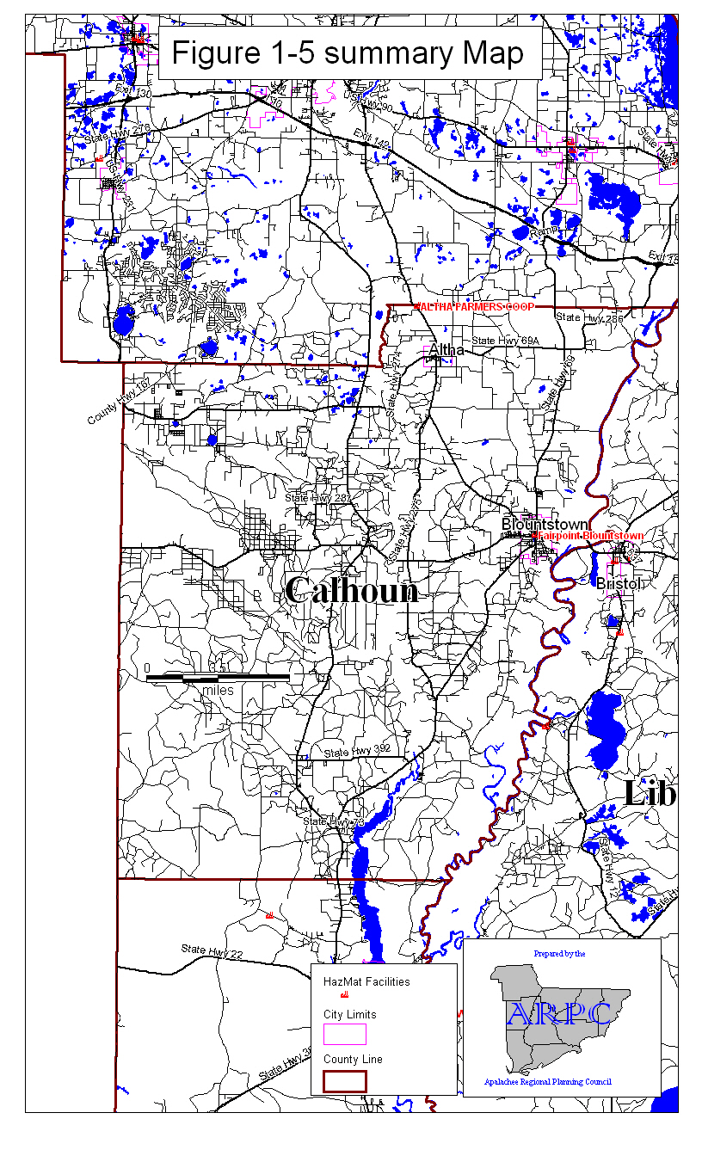
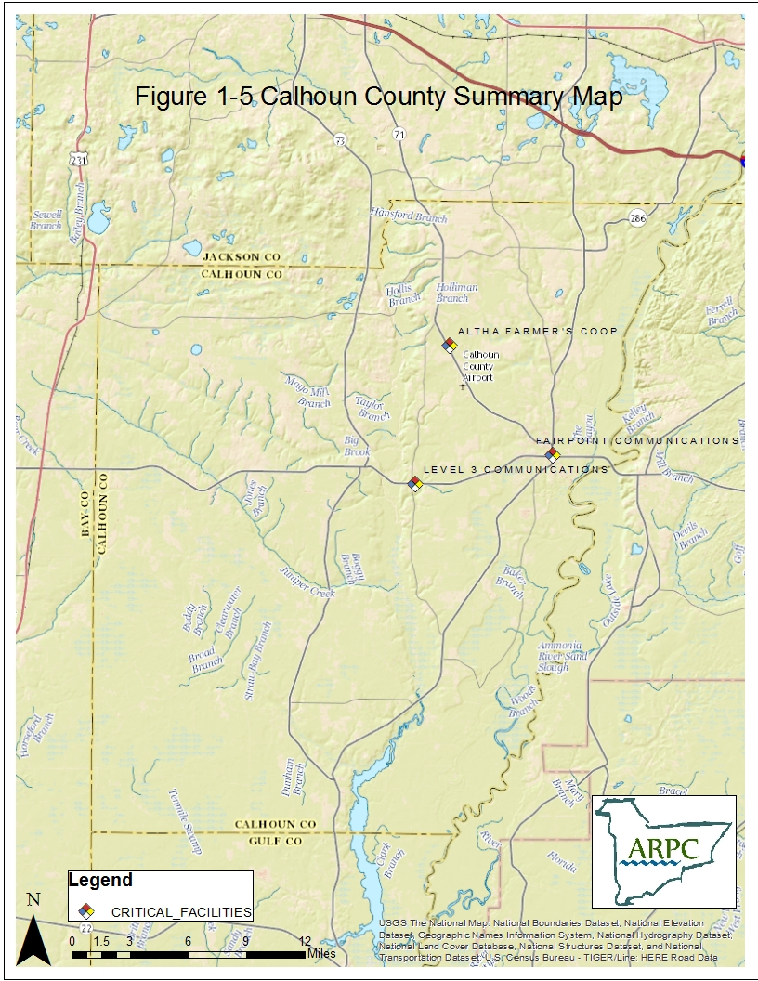
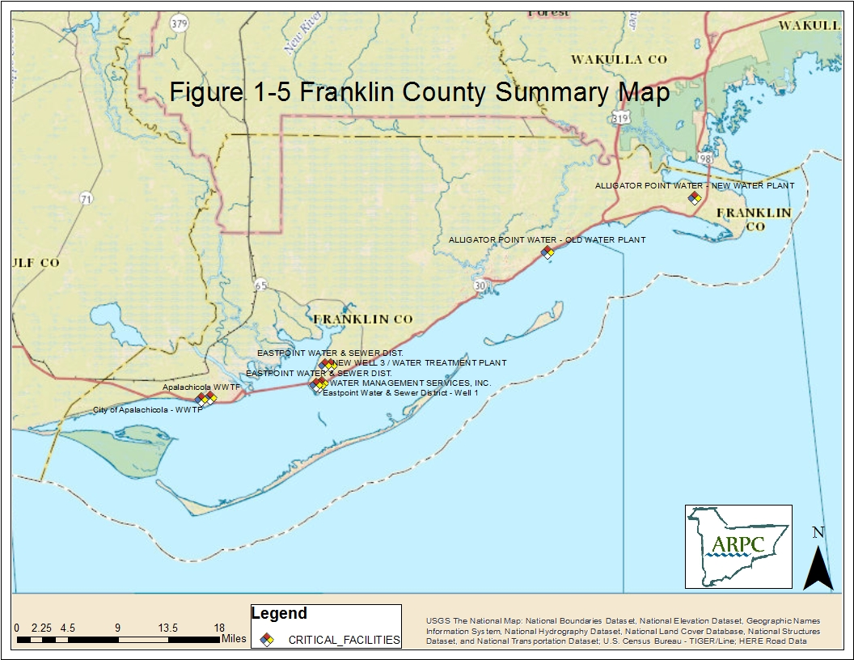
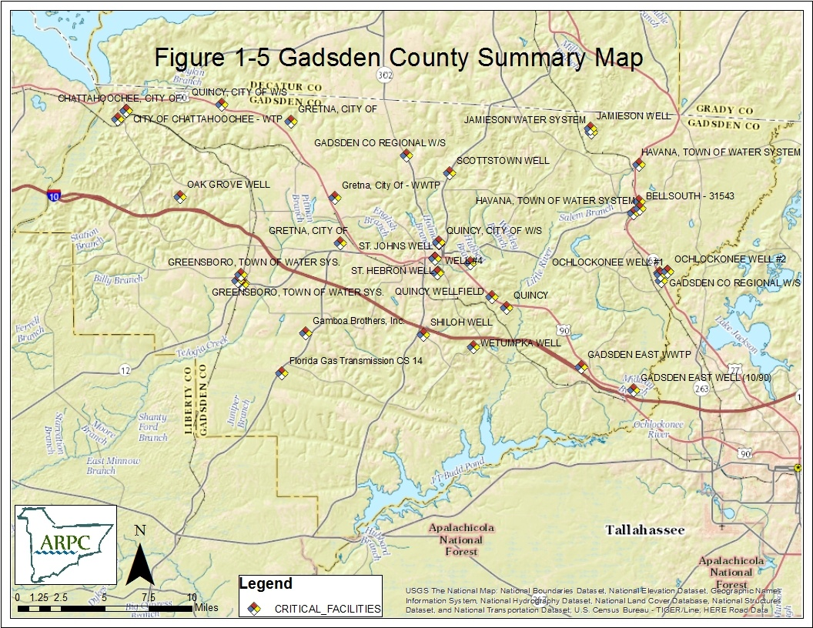
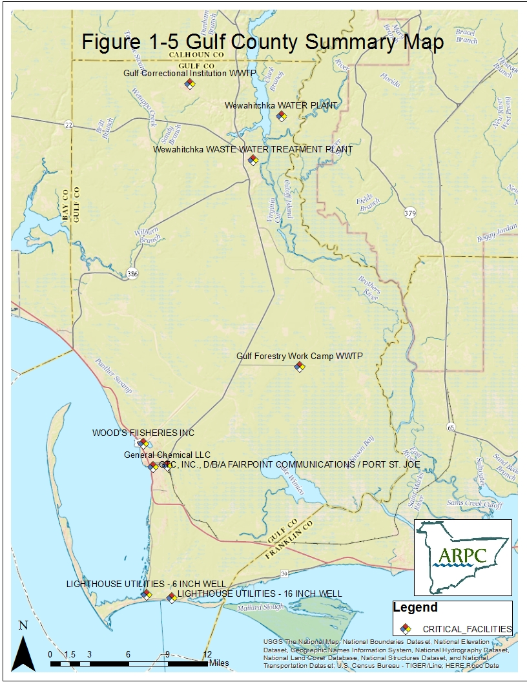
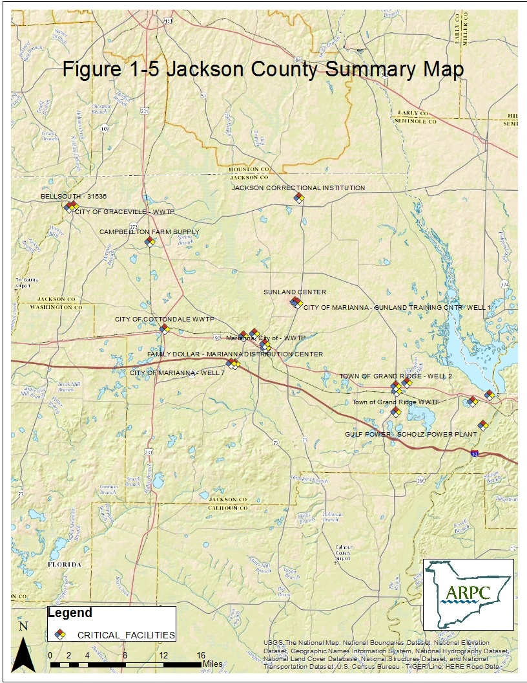
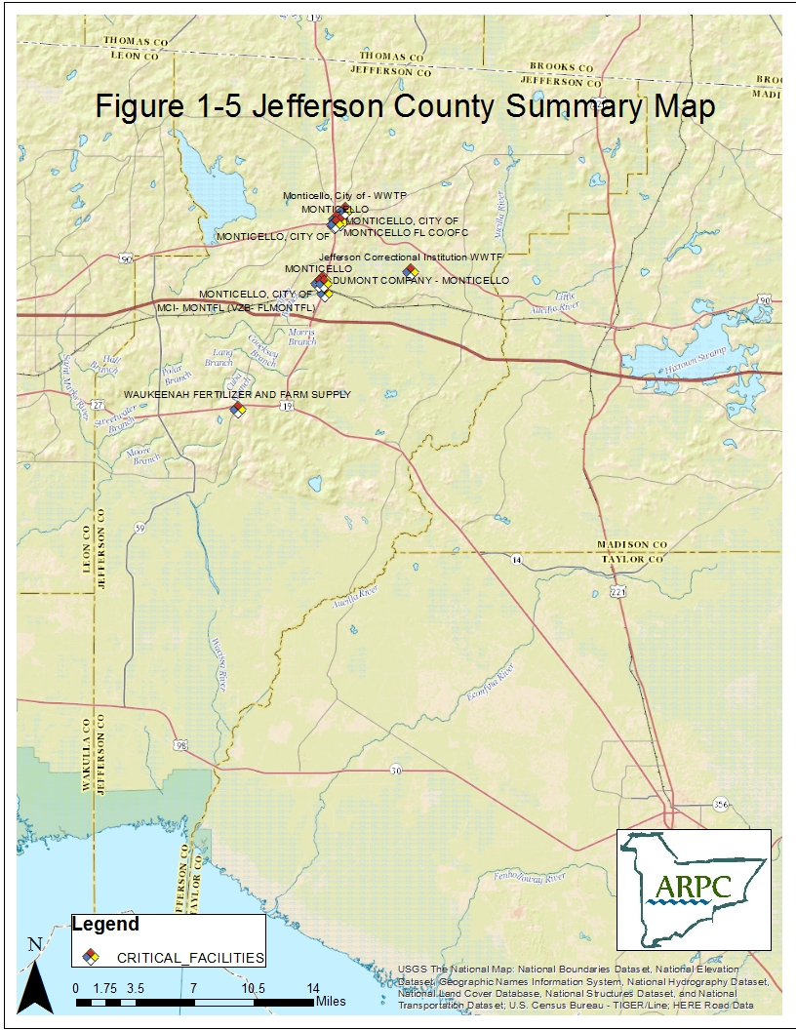
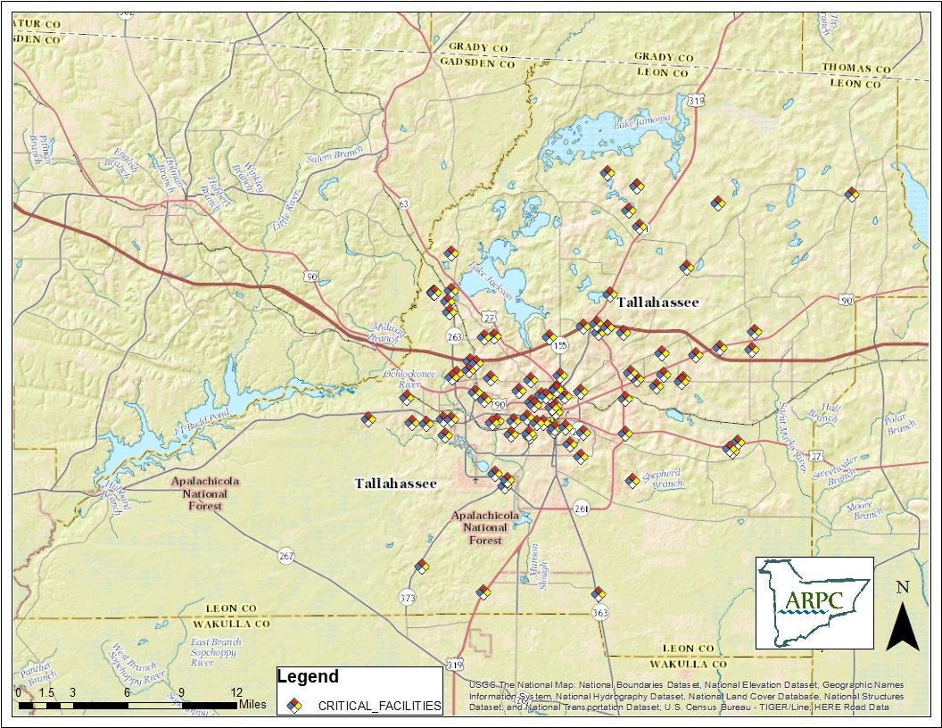
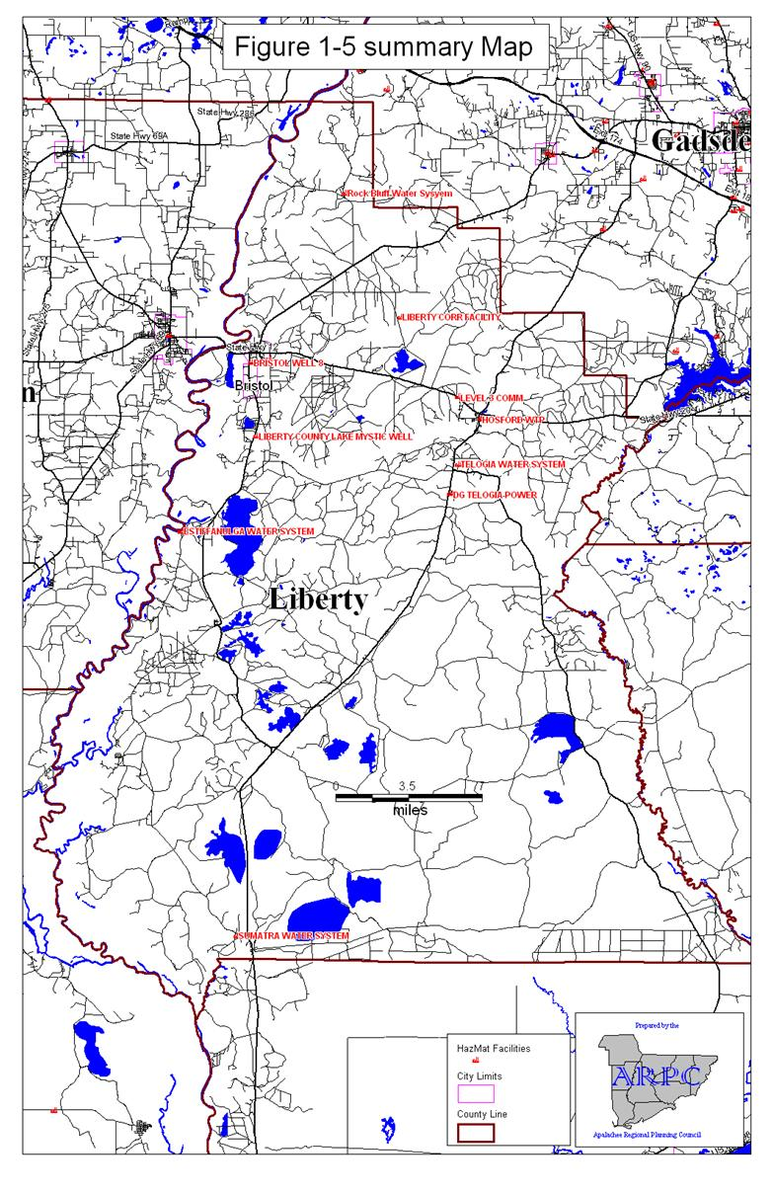
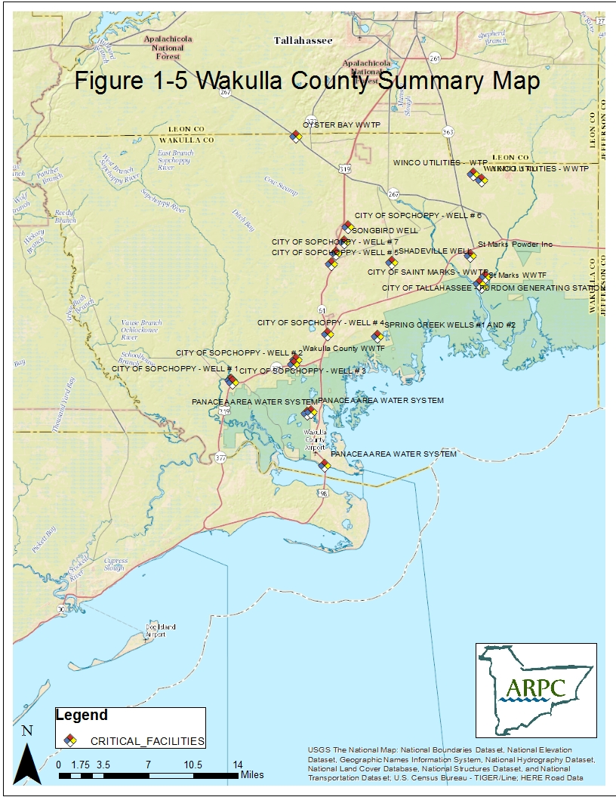
2.0 EMERGENCY RESPONSE ORGANIZATIONS AND RESPONSIBILITIES

2.1 General

This section identifies the county, state, federal, and private organizations that would participate in responding to an emergency involving hazardous materials and describes the responsibilities of each group. The individual officials who are responsible for coordinating the activities of the agencies listed below are responsible for assuring continuity of resources to support emergency operations over a protracted period of time.

2.2 Local Government Organizations and Responsibilities

2.2.1 - Chairperson of the Local Boards of County Commissioners

The Chairperson from each Board of County Commissioners (BCC) has the administrative responsibility for overall hazardous materials emergency response planning in each County within the District. The Chairperson, through the local Emergency Management department, typically will initiate actions and provide direction and control at the local level, to include consideration of sheltering-in-place or evacuation as an option for the protection of the public, and conduct emergency operations to respond to the effects of an emergency involving hazardous materials.

The Chairperson is responsible for the overall continuity of resources to ensure 24-hour operations for an extended period. If conditions warrant, the BCC will declare a local state of emergency.

2.2.2 County Administrator

Franklin, Gadsden, Gulf, Jackson, Jefferson, Leon, and Wakulla Counties have a County Administrator. The County Administrator may conduct news conferences and issue disaster preparedness news bulletins or other disaster public information statements as authorized by the BCC.

In Jackson and Gadsden Counties, the Administrator will be responsible for decisions concerning the health and safety of the citizens in the case a member of the BCC cannot be contacted in the available time.

2.2.3 Emergency Management Director

The Emergency Management Director in each county acts as the Community Emergency Coordinator (CEC) for the county. The Director will coordinate overall emergency operations and support needs with the Florida Division of Emergency Management, with other state and federal support agencies and with the facility owner/operators.

The local Emergency Management Directors are responsible for the coordination, development and maintenance of procedures to implement local hazardous materials emergency response plans consistent with existing conditions. The Directors also are responsible for maintaining the plans through periodic revisions.

The Emergency Management Directors, or the Director's designees, will be responsible for providing communications and other logistical support to the public safety agencies involved in emergency operations in response to a hazardous materials release. The Emergency Management Directors are responsible for early warning and notification of the population within the area affected by the release of hazardous materials, as well as notification of the county EOC staff, activation the EOC, and notification of all local governmental and non-governmental agencies supporting emergency operations as appropriate to the severity of the incident.

In cases when a coordinated federal response team (chaired by the EPA representative) is required, the Emergency Management Director will be the local representative.

2.2.4 Sheriffs and Municipal Law Enforcement

The emergency response responsibilities shared by the Sheriff's Offices and the municipal law enforcement departments include the:

- determination and confirmation of the occurrence of a hazardous materials release;

- notification of the appropriate fire department regarding a hazardous materials release and request that appropriate response be initiated;

- isolation and establishment of command over the area where evacuation, public safety, traffic control and protection of property are of concern;

- traffic control along evacuation routes and crowd control at reception centers and shelters;

- security for evacuated areas until residents are allowed to return to their homes; and

- provision of additional resources and support as necessary.

2.2.5 County, Municipal and Volunteer Fire Departments

Responsibilities of the fire departments include the:

- response to, investigation of, and assumption of direct control of the management of hazardous material incident scenes occurring within the affected jurisdiction;

- determination of the type and nature of the hazardous material involved;

- determination of the necessity for an evacuation and issuance of evacuation orders when appropriate, and identification of the vulnerable zone to be evacuated;

- notification of the emergency communication center which will then make proper notification to DEM and federal agencies, as required by law;

- initiation of the request for assistance from appropriate agencies necessary to neutralize and/or contain the hazardous materials involved;

- recommendation to office in charge to initiate a request for assistance from the appropriate agencies to neutralize and/or contain the hazardous materials release;

- cooperation with assisting agencies involved in determining actions to be taken to contain the hazardous material and restore the area to normalcy; and

- provision of vehicle wash-down and monitoring, when necessary, at prescribed locations and in a manner consistent with DEP and/or DOH specifications;

- Tallahassee Fire Department (TFD) is the primary and secondary District Response Team (DRT) for LEPC Apalachee region. Responsibilities include hazardous materials mitigation, training, and DRT procedures and policies.

- Bay County Fire Rescue is the primary DRT for 2 of the 9 Apalachee LEPC counties, Gulf and Calhoun. Responsibilities include hazardous materials mitigation, training, and DRT procedures and policies.

2.2.6 County Health Departments

The County Health Departments under the Department of Health are responsible for:

- monitoring potential public health problems;

- supervising local public health operations and coordinating all governmental and non-governmental relief agency resources involved in the prevention or control of emergency public health problems;

- coordinating all health and medical services; and

- informing the DEM, through the County's Emergency Management office, of existing adverse public health conditions.

2.2.7 Local Public Works or Road and Bridge Departments

To the extent possible, the local Public Works or Roads Department will:

- assist local fire departments in assembling and disassembling wash-down stations and disposing of waste materials;

- assist the American Red Cross by providing garbage pickup and disposal for reception centers and shelters;

- assist law enforcement agencies with evacuation operations by providing traffic control equipment and personnel; and

- assist in the containment and cleanup of spills by providing equipment and personnel, as necessary.

2.2.8 School Board

In general, the local School Boards will assist temporary shelter operations which utilize school facilities, and provide equipment for the preparation of food for evacuees in cooperation with the American Red Cross. The School Board also will assist in providing buses for evacuees needing transportation, if requested by the Emergency Management Director.

In Calhoun County, the Schools Superintendent is designated as the County's Director of Public Affairs with the responsibility for developing and implementing an educational program design to inform the public of the risks associated with hazardous materials and the appropriate actions to take in the event of an emergency involving the release of such materials. The Director of Public Affairs is authorized to issue any
public information statements during a disaster period necessary to implement any contingency plan previously approved by the County Board of Commissioners.

2.2.9 Community Transportation Coordinators.

The Community Transportation Coordinators (CTCs) may provide emergency transportation to the County's transportation disadvantaged residents, if requested by the local Emergency Management office. The CTCs will also assist in the evacuation of hospitals, nursing homes, schools, as well as the general public, if necessary and upon request of the local Emergency Management Director.

2.2.10 Hospitals

The local hospitals will provide emergency medical attention to persons affected by a hazardous material release and ensure transfer of those seriously ill to medical facilities capable of specialized treatment.

If evacuation is necessary, the local hospitals may also accommodate critical nursing home patients requiring hospitalization and accident victims injured during the evacuation operations.

2.2.11 Local Emergency Medical Services

The local Emergency Medical Services (EMS) provider will deliver emergency medical aid and will assist in the provision of emergency medical transportation to persons in need of such services. The EMS may also assist in the evacuation and transfer from affected areas of patients from nursing homes and hospitals, and persons with special needs.

2.2.12 Other County and Municipal Agencies

Other county and municipal agencies may be required to provide equipment, personnel and services to support emergency operations.

2.3 State Government Organizations and Responsibilities

2.3.1 Governor

Under the provisions of Chapter 252, F.S., the Governor is ultimately responsible for protecting the population of the State from the dangers created by emergencies which are beyond the capabilities of local governments or which are multijurisdictional in nature. The Governor is charged with the responsibility of providing such protection through the assignment of appropriate state resources and agencies. Implementation of these responsibilities will include:

- providing direction and control should the emergency be beyond the capabilities of the local governments affected;

- issuing necessary Executive Orders, proclamations, and regulations; and

- ensuring that timely emergency response operations can be initiated.

The Governor also will request federal assistance as necessary upon determining that the State has insufficient technical and/or logistical resources to adequately cope with the off-site consequences of an emergency involving hazardous materials.

2.3.2 Attorney General

The Attorney General will provide consultation to the Governor on legal matters pertaining to emergencies involving the release of hazardous materials.

2.3.3 Florida Division of Emergency Management (FDEM)

The Florida Division of Emergency Management (FDEM) is responsible for coordinating the State's response to emergencies involving hazardous materials. The FDEM will also request and coordinate materials and assistance, as necessary, from federal emergency response agencies. The FDEM will:

- notify appropriate local, state and federal agencies of an emergency involving hazardous materials;

- coordinate local, state and federal emergency response activities;

- ascertain the requirements of state and local political subdivisions for supplies and equipment, and locate and provide needed supplies and equipment;

- provide for activation of the State Emergency Operations Center, and provide personnel and equipment to operate emergency response facilities;

- carry out the provisions of the State Emergency Management Act, Chapter 252, Florida Statutes;

- prepare the State of Florida Comprehensive Emergency Management Plan through the Bureau of Preparedness;

- provide guidance and assistance in the preparation of local hazardous materials emergency response procedures; and

- assist the local governments in providing public education and information regarding proper response to a hazardous materials emergency.

2.3.4 Florida Department of Environmental Protection (FDEP)

The FDEP is responsible for coordinating the State's response to emergencies involving hazardous materials in the context of protecting environmental quality. To accomplish these responsibilities the FDEP will:

- act as the technical advisory agent in identifying, containing and removing hazardous materials threatening or affecting water or air quality, as authorized by Florida Statutes;

- locate sites and establish acceptable procedures for the disposal of hazardous materials;

- act as the primary operational agency in the containment and cleanup of inland hazardous materials spills (For hazardous materials other than petroleum products, the DEP will respond if the incident involves more than five gallons of the substance. If the incident involves petroleum products, the threshold for DEP response is 100 gallons.);

- act as the sole authority on the use of chemical dispersants in combating a hazardous materials incident. [The agency considers that containment and cleanup (neutralization) should be considered and are preferable alternatives to the use of dispersants.]; and

- provide assistance in dealing with a hazardous materials incident. (The assistance provided may include on-site response or remote technical assistance, as warranted by conversations with responders.)

Also, when pollutants, as defined in Section 376.031(7), Florida Statutes, are determined to be discharged into navigable waters within the geographic responsibility of the United States Coast Guard, the state response shall be as provided in the Florida Coastal Pollutant Spill Plan, as approved by the Governor and Cabinet, pursuant to Sections 376.05 and 376.07, Florida Statutes. (Section 376.031(7), F.S. defines pollutant as "oil of any kind and in any form, gasoline, pesticides, ammonia, chlorine, and derivatives thereof, excluding liquefied petroleum gas.") As part of the response efforts the DEP will:

- provide traffic supervision and control for water transportation routes adversely affected by a hazardous materials incident; and

- provide manpower and logistical support to any state park, or recreational area directly affected by a hazardous materials incident.

2.3.5 Florida Department of Transportation (FDOT)

As part of the response to an emergency related to a hazardous materials release, the FDOT will:

- coordinate activities between public and private agencies on matters relating to public transport;

- provide public transportation services where emergency services are required;

- support county highway/road departments in securing and installing barricades, signs, and other necessary equipment needed for traffic control;

- coordinate traffic management activities in and around the affected areas;

- coordinate movement of emergency resources to and from the designated area;

- assist in the containment and cleanup of hazardous materials spills that occur on a state- maintained street or highway. (Site check and cleanup of a hazardous materials incident will be provided only after those responsible for the initial incident have removed the majority of the waste.);

- repair highways and right-of-ways as necessary to ensure public safety;

- provide inspection of the condition of railroad tracks and all supportive, relative equipment, including locomotives and other rolling stock of any railroad operated within the state, and provide personnel to determine the cause of a railroad accident; and

- provide law enforcement and investigative response (limited to awareness level) for transportation related hazardous materials incidents subject to federal transportation regulations.

2.3.6 Florida Department of Law Enforcement (FDLE)

As part of the response to an emergency related to a hazardous materials release, the FDLE will:

- coordinate, integrate, and implement law enforcement planning and activities for the use of mutual aid and state resources;

- maintain lists of special law enforcement equipment, specially trained personnel, and all regular, auxiliary, and reserve law enforcement personnel and equipment within the State;

- coordinate the organization and direction of the law enforcement services of the Florida Mutual Aid Plan;

- maintain liaison with state law enforcement agencies in order to coordinate and integrate plans for traffic control and the participation of the agencies in law enforcement emergency operations;

- maintain liaison with the Governor, state departments/agencies, and local law enforcement officials in order to achieve close coordination and cooperation in planning and operations in trouble areas; and
- facilitate the flow of law enforcement information from state organizations to local law enforcement officials.

2.3.7 Department of Highway Safety and Motor Vehicles (DHSMV)

As part of the response to an emergency related to a hazardous materials release, the DHSMV will:

- enforce rules and regulations for the intrastate transportation of hazardous materials; and

- assist other law enforcement agencies in the movement of traffic during an emergency involving hazardous materials;

- assist other law enforcement agencies to police the affected area;

- provide security and assist in staffing roadblocks to support county personnel who are involved in emergency response operations;

- provide communications assistance as required.; and

- provide upon request, Florida Highway Patrol assistance for the transportation of soil, air and water samples for analysis when immediate analysis is necessary.

2.3.8 Florida Fish and Wildlife Conservation Commission (FWC)

As part of the response to an emergency related to a hazardous materials release, the FWC will:

  - assess damage to fish and wildlife populations and habitat resulting from a hazardous materials incident;

  - coordinate with other appropriate federal and state authorities any action deemed necessary, or required, for the protection of endangered, or threatened species;

  - provide support for law enforcement and search and rescue operations;

  - assist other agencies with manpower and logistical support for obtaining samples, controlling traffic and pursuing criminal investigations; and

  - maintain a toll free number for notification of incidents which may threaten fish and/or wildlife habitats (1-800-342-1676).

2.3.9 Florida Department of Military Affairs (FDMA)

As part of the response to an emergency related to a hazardous materials release, the FDMA will:

- under the direction of the Governor, activate the Florida National Guard to aid the civil authorities should they be unable to contain the emergency; and

- support state agencies and local governments on a mission-type basis during emergency operations.

2.3.10 Florida Department of Health (FDOH)

As part of the response to an emergency related to a hazardous materials release, the FDOH will:

  - coordinate the sheltering of persons affected by a hazardous materials incident;

  - assist in the identification of possible health hazards related to hazardous materials incidents and take corrective action as needed;

  - assist in solving problems affecting drinking water or food supplies contaminated by hazardous materials; and

  - provide response to all emergencies associated with radioactive materials or ionizing radiation.

2.3.11 Florida Department of Agriculture and Consumer Services (FDACS)

As part of the response to an emergency related to a hazardous materials release, the FDACS will:

  - assist in the identification, containment and disposal of pesticides and insecticides;

- enforce rules and regulations covering the design, construction, location and operation of equipment for liquefied petroleum gas storage, handling and intrastate transporting by tank truck, tank trailer or pipeline;

- assist in the identification of possible health hazards, related to a hazardous materials incident, which may affect the production or consumption of a food commodity; and

- provide support for law enforcement activities.

2.3.12 Florida Department of Financial Services (FDFS)

As part of the response to an emergency related to a hazardous materials release, the FDFS will:

  - enforce regulations covering the manufacture of hazardous materials;

  - provide personnel to determine the cause of an incident in conformance with DOI regulations.

2.3.13 Emergency Support Function (ESF) 10: Environmental Protection

The State Comprehensive Emergency Management Plan designates ESF 10 as the primary mechanism to coordinate response and support by State agencies to incidents that are beyond the capabilities of local governments. The FDEP is the lead agency for this ESF with support from the Division of Emergency Management, the Department of Transportation, the Department of Highway Safety and Motor Vehicles, the Department of Health, the Department of Agriculture and Consumer Services, the Department of Financial Services/Florida Fire Chiefs Association, and the Fish and Wildlife Conservation Commission.

2.4 Federal Government Organizations and Responsibilities

2.4.1. Federal Emergency Management Agency (FEMA)

The Director of FEMA is in charge of coordinating all federal assistance provided under Public Law 91-606. All requests for federal assistance must be forwarded through the State's DEM.

2.4.2. United States Coast Guard

The United States Coast Guard (USCG will:

  - provide for the cleanup and decontamination of any hazardous substance on the state's coastline and on navigable waterways within the State; and

  - operate the National Response Center (NRC) on a 24-hour a day basis. The telephone number for the NRC is 1-800-424-8802.

2.4.3 U.S. Environmental Protection Agency (EPA)

The role of the US EPA is to provide for the cleanup and decontamination of any hazardous substance that has the potential to affect public health, safety and the environment. The US EPA will also provide technical assistance and decision making information to state and local agencies during planning efforts and response actions.

2.4.4 U.S. Department of Transportation (US DOT)

The US DOT regulates interstate issues related to the transportation of hazardous materials.

2.4.5 Regional Response Team (RRT)

The RRT provides a coordinated federal response capability through key agencies (e.g. EPA, USCG, US DOT) at the scene of a hazardous materials incident that poses a threat to the public health and welfare by affecting the navigable waters of the United States, adjoining shorelines or into or upon waters of its contiguous zones, and all inland waters.

2.4.6 National Weather Service (NWS)

The National Weather Service is a component of the National Oceanic and Atmospheric Administration (NOAA). NOAA is an Operating Unit of the U.S. Department of Commerce. The NWS uses the Hybrid Single Particle Lagrangian Integrated Trajectory (HYSPLIT) model to model chemical plumes from large-scale hazardous materials releases with chemicals that are lighter than air. The plume can be modeled in approximately in 10-20 minutes after providing basic release information.

2.5 Facility Owners/Operators

As part of the response to an emergency related to a hazardous materials release, facility owner/operators are responsible for:

  - designating a representative/coordinator to participate in the emergency planning process as a facility emergency coordinator and assisting local emergency management directors and LEPCs in the preparation and maintenance of emergency response plans for hazardous materials at their facility(ies);

  - notifying the SERC if subject to the requirements of EPCRA;

  - submitting Material Safety Data Sheets (MSDSs) and emergency inventory forms to the SERC, corresponding LEPCs and local fire departments.

  - submitting toxic chemical release forms to the SERC and the EPA for each toxic chemical defined in EPCRA Section 313 that was manufactured, processed or otherwise used in quantities exceeding the established threshold planning quantity during the preceding calendar year;

  - providing immediate notification to the local fire departments, SERC and LEPC of the release of a listed hazardous substance in excess of the reportable quantity for that substance; and

  - providing written follow-up emergency notice to the SERC and LEPCs after the release.

2.6 Volunteer Organizations

The following discussion relates to several specific volunteer organizations which are likely to become involved in the response actions to an emergency involving hazardous materials. Other groups may provide support in an emergency situation. Their activities will be coordinated through the local Emergency Management office.

2.6.1 American Red Cross

The American Red Cross helps to provide reception and care for evacuees. This service will include registration of evacuees, provision of shelter managers, and special assistance to evacuees. Additional shelter space may have to be established by the American Red Cross should the relocation period last longer than anticipated. In this event, mobilization and relocation of evacuees will be coordinated by the American Red Cross through the local EOC.

2.6.2 Emergency Alert System (EAS)

The local EAS system provides early warning to the public and to area broadcasting stations via EAS tone alert systems as well as direct voice access.

2.6.3 Florida Wing, Civil Air Patrol

The Florida Wing, Civil Air Patrol (CAP) provides assistance to the state and its political subdivisions in responding to emergencies. The CAP has the capability to provide the following assistance:

  - aerial control, direction and surveillance of surface traffic;

  - light transport flights for emergency movement of personnel and supplies;

  - aerial photographic and reconnaissance flights;

  - search and rescue (including aircraft ramp checks for missing craft and aerial and ground search activities);

  - radio communications; and

  - other activities as approved by the Wing Commander, CAP, and Director, DEM.

2.6.4 Amateur Radio Emergency Services (ARES)

The Amateur Radio Emergency Services (Eastern Panhandle District) may be used for providing communications between all primary shelters and between the shelters and the EOC.

2.6.5 Other Local Volunteer Organizations

There are local volunteer organizations that have specific duties pursuant to the local response plans. These include:

- Salvation Army

In Gadsden and Gulf Counties, the Salvation Army may provide the following assistance following a hazardous materials release emergency:

  - Mobile canteen service and emergency feeding to government workers, volunteers and disaster victims, in coordination with the Red Cross; and

  - Distribution of food, clothing and other supplies, following a local disaster or during recovery operations; and

The Salvation Army should establish a liaison with the EOC to ensure full coordination of relief efforts.

- The Florida Baptist Convention Disaster Relief Service.

In Gulf County, the following services may be provided as needed or requested, within the limits of the group's resources:

      - Disaster relief preparedness for churches and associations;

      - Assistance plans in coordination with the Home Mission Board of the Southern Baptist Convention and Gulf County Emergency Management Office;

      - An emergency first aid station through the use of its mobile medical/dental unit;

      - Assistance to churches and associations in their recovery and rebuilding procedures;

      - Emergency centers when necessary to provide food and shelter for persons in need.

3.0 DIRECTION AND CONTROL

3.1 General

This section describes the general coordination and management of emergency response operations between local, state and federal agencies. Other sections of the plan deal more specifically with individual response functions.

3.2 The Role of the LEPC

The primary function of the Apalachee LEPC is to perform the activities in accordance with EPCRA. The LEPC oversees the development of the Regional Hazardous Materials Emergency Plan, which consolidates the information included in the local hazards analyses for Section 302 facilities. The LEPC acts as a clearinghouse for the facility information collected pursuant to the state and federal legislation, promotes public education regarding the law, serves as a forum for information exchange on hazardous materials management and response, and provides for interaction between the different occupations involved in the management and response to hazardous materials incidents. LEPC staff also provides support for local hazardous materials activities.

The Apalachee LEPC serves the nine counties of the Apalachee region and meets quarterly to discuss and deal with hazardous materials issues that affect the District. The committee is composed of representatives from the following occupational categories:

- Elected State/Local Officials
- Emergency Management
- Firefighting
- Emergency Medical Services
- Health
- Law Enforcement
- Local Environmental Groups
- Hospitals
- Transportation Personnel
- Broadcast/Print Media
- Community Groups
- Facility Owners/Operators
- Non-Elected Local Officials
- Interested Citizens
- Water Management Districts
- Local Option(s)

3.3 Local Government Role

Typically, local governments have the primary role in preventing and controlling unnecessary hazards to the general public from an emergency involving the release of hazardous materials. When an accidental release of hazardous materials occurs, the effects of which are strictly confined to the premises of a private facility, governmental response agency assistance should be on a cooperative basis with the facility. Care must be exercised that a local government is not unnecessarily subjected to liability for damages because actions were forced by a local government representative upon a facility operator in an improper manner. However, when there is an off-site threat to the general public or the environment, a public safety agency must legitimately assert its authority and take charge of the scene.

The initial response to hazardous materials accidents will be the responsibility of the law enforcement, fire and emergency medical services agencies within the jurisdiction in which the accident occurred. In the unincorporated areas of the District, initial response will be the responsibility of the Sheriff's office and/or the appropriate Fire Department.

The Chairperson of the local BCC will coordinate and direct emergency response through emergency management organizations and other county emergency response agencies. This direction and control function is primarily performed by preplanning and providing operational guidance to the primary emergency response agencies prior to the occurrence of an actual emergency. The local Emergency Management Director will coordinate overall emergency response activities and operations until such time as increased state assistance is deemed necessary. Direction and control will be exercised through a designated field command center or the County Emergency Operations Center (EOC).

3.3.1 On-Scene Command

The senior law enforcement or fire official at the site will become the Incident Commander until transfer of command has occurred. Life Safety (first), Incident Stabilization (second) and Property Preservation (third) will guide and prioritize the Incident Commanders actions. The Incident Commander will be responsible for:

    - directing the overall management of the incident and the response activities;

    - keeping county officials apprised of on-scene activities;

    - implementing the necessary actions to protect public health and safety; and

    - coordinating the clean-up and recovery operations.

It is the responsibility of the Incident Commander to designate a command post in the event of a hazardous materials incident. The post must be located at a safe distance from the incident. The location will be selected on the basis of the specific circumstances (e.g., nature of chemical, location, weather, etc.) of the incident. The On-Scene Command post will serve as the operation center for the response activities in small scale incidents. The evaluation of the incident and the alternative actions will be analyzed at the command post.

3.3.2 Emergency Operations Center (EOC)

In the event that the nature or extent of an emergency involving hazardous materials requires resource coordination beyond the capabilities available at the On-Scene Command Post, the local County Emergency Operations Center (EOC) may be activated (Figure 7-1 lists EOCs in the District). Appropriate response and support personnel will be called to the EOC to coordinate the actions of their respective agencies and organizations. Upon activation, direction and control of county emergency operations would be exercised by the Chairperson of the BCC or his/her designee. Once fully activated, the EOC will continue to function on a continuous basis until the emergency is over and its effects can be more effectively controlled through normal governmental channels. The EOC will only support the On-Scene Command and assist with coordination of resources.

3.4 State Government Role

The designated role of state government in response to a hazardous materials emergency is to support local government operations primarily through the provision of additional or specialized resources unless the scope of the emergency warrants increased state action. The state government response is coordinated by the DEM from the State EOC.

Upon notification by a County that a release of hazardous materials has occurred, staff from the FDEP may be dispatched to the scene to provide guidance to local emergency operations personnel and to mitigate environmental damage, to the extent possible. In the event of a major hazardous materials accident, the local government can request additional resources from FDEM. As previously noted, ESF 10 has been designated as the primary mechanism to coordinate response and support by State agencies to a hazardous materials spill that exceeds the capabilities of local governments.

When multijurisdictional hazards are involved or when the affected county government believes that the emergency is beyond the capabilities of local resources or when the Governor determines there is an overriding concern for the safety of the public, increased state actions may be warranted. For these situations, the Governor may designate the primary responsibility for emergency response to the state by issuing an Executive Order under the provisions of Section 252.36, F.S. An example of an Executive Order is shown in Figure 3-1. The implementation of the Executive Order will be coordinated with affected local governments. The local governments will continue to coordinate the emergency response operations of the local agencies.

3.5 Federal Government Role

The role of the federal government in response to an emergency involving the release of hazardous materials is to support local and state emergency operations. Activation of the Federal Regional Response Team (RRT) provides access to federal resources which typically are not available at the state and local levels. A federal on-scene Coordinator will be designated to coordinate federal resources and support.

Figure 3-1

EXAMPLE EXECUTIVE ORDER
STATE OF FLORIDA
OFFICE OF THE GOVERNOR
EXECUTIVE ORDER NUMBER _____

WHEREAS, on ___________________, 20___, a hazardous materials emergency condition was declared at ___________________, operated by ___________________ in ____________________ County, causing a potentially hazardous chemicals release into the atmosphere; and

WHEREAS, certain additional specialized equipment, personnel and resources are required; and

WHEREAS, ________________ has exerted every effort to correct the emergency condition; and

WHEREAS, local governments in the affected counties and municipalities have exerted every effort to assist the affected citizens; and

WHEREAS, the _______________ County Commission has declared a local state of emergency and has requested assistance from the state.

NOW, THEREFORE, I, _______________________, as Governor of the State of Florida, by virtue of the authority vested in me by Article IV, Section 1(A), Florida Constitution (1968), Section 252.31, et seq., Florida Statutes (1974), Section 250.06, Florida Statutes (1973), and all applicable law, do hereby declare the existence of a disaster emergency and promulgate the following Executive Order effective immediately:

1. That a state of emergency exists within ________________ County due to the potentially hazardous effects of a chemical release from ______________________.

2. That the Florida Comprehensive Emergency Management Plan is hereby activated and the Department of Community Affairs shall be responsible for emergency management and is hereby empowered to take all action under the plan necessary to protect the health, welfare, and safety of the people and property in the vicinity of the chemical release.

3. That the Chairperson of the Board of County Commissioners of _________________ County or the Chairperson’s designee shall act as coordinator of the local emergency management effort within ________________ County.

4. That the Division of Emergency Management is hereby authorized to order the evacuation of those portions of ________________ County whose people and property are in imminent or existing danger as a result of the emergency at ___________________ and the chemical release. Should such action become necessary, the evacuation orders shall have the force and effect of state law.

5. That the Florida Division of Emergency Management is hereby authorized to direct the use of any State and county facility, including public schools, to ensure the proper reception, sheltering, and care of evacuees.

6. That State agencies and the Florida National Guard, as coordinated by the Florida Division of Emergency Management, shall provide mission support by furnishing resources and support personnel to alleviate threat to life and property resulting from the state of emergency at ________________________ .

7. That all affected toll facilities are hereby ordered to suspend the collection of toll charges until such time as the Governor or his Authorized Representative designates this as no longer necessary.

8. That ___________________ is hereby appointed the Governor’s Authorized Representative for _______________ County and the area(s) within the vulnerable zone surrounding ________________________ .

9. In the event of _____________________ absence, ____________________ shall act the Governor’s Authorized Representative.

10. This Executive Order shall remain in effect for a period of thirty days unless otherwise rescinded.

IN TESTIMONY WHEREOF, I have hereunto
set my hand and caused the Great Seal of the State
(SEAL) of Florida to be affixed at Tallahassee, the Capitol,
this ______ day of _______________, 20____ .
(Day) (Month)

______________________________________
Governor

ATTEST:

______________________________________
Secretary of State

4.0 NOTIFICATION AND ACTIVATION

4.1 General

This section outlines the procedures and responsibilities for notifying appropriate emergency response organizations; for alerting key local, state and federal emergency response personnel; and for providing warning and instructions to the general public.

4.2 Warning Points

Each County in Apalachee has designated a county warning point in the event of a hazardous materials emergency (see Figure 4-1). The county warning point is staffed on a 24-hour a day basis for receipt of notification by a facility experiencing a hazardous materials release and for alerting key local and state emergency response personnel.

The FDEM State Watch Office is the designated State Warning Point in the event of a hazardous materials emergency. As such, the State Watch Office is responsible for receiving notification of an emergency from the county warning point and for alerting key state and federal emergency response personnel. The FDEM also is responsible for assisting the LEPC in providing warnings and instructions to the general public. An officer is on duty at the State Watch Office in Tallahassee on a 24-hour a day basis.

Upon notification from the county warning point that a release involving hazardous materials has occurred, the State Watch Office will make the appropriate notification to the National Response Center (NRC). The NRC is the national warning and communications center for emergencies involving the release of hazardous materials. Located at the U.S. Coast Guard headquarters in Washington, D.C., the NRC receives and relays notices of discharges and releases to the appropriate on-scene commander, and provides facilities for the National Response Team (NRT) to use in coordinating a national response action when required.

Figure 4-1: Warning Points in Apalachee
County | Warning Point | Phone
Calhoun | Sheriff's Department | 674-5049 or 911
Franklin | Sheriff's Department | 670-8500 or 911
Gadsden | Sheriff's Department | 875-8642 or 911
Gulf | Sheriff's Department | 227-1115 or 911
Jackson | 911 Communications Center | 482-9624 or 911
Jefferson | Sheriff's Department | 997-2023 or  911 (Basic)
Leon | Sheriff's Department/  Tallahassee Police Department (alternate site) | 922-3300 or 911  911 or 891-4200
Liberty | Sheriff's Department | 643-2235 or  911 (Basic)
Wakulla | Sheriff's Department | 926-7171/0800 or 911
State Warning Point | State Watch Office - Tallahassee | 850-413-9911 or  800-320-0519
National Response Center | U.S. Coast Guard – D.C. | 800-424-8802

4.3 Notification and Activation

Facility owners or operators are required to immediately notify local, state (and in some cases federal) authorities following a reportable release of a listed extremely hazardous substance (EHS) in an amount that exceeds the reportable quantity for that particular substance. The Hazardous Materials Emergency Planning and Community Right-to-Know - How to Comply Handbook is a useful guide for understanding reportable releases and is available free at the Apalachee Regional Planning Council or the FDEM.

It is the responsibility of the owner/operator of the facility from which hazardous materials have been released to notify the County Warning Point that a release has occurred. The types of information to be included in the facility’s initial and follow-up messages are identified in Figure 4-2. In the event that the State Warning Point receives notification of a release from a source other than the county designated warning points, the State Warning Point will immediately notify the appropriate warning point.

Section 304 of EPCRA requires certain releases of chemicals to be reported by the facility owner or operator. There are two types of chemicals that require reporting under this section:
1) | Extremely Hazardous Substances (EHSs); and
2) | Comprehensive Environmental Response, Compensation and Liability Act (CERCLA) hazardous substances.
Both the EHSs and the CERCLA hazardous substances are found in the "Title III Consolidated List of Chemicals."

If an amount equal to, or greater than, the reportable quantity (RQ) is released or spilled from a fixed facility, notification must be made immediately (within 15 minutes) to the SERC and LEPC by calling the Florida State Warning Point (SWP) at (850) 413-9911 or (800) 320-0519 (this telephone is answered 24 hours a day and is an EMERGENCY number only). An RQ is the amount which requires notification if released into the environment (air, water or land). In addition, CERCLA spills must also be reported to the National Response Center at (800) 424-8802. In the event that the incident is transportation related, Section 304 requirements can be met by calling 911 or, in the absence of a 911 system, contacting the local telephone operator. This emergency notification must include:

- the chemical name;
- an indication of whether the substance is an EHS;
- an estimate of the quantity released into the environment;
- the time and duration of the release;
- the medium into which the release occurred;
- any known or anticipated acute or chronic health risks associated with the emergency and, where appropriate, advice regarding medical attention necessary for exposed individuals;
- proper precautions, such as evacuation; and
- the name and telephone number of a contact person.

EHS/CERCLA releases of greater than or equal to the RQ that occur under normal operations and are stable in quantity and rate are to be reported under "Continuous Release" reporting guidelines only if the release does not qualify as a "Federally Permitted Release."

The Section 304 Reporting Form was developed by the SERC to familiarize a facility with the information that will be needed when reporting a release over the telephone. Use of the form is not mandatory, and the form should not be mailed in. It is recommended that the form be reviewed and then filed for use if a release occurs.

As soon as practicable (within seven days) after a release which requires notification, the owner or operator of the facility must provide one or more written follow-up emergency notice(s). The Section 304 Reporting Form must not be used for the written follow-up notice. The written follow-up emergency notice(s) must include:

- information setting forth and updating the information required for the initial emergency notification;
- actions taken to respond to and contain the release;
any known or anticipated acute or chronic health risks associated with the release; and,
- advice regarding medical attention necessary for exposed individuals.

This follow-up notice must be sent to:

- the SERC; and

- the appropriate Community Emergency Coordinator for the LEPC, at the LEPC mailing address. The map which shows the boundaries of the LEPCs and their addresses is located on page IV-14.

The SERC's address is:
State Emergency Response Commission
2555 Shumard Oak Boulevard
Tallahassee, Florida 32399-2100
Fax: (850) 488-1739

EXEMPTION: Section 304 does not apply to any release of an EHS which results in exposure to persons solely within the site on which the facility is located. However, caution dictates that notification be made anyway, unless you are certain that the release will not result in exposure to persons outside the site.

NOTE: Releases of CERCLA hazardous substances are also subject to the release reporting requirements over their respective RQs of CERCLA Section 103 (40 CFR, Part 302).

EPA regulations implementing Section 304 are set out in 40 CFR Part 355

Figure 4-2

This form provides guidance for initial notification.
It does not fulfill the requirements for a follow-up report.

SECTION 304 REPORTING FORM

1. General Information

A. Time/Date___________/__________
B. Reported by (Name/Company)________________________________
__________________________________________________________
C. Contact Person (If different from 1-B above)_____________________
__________________________________________________________

D. Location__________________________________________________
__________________________________________________________
E. Telephone Number__________________________________________

2. Release Information

A. Substance(s) Involved_____________________________________
__________________________________________________________
B. Release Medium: Air________
Water________ (surface/ground)
Land________

C. Event Terminated: Yes/No
Release Began_______; Ended_______ Duration_______
D. Quantity Released______________________
E. EHS Release: Yes/No; CERCLA Release: Yes/No

3. Is this a Reportable Incident/Emergency under Section 304?

4. Incident Description __________________________________________
_______________________________________________________________
_______________________________________________________________

5. Action Taken to Respond or Contain ____________________________
_______________________________________________________________

6. Potential Health Risk (If known or anticipated)

A. Off-Site _________________________________________________
__________________________________________________________
B. Injuries: Release Related/Number_________________________
Non-Release Related/Number_____________________

7. Recommended Protective Actions (Where Appropriate Advise

Regarding Attention Necessary for Exposed Individuals)_________
_______________________________________________________________
_______________________________________________________________
_______________________________________________________________

8. Agencies Notified By Industry

A. County E.M. ________ D. State DEP________
B. Local Fire Dept. ________ E Other ________
C. Local Environ. Health ________

9. Emergency Assistance Requested: Yes/No; If Yes:

A. Local Fire Department ________
B. County Emergency Management ________
C. Local Environmental Health Services ________
D. Local Law Enforcement ________
E. Local County Health Department ________
F. State DEP ________
G. Other ________

10. Should More Than 15 Minutes Difference Exist Between Release
Beginning Time (____) and Reporting Time (____) - Explain
Reason For Not Immediately Reporting the Incident_________________
____________________________________________________________
____________________________________________________________
____________________________________________________________

11. Message Received By: Name______________ Time______ Date______
When reporting a suspected or verified accident involving hazardous materials, the following information should be provided:

  - Name, location and telephone of the reporting person;

  - Location of the release; and

  - Date and time of the incident.

Upon notification of an emergency involving the release of hazardous materials, the affected county warning point will make every effort to verify information contained in the initial report. Local response organizations will be notified of the emergency by the county warning point, at the direction of the officer at the warning point. The names and telephone numbers of the involved primary and alternate contacts for each emergency response organization identified in Figure 4-3 will be maintained by the appropriate local Emergency Management office. The names and telephone numbers will be verified and kept up to date at the local Emergency Management office to ensure accurate and timely notification. The notification message will specify that the organization stand by or start to mobilize emergency response personnel. Emergency response personnel will be called to duty using established local notification procedures. Support agencies will be alerted by the agency they are to support and will be done so early in the incident to ensure adequate time is allowed for their response. Should mobilization be required, emergency response personnel will report to their agency response center for specialized equipment and further instructions. The sequences for notification and activation of emergency response personnel for each level of threat are discussed below. Details of notification and activation are contained in the local operating procedures.

    - Notification of Potential Emergency Conditions

- Description - a "potential emergency condition" is defined as one in which the threat of a release can be controlled by the first response agencies and does not require evacuation of other than the involved structure or the immediate outdoor area. The incident is confined to a small area and does not pose an immediate threat to life or property.

- Notification - Upon receipt of notification from a facility operator that a potential emergency condition exists, the involved Warning Point will notify the appropriate emergency personnel as listed in Figure 4-3.

- Activation - Activation of emergency response personnel beyond the first response agencies (fire department, emergency medical services, police department, etc.) and partial EOC staff is not anticipated for this level of emergency. The Emergency Management Director will monitor the situation, coordinate local response activities, and be prepared to take further action, if necessary, to protect the public.

4.3.2 Notification of Limited Emergency Condition

- Description - A "limited emergency condition" is defined as an incident involving a greater hazard or larger area than a potential emergency and which poses a potential threat to life and/or property and may require a limited evacuation of the surrounding area.

- Notification - Upon notification of a limited emergency condition from the facility owner or operator, the involved Warning Point will notify the appropriate emergency personnel as listed in Figure 4-3.

- Activation - Upon notification, the Emergency Management Director and appropriate staff will report to the incident command post to facilitate the rapid deployment of emergency response personnel, if needed. If the situation warrants, the county Emergency Management Director will activate the County EOC.

Figure 4-3: Emergency Contact List Regional Summary
County | BCC Chair | Emergency Manager | Sheriff | Municipal Police | Fire Dept. | EMS | Health Dept. | School Admin | Public Works | Red Cross
CALHOUN | 674-4545 | 674-8075 | 674-5049 /911 |  |  | 674-8075/911 | 674-5420 | 674-5927 | 674-5325 | 674-8773 or  674-8570
Altha |  |  |  | 762-3900 | 762-3300
Blountstown |  |  |  | 674-5987 | 674-5600
Carr-Clarksville |  |  |  |  | 762-8269
Red Oak |  |  |  |  | 674-4641
Westside |  |  |  |  | 674-2416
Nettle Ridge |  |  |  |  | 674-8860
Mossy Pond |  |  |  |  | 762-3885
Scotts Ferry |  |  |  |  | 674-4304
Kinard |  |  |  |  | 639-5011
FRANKLIN | 653-8861 | 653-8977 | 670-8500 /911 |  |  | 911 | 697-2111 | 653-8831 | 670-8640 | 878-6080
Apalachicola |  |  |  | 653-9432/911 | 653-9330
Carrabelle |  |  |  | 697-3691/911 | 697-3800
East Point |  |  |  |  | 670-8500
St. George |  |  |  |  | 670-8500
Alligator Point |  |  |  |  | 349-8500
GADSDEN | 875-8650 | 875-8642 | 627-9233/911 |  |  | 911 | 875-7200 | 627-9651 | 875-8672 | 878-6080
Chattahoochee |  |  |  | 663-4383/911 | 663-4600/911
Greensboro |  |  |  | 442-9342/911 | 442-6100/911
Gretna |  |  |  | 856-9470/911 | 856-5257/911
Havana |  |  |  | 539-6464/911 | 539-6424/911
Midway |  |  |  | 875-7315/911
Quincy |  |  |  | 627-7111/911 | 627-7681/911

Figure 4-3: Emergency Contact List Regional Summary (cont’d)
County | BCC Chair | Emergency Manager | Sheriff | Municipal Police | Fire Dept. | EMS | Health Dept. | School Admin | Public Works | Red Cross
GULF | 229-6113 | 229-6111 | 227-1115 |  |  | 229-9110 | 227-1276 | 229-8256 | 639-2238 | 647-5253
Port St. Joe |  |  |  | 229-8265/911 | 227-1414/911
Wewahitchka |  |  |  | 229-8975/911 | 639-2300/911
JACKSON | 482-9633 | 718-0008 | 482-9624 |  | 488-1320/911 | 488-1320 | 526-2412 | 482-1200 | 482-9629 | 526-2260
Alford |  |  |  |  | 579-4864/911
Campbellton |  |  |  |  | 263-4535/911
Cottondale |  |  |  |  | 352-2231/911
Graceville |  |  |  | 263-3944/911 | 263-3214/911
Grand Ridge |  |  |  |  | 592-2736/911
Malone |  |  |  |  | 569-5316/911
Marianna |  |  |  | 526-3125/911 | 482-2414/911
Sneads |  |  |  | 593-6403/911 | 593-5151/911
JEFFERSON | 342-0218 | 342-0211 | 997-2523/911 |  | 342-0182/911 | 342-0211/911 | 342-0170 | 342-0100 | 997-2036 | 878-6080
Monticello |  |  |  | 342-0152/911 | 342-0151
LEON | 488-4710 | 488-5921 | 922-3300 |  | 891-6600/911 | 911 | 487-3146 | 487-7100 | 487-3070 | 878-6080
Tallahassee |  | 891-4751 |  | 891-4200/911 | 891-6600/911
LIBERTY | 643-5404 | 643-3499 | 643-2235/911 |  | 643-2400/911 | 643-5866/911 | 643-2415 | 643-2275 | 643-5404 | 878-6080
Bristol |  |  |  |  | 643-2400
WAKULLA | 926-0919 | 926-7171 | 926-0800 | 911 | 911 | 926-5424 | 926-3591 | 926-7131 | 926-5228 | 878-6080
Crawfordville |  |  |  |  | 926-6220
St. Marks |  |  |  |  | 925-6224
Sopchoppy |  |  |  |  | 926-7171

4.3.3 Notification of Full Emergency Condition

- Description - A full emergency situation is defined as an incident involving a severe hazard or large area which poses an extreme threat to life and/or property and will probably require a large scale evacuation, or an incident requiring the expertise or resources of county, state, federal and/or private agencies.

- Notification - Upon receipt of notification of full emergency conditions from the owner or operator of the facility, the involved Warning Point will notify the appropriate emergency personnel as listed in Figure 4-3.

- Activation - The County Emergency Management Director and staff will activate the EOC and assist in the notification process. Rumor control telephone numbers will be activated. Designated emergency personnel will report to the EOC and other emergency response personnel may be directed to take appropriate emergency actions.

4.4 Notification to the Public

Upon determination that a Limited Emergency Condition or a Full Emergency Condition is in progress, the local Emergency Management Director will activate procedures to provide the incident commander's notifications and clear instructions, including periodic status updates, to the general public within the area affected by the release.

The County Emergency Management office for the affected area will activate the Emergency Alert System (EAS) to notify the public of a general emergency caused by a hazardous material release. Residents and transients will be advised to tune to the radio and television stations listed in Table 4-4 for detailed information and instructions.

As a backup, sheriff, police and fire rescue vehicles and aircraft equipped with public address systems will move throughout the area advising residents of the protective actions they should take based on the severity of the emergency in accordance with the response agencies' established procedures. A vehicle with sirens should be used to awaken or get the attention of residents at night or those in air conditioned buildings, followed by a second vehicle which gives instructions by loudspeaker. If a toxic cloud is already in the air, information contained in Media Release B (Figure 6-2) should be given by loudspeaker.

The County Emergency Management Office for the affected area will update social media accounts, when applicable, to inform citizens of a general emergency caused by a hazardous materials incident. The update should include any non-emergency numbers, evacuation procedures and any other relevant safety information as identified by County Emergency Management.

If there are any boaters in waters near the affected facilities, they will be notified of the emergency by loud speakers from boats and aircraft operated by the local law enforcement, Florida Marine Patrol, Florida Game and Fresh Water Fish Commission, and U.S. Coast Guard.

Figure 4-4: Radio and Television Stations in Apalachee
Television  Station | Channel | Phone  Number | Fax  Number | Counties Covered  by TV Station
WTVY | 4 | 334-792-3195 |  | Cal, Gulf, Jack
WJHG | 7 | 850-234-7777 | 850-233-6647 | Cal, Fran, Gad, Gulf, Jack, Lib
WCOT | 13 | 850-769-2313 | 850-891-8533 | Cal, Fran, Gad, Gulf, Jack, Lib
WCTV | 6 | 850-893-2126 | 850-668-3851 | Cal, Fran, Gad, Jeff, Leon, Lib. Wak.
WFSU | 11 | 850-487-3170 | 850-487-3093 | Cal, Fran, Gad, Jeff, Leon, Lib, Wak
WTXL | 27 | 850-893-1313 | 850-668-1460 | Gad, Jeff, Leon, Lib, Wak
WTWC | 40 | 850-668-2656 | 850-893-6974 | Gad, Jeff, Leon, Wak
WTLH | 49 | 850-942-4900 | 850-942-0062 | Gad, Jeff, Leon, Wak
WTBC | 65 | 850-386-6500 | 850-325-3758 | Jeff, Leon, Wak
WO9B1 | 9 | 850-224-6141 | 850-224-6142 | Jeff, Leon, Wak
COMCAST | Cable | 850-574-6166 | 850-574-4030 | Leon
Radio  Station | Frequency | Phone  Number | Fax  Number | Counties Covered  by Radio Station | EAS
WPAP-FM | 92.5 | 850-769-1409 | 850-769-0659 | Cal, Fran, Gulf, Lib | *
WPFM-FM | 108 | 850-234-8858 | 850-234-6592 | Cal, Gulf
WYBT-AM | 1000 | 850-674-5101 | 850-674-2965 | Cal
WTNT-FM | 94.9 | 850-386-6143 | 850-385-8789 | Cal, Gad, Jeff, Leon, Lib, Wak | *
WFSU-FM | 91.5 | 850-487-3292 | 850-487-3293 | Cal, Gad, Jeff, Leon, Lib, Wak
WOYS-FM | 100.9 | 850-670-8450 | 850-670-8450 | Fran, Lib | *
WGNE-AM | 590 | 850-769-6161 | 850-769-6164 | Fran, Gulf
WGLF-FM | 104.1 | 850-878-1104 | 850-877-1040 | Gad, Jeff, Leon, Lib, Wak
WTHZ-FM | 103.1 | 850-396-5141 | 850-422-1897 | Gad, Jeff, Leon, Lib, Wak
WBGM-FM | 98.9 | 850-385-1158 | 850-224-8329 | Gad, Jeff, Leon, Lib, Wak | *
WPBH | 94.5 | 850-227-1101 |  | Gulf
WMTO |  | 850-648-8700 |  | Gulf
WPCF |  | 850-234-3128 |  | Gulf
WKGC |  | 850-769-5241 |  | Gulf
WTMG-FM | 95.5 | 850-576-8366 | 850-576-9696 | Jeff, Leon, Wak
WMLO-FM | 105 | 850-539-9990 | 850-539-9360 | Jeff, Leon, Wak
WCNN-AM | 1070 | 850-222-1070 | 850-561-3645 | Jeff, Wak
WTAL-AM | 1450 | 850- |  | Jeff, Leon, Wak
WANM-AM | 1070 | 850-222-8688 |  | Leon
WKQE-AM | 1410 |  |  | Leon, Wak
WTOT-AM | 98.0 |  |  | Jackson
WKAQ-FM | 100.0 |  |  | Jackson
WTYS-AM | 1340 |  |  | Jackson
WJNF-FM | 91.1 |  |  | Jackson
WANM-FM | 90.5 | 850-599-3083 | 850-561-2829 | Gad, Jeff, Leon, Wak

The public notification system may be activated for a Potential Emergency and will be activated for a Limited Emergency or Full Emergency. Activation of the public notification system should be accomplished within 15 minutes after the decision is made to activate. Notification of the public should occur between 15 to 45 minutes after activation.

5.0 EMERGENCY COMMUNICATIONS

5.1 General

This section describes the various communications systems, which can be used during emergencies involving hazardous materials. It also generally describes the procedures to be used for communications.

5.2 Coordination of Emergency Communications

The communications center in each County within Apalachee is staffed 24 hours a day and serves as the designated warning point for the County. Figure 5-1 lists the communications center and the agency in charge of the center for each county in the District. The Dispatcher for the communications center will coordinate communications among response organizations during an emergency.

The EOC will provide all off-site communications support to the incident commander of the public safety agency having responsibility for coordinating emergency response to hazardous materials incidents for the jurisdiction involved in the response efforts.

Upon activation of the appropriate local EOC, all additional emergency communications systems will be placed into service and tested. The Communications Officer for the affected area will organize all communications for emergency use. The Communications Officer will establish liaison with county communications, American Red Cross communications personnel, Emergency Medical Services, Civil Air Patrol, amateur radio operators, and any other organization with the capability to provide supplemental communications.

The Emergency Management Director or his/her designee will arrange for staffing of the communications center (including volunteer communicators) to operate emergency communications systems. Emergency communications personnel will be directed to report to the County EOC for assignment. The local Emergency Management office will be responsible for the operation of the local Communications Center. Upon receipt of a mobilization order, amateur radio operators will report to their assigned duty stations with their equipment and begin to open communications networks with the command post or with the EOC. Amateur radio operators assigned to shelters will report to the American Red Cross Shelter Manager; those assigned to the EOC will operate the amateur repeater positions. Radio positions from law enforcement, fire departments and volunteer organizations will be staffed at the EOC by personnel from those departments and volunteer communications will provide staff for their respective operations at the EOC.

Direct communications between the local EOC and the following organizations will be established and maintained:

    - DEM (regarding the local situation and requests for state and federal support and resources);

    - The facility where the release of hazardous materials is occurring;

    - Local emergency response agencies (by radio systems and commercial telephone); and,

    - Medical facilities and ambulance services.

Contact with federal agencies will be accomplished through DEM.

Telephone service within the EOC operations room will be established and a log of incoming and outgoing messages will be maintained.

5.3 Communications Systems

Communications systems available within the District in the event of an emergency are constantly undergoing change. Many agencies are upgrading their communications technology from ultra-high frequency (UHF) to 800 MHz enhance their ability to communicate internally and with outside agencies. A complete list of communication systems is available in the Comprehensive Emergency Management Plan (CEMP) for each county in the region. The frequencies for the different networks are also provided. Any or all of the systems may be used depending on the extent of the emergency.

Due to the various communications systems used by various first responder disciplines within the region, effective interoperable communications is a major challenge during a multijurisdictional response. The following interoperable communication systems can be requested by a county EOC during a long-term, multijurisdictional response:

Emergency Deployable Interoperable Communications System (EDICS)
- Ability to “patch” between different radios and systems.
- 1 – 2 mile radius of coverage.
- Low Band, VHF, Aircraft, UHF, 800 MHz, SLERS, cellular, and satellite radios.
- Raytheon ACU-1000 modular interoperability system.
- Florida Interoperable Network (FIN) workstation.

Emergency Deployable Wide Area Data System (EDWARDS)
- 6 Tactical hand-out MESH network kits.
- Satellite based Internet – 2Mb up/down (Wide Area 5 mile - 802.11S footprint).
- 4 VoIP telephone circuits/ 32 lines per kit.
- Accommodates 12-16 data users (8 wired)
- 4.9 GHz public safety network between sites.
- MESH network software controlled.

Florida Department of Law Enforcement POS3C (FDLE PO3C)
- Ability to “patch” between different radios and systems.
- VHF, UHF, 800 MHz, and SLERS radios.
- Raytheon ACU-1000 modular interoperability system.
- Satellite based Internet – 256Kbps up/728Kbps down.
- 12 VoIP telephone circuits.
- Digital Satellite Television.

Figure 5-1: Local Communications Systems
County | Warning Point | Phone
Calhoun | Sheriff's Department | 674-5049 or 911
Franklin | Sheriff's Department | 670-8500 or 911
Gadsden | Sheriff's Department | 875-8642 or 911
Gulf | Sheriff's Department | 227-1115 or 911
Jackson | 911 Communications Center | 482-9624 or 911
Jefferson | Sheriff's Department | 997-2023 or  911 (Basic)
Leon | Sheriff's Department/  Tallahassee Police Department (alternate site) | 922-3300 or 911  911 or 891-4200
Liberty | Sheriff's Department | 643-2235 or  911 (Basic)
Wakulla | Sheriff's Department | 926-7171/0800 or 911
State Warning Point (State Watch Office) |  | 850-413-9911 or  800-320-0519
National Response Center |  | 800-424-8802

6.0 PUBLIC INFORMATION AND EDUCATION

6.1 General

This section describes several aspects of public information and guidance about potential hazards present at chemical facilities, emergency response required to cope with a hazardous material emergency, and protective measures that can be taken to minimize or alleviate adverse public health effects. It also provides procedures for the timely and accurate collection, coordination, and dissemination of appropriate information to the public.

Public information provides for an understanding of the individual responsibilities, actions and duties of team members when an emergency incident occurs. Public actions may be controlled through public information received during the period before an emergency, as well as during the response and recovery phases. Unless the public knows how to access the emergency system, is familiar with what the emergency system can do for them and is aware of what is expected of it, all other efforts may be to no avail.

The public should be advised of the measures being taken to handle the situation, including all governmental decisions, recommendations and instructions in time of emergency. Accurate, credible information becomes vital, since the public otherwise may accept rumors, hearsay and half-truths that may cause panic, fear and confusion. A continuous flow of accurate information is necessary to provide full knowledge of the emergency conditions and relief services available.

Some areas of information may be of critical importance. The following priorities are established:

    - Lifesaving - information essential to survival, health and safety within the emergency area.

    - Recovery - information concerning emergency recovery and relief programs and services.

    - Other - nonemergency information released by participating government and voluntary agencies.

The emergency public information process assures timely and factual release of information from official government sources to disaster victims and the general public. Public information in Apalachee is usually coordinated through the local County Emergency Management office. This office will be the only official source of public information of this nature, during an emergency.
6.2 Public Information Officers

A Public Information Officer (PIO) is authorized by the appropriate government agency to release news and background information to the media, to monitor events and to summarize information for distribution to responders and the media. The PIO will also coordinate and verify information from and with all entities, to assure support in imparting information to the public, and to assist public information spokespersons maintain records of news releases and public information as well as a log of events. The PIO will only release information after approval from the Incident Commander. Specific duties to be performed by PIOs include the following:

      - collect, edit, and release information and instructions to the media;

      - establish contact with wire services;

      - assist news media personnel in the performance of their functions, including accreditation and identification;

      - coordinate the release of information with the facility representatives and other public information officers;

      - brief the news media as conditions warrant; and,

      - keep concerned staffs informed through "in-house" news summary bulletins.

6.2.1 Local Public Information Officer

The Public Information Officers (PIOs) for the counties in the District during an emergency related to hazardous materials are listed in Figure 6-1. Release of information to the news media from any local agency will be coordinated through the local PIO and/or the Chairperson of the BCC. For hazardous materials incidents which do not require the activation of the County EOC, the PIO designated by the appropriate local jurisdiction will release information to the news media.
Figure 6-1: Public Information Officers
County | Local PIO
Calhoun | EM Director/BCC Chair (or designee)
Franklin | EM Director/BCC Chair (or designee)
Gadsden | Gadsden County PIO
Gulf | EM Director/BCC Chair (or designee)
Jackson | County Administrator (or designee)
Jefferson | EM Director/BCC Chair (or designee)
Leon | Leon County PIO
Liberty | EM Director/BCC Chair (or designee)
Wakulla | EM Director/BCC Chair (or designee)

The local PIO will be responsible for the overall management and coordination of media activities. The County PIO will be responsible for:

      - adequate physical accommodations (including space and equipment);

      - schedules for briefings;

      - background information (including press kits);

      - notice of events such as evacuations or other noteworthy occurrences;

      - security (to include identification procedures); and

      - periodic update releases to wire services.

6.2.2 State Public Information Officer

The Governor's Director of Communications is the Public Information Officer for the Governor's Office, and will operate from the FDEM Press Room or the local Emergency Operations Center. Releases of information to the news media from any state agency will be coordinated through the State PIO and/or the Governor's Authorized Representative.

The FDEM also will provide a Public Information Officer who will work from the local Emergency Operations Center or the DEM Press Room, as appropriate.

6.2.3 Federal Public Information Officer

When federal agency resources are used, the State PIO will coordinate public information efforts with the federal agency representative (federal PIO) and appropriate state and local public information representatives.

6.2.4 Facility Public Information Officer

The facility coordinator or designated PIO will serve as a Public Information Officer in cooperation with the local PIO and State PIO.

6.3 Emergency News Facilities

Each county within LEPC Apalachee will provide space and equipment for media representatives to aid in the dissemination of information during an emergency. For large, long-term, multijurisdictional incidents a Joint Information System and Joint Information Center (JIC) may be established. The North Florida RDSTF Mobile JIC, housed at the Florida Department of Law Enforcement in Tallahassee, may be requested by a County EOC.

A Joint Information System (JIS) provides the mechanism to organize, integrate, and coordinate information to ensure timely, accurate, accessible, and consistent messaging across multiple jurisdictions and/or disciplines with nongovernmental organizations and the private sector. A JIS includes the plans, protocols, procedures, and structures used to provide public information. Federal, State, tribal, territorial, regional, or local Public Information Officers and established Joint Information Centers (JICs) are critical supporting elements of the JIS.

A JIC is a central location that facilitates operation of the Joint Information System. The JIC is a location where personnel with public information responsibilities perform critical emergency information functions, crisis communications, and public affairs functions. JICs may be established at various levels of government or at incident sites, or can be components of Multiagency Coordination Systems. A single JIC location is preferable, but the system is flexible and adaptable enough to accommodate virtual or multiple JIC locations, as required.

6.3.1 Emergency Operations Center

The local Emergency Operations Center (EOC) serves as the focal point for news and information releases during a major emergency. From this location, public information staff (including technical experts from the facility, state and county) will provide news releases. Spokespersons from each organization will conduct periodic press conferences as conditions warrant. The EOC will provide space and equipment to a limited number of media representatives.

6.3.2 FDEM Press Room

The FDEM Press Room is located adjacent to the State Emergency Operations Center in Tallahassee and serves as the primary location for news and information releases with regard to emergency actions taken by the state agencies. The FDEM Press Room will be activated upon the arrival of the State PIO and will provide telephones and copying equipment for up to twenty-five media representatives.

6.4 Coordination of Media Releases

As stated above, the EOC is the focal point for news releases during a major hazardous materials incident. The most expeditious method of disseminating emergency information to the public typically is through the electronic broadcast media. County releases will be transmitted to radio and television stations with requests for verbatim rebroadcasts. The dissemination of information to the news media and public will be coordinated by the PIOs from the county, facility and state. Each PIO will collect, from their respective personnel in emergency response operations, information regarding emergency operations and recommended protective actions. Upon verification of the information, the PIOs will develop a coordinated news release for approval by the appropriate decision makers. Sample media releases are included in Figures 6-2 through 6-8.

6.5 Rumor Control

When the situation warrants, a Citizens' Information Center for rumor control will be activated to respond to public inquiries and to assess public attitudes during a hazardous materials incident and will be staffed by county personnel and/or volunteers. The telephone numbers for the rumor control center will be released to the general public upon activation of the EOC.

6.6 Public Education

Each local government, in coordination with the Apalachee LEPC and adjacent jurisdictions, will assure the provision of information and materials needed to advise residents and transients of appropriate protective measures during a hazardous materials incident.

Emergency Public Information (EPI) materials designed to educate the public on the risks associated with the release of hazardous materials, and the protective actions to take, will be made available to the public. These materials will address all types of hazards affecting county residents and property and will be distributed through local newspapers, radio and television stations, special mail-outs, and other means.

In addition to educating the public, the LEPC, in coordination with local Emergency Management offices will organize efforts to educate the media by conducting periodic media briefings concerning emergency plans and procedures, the flow of information, the role of the media during an emergency, and the names of emergency contact persons. Briefing materials may include slide/tape presentations, press packages and other materials, and any other available means for information dissemination.

6.7 Post-Emergency Operations

The provision of post-emergency information to the public is essential to facilitate recovery operations and for the continued safety, health and well-being of the population. The public must be provided with instructions designed to preclude the hindrance of cleanup operations and promote avoidance of hazards to health and safety. The public must also be notified as to where and how they can receive assistance. Most post-emergency public information will originate from local county agencies assigned to various services of the emergency organization. These agencies will submit releases to the PIO for consolidation and necessary coordination prior to subsequent releases to the public. Post emergency information releases of a technical nature, such as potential residual effects on the quality of drinking water, will be developed by those with appropriate expertise. The designated local PIO will assist state and federal PIOs who, when federal disaster assistance is being provided in the area, will require local dissemination of information about their programs.

6.8 Public Access

Pursuant to EPCRA, Section 324, the following information is available to the public upon request from the SERC and/or the LEPC:

- Material Safety Data Sheets;
- Tier Two Hazardous Materials Inventory Reporting Forms;
- Toxic Release Inventory Forms (SERC only);
- Emergency follow up notices; and
- Hazardous Materials Emergency Plan

The information is available free for public viewing. A fee may be charged for reproduction, as authorized in Section 252.88(4), Florida Statutes.

Fire departments are not required to provide for public scrutiny the information available at their facilities (Section 252.88(3), Florida Statutes). The files for Apalachee LEPC are maintained at the offices of the Apalachee Regional Planning Council, 2507 Callaway Road, Suite 200, Tallahassee, Florida 32303. The phone number for the Apalachee LEPC is (850) 488-6211. Records for other areas of the State are maintained at the respective LEPCs (see Figure 6-9.)

6.9 Facility Outreach

The Apalachee LEPC will work, as funding allows, with Section 302 facilities and emergency responders throughout the region to improve facility safety and emergency response capabilities. Annually, LEPC staff provides all Section 302 facilities in the region with their hazard analysis (HA), explaining the importance of the HA for emergency planning activities. Staff also provides all facilities with information concerning LEPC training, exercises, and technical assistance; EPCRA and CERCLA spill reporting requirements; and local emergency responder contact information.

Figure 6-1

MEDIA RELEASE A: Alert - No Protective Action

The ________________ County Emergency Management Director received a report that

has occurred. It has been determined that no protective actions are required to ensure and maintain public health and safety.

The County Emergency Management Division will continuously monitor and assess the situation to confirm earlier reports. As monitoring results become available, protective actions may be recommended as needed.

NOTE TO CORRESPONDENTS:

This message has been issued by authority of the ________________ County Board of Commissioners. Additional information may be obtained from

Date/Time of issue:_____________________________________________

Issued by:_____________________________________________________

Figure 6-2

MEDIA RELEASE B: Shelter-In-Place Notice

The _____________ County Board of Commissioners has declared an emergency situation in the vicinity of _________________________. This is a warning to all residents within a __________ mile radius of the _______________. You are advised to seek shelter immediately; go indoors... close windows and doors... turn off air conditioners and fans. Stay inside until you receive further instructions. There has been a release of hazardous materials. To avoid exposure, seek shelter immediately indoors... close windows and doors... turn off air conditioners and fans. Evacuation has not been recommended at this time. Keep your radios and television sets turned on for additional information.

NOTE TO CORRESPONDENTS:

This message has been issued by authority of the ________________ County Board of Commissioners. Additional information may be obtained from

Date/Time of Issue:______________________________________________

Issued by:______________________________________________________

Figure 6-3

MEDIA RELEASE C: Evacuation Preparation

The _______________ County Board of Commissioners has declared an emergency situation in the vicinity of _________________________. Should the decision be made to evacuate your area, you should plan to be away from your home for __________ or less. You should now begin thinking about where you would stay and the necessities you may wish to take with you. You should review any evacuation instructions on hand which may have previously been supplied by local officials. This station will broadcast instructions if evacuation is ordered. The following items are recommended as evacuation supplies:

1. Two (2) blankets per person, or a sleeping bag.

2. Change of clothing.

3. Important papers (checkbook, etc.)

4. Medicine, particularly special medication.

5. Toiletries.

We repeat that evacuation has not yet been recommended. These are only preparatory instructions.

NOTE TO CORRESPONDENTS:

This message has been issued by authority of the ______________ County Board of Commissioners. Additional information may be obtained from

Date/Time of Issue:_____________________________________________

Issued by:_____________________________________________________

Figure 6-4

MEDIA RELEASE D: Evacuation Notice

The County Board of Commissioners has issued an order directing the immediate evacuation of . Local emergency management authorities have begun the evacuation of this area. This evacuation order was issued in response to the reported release of hazardous materials by ______________. Persons living in the affected area should follow the instructions given below:

1. Take the following items with you:

a. Two (2) blankets per person, or a sleeping bag.
b. Change of clothing.
c. Important papers (checkbook, etc.)
d. Medicine, particularly special medication.
e. Toiletries.

2. Lock your home. Turn off electricity, gas and water.

- Go to _________________________________. Follow the evacuation route nearest you. Do not move against traffic.

4. Time is important, but move safely.

5. Persons not having transportation should notify the __________________________.

6. Persons immediately outside of the affected area are not subject to a direct hazard; however, these persons should remain alert to any possible changes in instructions resulting from changes in wind direction or accident conditions. Stay by your radio or TV. Persons outside the affected area are also asked not to travel on or near routes being used for evacuation. These routes are:

NOTE TO CORRESPONDENTS:

This message has been issued by authority of the ______________ County Board of Commissioners. Additional information may be obtained from

Date/Time of Issue:________________ _____________________________

Issued by:________________________ _____________________________

Figure 6-5

MEDIA RELEASE E: Evacuation Follow-Up

During the period of evacuation, law enforcement officers will patrol the perimeter of the evacuated areas to ensure protection of homes and businesses. No unauthorized persons will be allowed in the evacuated areas. County officials will monitor the affected areas continuously. When conditions are determined safe, you will be notified to return home. Transportation will again be provided for those in need.

NOTE TO CORRESPONDENTS:

This message has been issued by authority of the ________________ County Board of Commissioners. Additional information may be obtained from

Date/Time of Issue:_____________________________________________

Issued by:_____________________________________________________

Figure 6-6

MEDIA RELEASE F: All Clear

The _______________ County Board of Commissioners has announced that the emergency conditions at ______________________________ have ended. It is now safe to return to your residence and/or business. Repeating... the emergency conditions in the area of ____________________________ have now ended. You may return home and resume normal activities. There is no longer any threat to persons in the area. If you need additional information, you may contact ________________________________.

NOTE TO CORRESPONDENTS:

This message has been issued by authority of the ______________ County Board of Commissioners. Additional information may be obtained from

Date/Time of Issue:_____________________________________________

Issued by:_____________________________________________________

Figure 6-7

MEDIA RELEASE G: School Evacuation

The Superintendent of Public Instruction, ______________ County School Board has issued an order directing the immediate evacuation of ____________________ School. School authorities have begun the evacuation of children to _______________________. Parents of children attending ___________________ School are advised to pick up their children at _______________________. If you need additional information, you may contact

NOTE TO CORRESPONDENTS:

This message has been issued by authority of the Superintendent of Public Instruction, ________________ County School Board. Additional information may be obtained from

Date/Time of Issue:_____________________________________________

Issued by:_____________________________________________________

Figure 6-9: Local Emergency Planning Committees

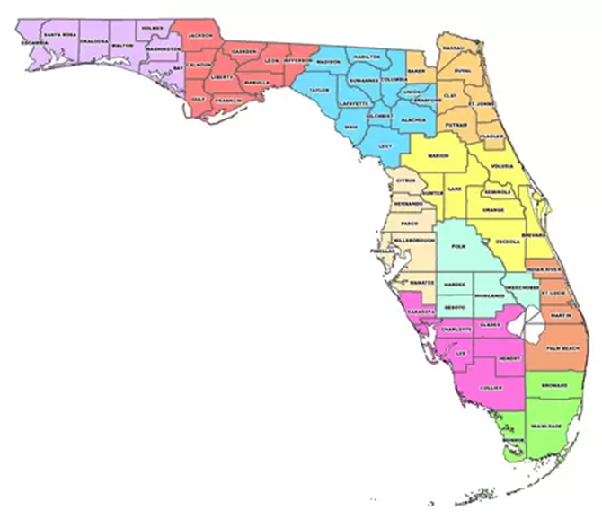
District 1  WEST FLORIDA REGIONAL PLANNING COUNCIL  LEPC Chairperson: Richard Delp  Staff Contact: Garrett Griffin  4081 East Olive Road, Suite A  Pensacola 32524-1399  (850) 332-7976 ext. 206 (800) 226-8914  FAX: (850) 637-1923  E-mail address: kathy.ahlen@wfrpc.org | District 6  CENTRAL FLORIDA REGIONAL PLANNING COUNCIL  LEPC Chairperson: Chief Mike Linkins  Staff Contact: Chuck Carter  Post Office Box 2089  Bartow 33831-2089  (863) 534-7130 ext. 107  FAX: (863) 534-7138  E-mail address: ccarter@cfrpc.org
District 2  APALACHEE REGIONAL PLANNING COUNCIL  LEPC Chairperson: Kevin Peters  Staff Contact: Zachary Annett  2507 Callaway Road, Suite 200  Tallahassee 32303  (850) 488-6211 ext. 102  FAX: (850) 488-1616  E-mail address: crietow@thearpc.com | District 7  TAMPA BAY REGIONAL PLANNING COUNCIL  LEPC Chairperson: Scott Ehlers  Staff Contact: John Meyer  4000 Gateway Centre Blvd., Suite 100  Pinellas Park 33782-3616  (727) 570-5151 ext. 33  FAX: (727) 570-5118  E-mail address: johnm@tbrpc.org
District 3  NORTH CENTRAL FLORIDA REGIONAL  PLANNING COUNCIL  LEPC Chairperson: Shayne Morgan  Staff Contact: Dwayne Mundy  2009 N.W. 67 Place, Suite A  Gainesville 32653-1603  (352) 955-2200 ext. 108  FAX: (352) 955-2209  E-mail address: mundy@ncfrpc.org | District 8  SOUTHWEST FLORIDA REGIONAL  PLANNING COUNCIL  LEPC Chairperson: Bruce Porter  Staff Contact: CK Kammerer  1926 Victoria Avenue  Ft. Myers 33901  (239) 338-2550 ext. 229  FAX: (239) 338-2560  E-mail address: ngwinnett@swfrpc.org
District 4  NORTHEAST FLORIDA REGIONAL COUNCIL  LEPC Chairperson: Richard Knoff  Staff Contact: Tyler Nolen  6850 Belfort Oaks Place  Jacksonville 32216  (904) 279-0885 ext. 178  FAX: (904) 279-0881  E-mail address: eanderson@nefrc.org | District 9  TREASURE COAST REGIONAL PLANNING COUNCIL  LEPC Chairperson: Frank Lasaga  Staff Contact: Kate Boer  421 SW Camden Avenue  Stuart 34994  (772) 221-4060 ext. 24  FAX: (772) 221-4067  E-mail address: kboer@tcrpc.org
District 5  EAST CENTRAL FLORIDA REGIONAL  PLANNING COUNCIL  LEPC Chairperson: Butch Loudermilk  Staff Contact: Michelle Cechowski  309 Cranes Roost Boulevard, Suite 2000  Altamonte Springs 32701  (407) 623-1075 ext. 335  FAX: (407) 623-1084  E-mail address: mcechowski@ecfrpc.org | District 10  SOUTH FLORIDA REGIONAL PLANNING COUNCIL  LEPC Chairperson: Ray McDonald  Staff Contact: Manny Cela  3440 Hollywood Blvd., Suite 140  Hollywood 33021  (954) 985-4416  FAX: (954) 985-4417  E-mail address: celam@sfrpc.com

7.0 EMERGENCY FACILITIES AND EQUIPMENT

7.1 General

This section describes the emergency response facilities, identifies supplies and equipment designated for emergency response, and identifies the key personnel and organizations that are anticipated to respond to emergencies.

7.2 Emergency Response Facilities and Personnel

7.2.1. Emergency Operations Centers

- County Emergency Operations Center

The local EOCs for the Apalachee LEPC are depicted in Figure 7-1. Each EOC has auxiliary power and logistical provisions to support emergency operations for a large scale emergency. Each agency, department or division tasked with emergency response activities within the affected county will establish communications or provide a representative to the EOC upon activation. A list of the agencies involved in the response efforts for a full scale of limited emergency conditions is found in Figure 4-3. Activation of the EOC is not expected during a potential emergency condition.

- State Emergency Operations Center

The FDEM is responsible for operating and staffing the State Emergency Operations Center (SEOC). The SEOC is the center for coordination of state response for any major emergency. The SEOC is located within the FDEM offices at 2575 Shumard Oak Boulevard, Tallahassee, Florida 32399. During a limited emergency condition, key personnel will report to the SEOC. Upon declaration of a full emergency condition, the SEOC will be activated to coordinate all state operations and establish communications with the involved EOCs.
Figure 7-1: Emergency Operations Centers in Apalachee
County | Address
Calhoun | Calhoun County Emergency Management  20859 Central Avenue East, Room G-40  Blountstown, Florida 32424
Franklin | Emergency Management Office  28 Airport Road  Apalachicola, Florida 32320
Gadsden | Emergency Management Office  339 E Jefferson St  Quincy, Florida 32351
Gulf | Emergency Management Office  1000 Cecil G. Costin, Sr. Blvd Bldg 500  Port St. Joe, FL 32456
Jackson | Emergency Mgmt. Office (Dunn Bldg.)  2819 Panhandle Rd  Marianna, Florida 32446
Jefferson | Emergency Management Office  169 Industrial Park Blvd  Monticello, Florida 32344
Leon | Leon County Emergency Management  911 Easterwood Drive  Tallahassee, Florida 32311
Liberty | Liberty County Emergency Management  Post Office Box 877; 11109 Northwest SR 20  Bristol, Florida 32321-0877
Wakulla | Emergency Management  15 Oak Street  Crawfordville, Florida 32327

7.2.2 On-Scene Command Post

In the event of a hazardous materials emergency, the first responding unit at the site will establish an On-Scene Command Post. The Incident Commander at the On-Scene Command Post will be the senior responding officer and shall direct and control on-scene emergency operations. The On-Scene Command Post is the center for Direction and Control throughout the emergency and receives support and additional resource procurement through the partially or fully activated EOCs.

7.3 Equipment and Resources

7.3.1 Equipment
The equipment necessary for a particular release will be dependent of the nature of the incident. Generally, the counties within Apalachee LEPC should have access to the following equipment which will be used in response to emergencies involving the release of hazardous materials:

- Chemical suits
  - 1 PVC
  - 1 Viton
  - 1 Teflon
  - 1 Chlorinated polyethylene (CPE)
  - 1 Butyl rubber
- Air masks and tanks
- In-suit radios
- Portable hand-held radios
- Combustible gas detectors
  - MSA 2A bulb type
  - Draeger detection tube
  - Tritector
- Recovery drums
  - 85-gallon drum
  - 55-gallon drum
- Vetter bags (assorted)
- Chlorine kits
  - Kit A (l50 lb. cylinder)
  - Kit B (l-ton container)
  - Kit C (rail car)
- Pipe frame simulator
- Hand tools (assorted)
- Resource manuals (assorted)
- Area maps (assorted)

In support of county emergency operations, each of the facilities subject to the requirements of EPCRA should maintain the following emergency equipment (as appropriate, based on the materials on site):

- Foam (protein, AFFF and alcohol)
- Nozzles and educators
- Reference books
- Minimum of two proximity or entry suits
- Assorted hand tools
- Plug and patch kits
- pH meter or tape
- Explosive gas meter
- Wind sock
- Self-contained breathing apparatus and spare tanks
- Radio (fire or police)
- Area maps
- Ladders, hose, forcible entry tools
- Gas detectors
- Recovery drums, brooms, shovels
- Absorbent material
- Spare valves, fittings, etc.
- Piping materials, drains (PVC pipe)
- Chlorine kit(s)
- Safety valve protectors
- Paper, tags, pencils, grease pens, shipping tags, etc.

Grants are available for local agencies to apply for and receive funding to gather additional equipment and resources. Grants can be found through FEMA’s U.S. Fire Administrations Assistance to Firefighters Grant Programs.

7.3.2 Laboratory Analytical Support

The FDEP has arranged with private emergency response contractors located throughout Florida to provide response personnel and equipment, including mobile analytical laboratories, for major chemical releases.

The FDOH has public health laboratories in Pensacola, Tallahassee, Jacksonville, Orlando, Tampa, West Palm Beach and Miami through the National Laboratory Response Network (NLRN). These FDOH laboratories will provide diagnostic, reference, emergency and research public health laboratory services to County Health Departments, FDOH program components, physicians, hospitals and private laboratories.

In the event that the need for laboratory and analytical support exceeds the capability of county resources, private contractors may be called upon for laboratory and analytical support. A list of available local private contractors and their capabilities is provided in Figure 7-2.

Facilities responsible for the release often have the specialized equipment for monitoring purposes. Air, water and soil samples may be collected and taken to the facility's laboratory for analysis.

7.3.3 Other Technical Support

On site assistance can be made available from any of the following agencies through the State's FDEM:

  - FDEP - information regarding toxic air or water pollutants, disposal of hazardous waste, oil spills;

  - FDACS - information regarding pesticides and liquid propane gas;

  - FDOH, Radiation Control Services - information on radioactive materials and health hazards, (850) 487-1004.

  - National Pesticide Telecommunication Network - information on pesticides, (800) 858-7378

  - 44th & 48th Weapons of Mass Destruction Civil Support Teams, Florida National Guard – fully equipped teams for hazardous materials assistance of terrorism-related incidents located in Camp Blanding and Clearwater, respectively

  - FEMA IMAAC - Interagency Modeling and Atmospheric Assessment Center (IMAAC) can provide real-time plume modeling for emergencies involving significant hazardous atmospheric releases. To activate IMAAC local, state or federal officials can call (703) 767-2003 or email IMAAC@fema.dhs.gov

Other resources that can be used in planning and response efforts to deal with hazardous materials emergencies include:

    - Computer Aided Management of Emergency Operations (CAMEO) - CAMEO is a computer program developed by the National Oceanic and Atmospheric Administration (NOAA), Hazardous Materials Response Branch. The program can be used for planning and operations purposes. CAMEO's capabilities include:

      - Access to an extensive database of chemical information (over 3,000 substances). Available information include: names (chemical names and synonyms), identification numbers (CAS, NOAA, United Nations numbers), labeling conventions, chemical formulas, chemical characteristics and response information.

      - Ability to draw/display maps of geographic areas, facility sites and floor plans. The geographic information (maps) are based on the Bureau of the Census TIGER files and are separate from the CAMEO program. A separate program (MARPLOT), accessed through CAMEO is needed to access the geographic information.

      - Identification of chemicals with only partial information (queries can be done on CAS numbers, synonyms or partial numbers).

      - The depiction of areas that is likely to be affected by the release. The programs uses a dispersion model to predict the potential plume based on the information provided by the user. This is also used for planning purposes to determine the potential scenarios based on climatic data and several assumptions about the release.

    - E-Plan - The nation's largest database of chemical and facility hazards data with over 200,000 facilities and 22,000 unique chemicals. E-Plan collects information required by the EPRCRA and Section 112(r) of the Clean Air Act Amendments of 1990. It allows information previously stored only as hard copies in physical storage to be accessible to first responder on-demand. The program displays facilities, schools, and hospitals in Google Maps online at www.erplan.net. It has nationwide coverage in all 50 States and four U.S. territories.

    - Apalachee LEPC Regional Hazardous Materials Commodity Flow Study - A transportation flow study of the hazardous materials shipped through the region. Placard survey data collection occurred 2009 throughout the Apalachee region. The study provides results for the highway placard survey as well as CSX Transportation. In addition, hazardous materials training recommendations are included based on the findings.

    - CHEMTREC - The Chemical Transportation Emergency Center (CHEMTREC) is operated by the Chemical Manufacturers Association. It provides information and/or assistance to emergency responders. CHEMTREC will contact the shipper or producer of the material to obtain detailed information or on-scene assistance. The CHEMTREC telephone number is 1-800- 424-9300 (for emergencies only).

    - Manufacturers Technical Bulletins - Manufacturers technical bulletins are the best single source of general information about the chemical in question. It also contains the most recent data about the chemical.

    - Material Safety Data Sheets (MSDSs) - Anyone using or storing a hazardous material in Florida is required to have and make available upon request, a MSDS for each chemical at the facility (fixed facilities only). MSDSs provide information such as, the chemical characteristic of the substance, health and safety concerns, flammability and flammable range, reactivity, disposal, spill control, cleanup and procedures, etc.

    - OHM-TADS - The Oil and Hazardous Materials Technical Assistance Data Systems (OMH-TADS) is a collection of interactive computer programs which can provide the necessary technical support for the assessment of potential or actual dangers encountered as a result of the release of a hazardous substance. OHM-TADS can be accessed at the ten EPA regional offices, EPA headquarters in Washington, and the Coast Guard Marine Safety Offices.

    - Shipping Papers - All transporters of hazardous materials are required by USDOT to have in their possession a document that describes the materials shipped. This information can be indexed and accessed by responders.

    - ESF 8 Dashboard – Provides locations of all healthcare facilities within the State and Regions available for use. As well as contact info for key contacts throughout the state. Can be found at flhealthresponse.com

FIGURE 7-1
PRIVATE CONTRACTORS' LABORATORY
AND ANALYTICAL CAPABILITIES

LABORATORIES CERTIFIED
1. Ardaman & Assoc., Inc. Metals
3175 West Tharpe Organic Extractables
Tallahassee, FL 32303 Purgeable Organics
850-576-6131 Hazardous Waste
Solvents

2. AMEC Environment & Infrastructure Metals
404 SW 140th Terrace Nutrients
Gainesville, FL 32602-1703 Demands
352-332-3318 Extractables
Gen I, Gen II
Pest-Herb
Purgeables
Hazardous Waste
Bioassay

8.0 ACCIDENT ASSESSMENT

8.1 General

This section describes responsibilities and procedures for assessing the offsite impacts of an emergency involving the release of hazardous materials and its effects on the health and well-being of the residents and visitors to the Apalachee region.

8.2 Initial Assessment

The initial accident assessment will be performed by the facility owner/operator as soon as possible after the accident. The results of the assessment will be reported immediately to local and state emergency response organizations in accordance with Chapter 4 of this plan. Until the arrival of off-site emergency response personnel, the facility owner/operator will assess actual and potential off-site consequences and provide the results of this assessment to the 24-hour warning point of the affected county.

Upon the arrival of off-site emergency response personnel, the responsibility for assessing the impacts or potential impacts of a release will be assumed by the Incident Commander operating from the on-scene Command Post. The assessment should include, but is not limited to the following:

    - identification of priorities for protecting public health, safety and the environment;

    - identification of the nature, amount and location of released materials;

    - identification of potentially responsible party(ies);

    - determination of the probable direction and time of travel for released materials;

    - identification of possible exposure pathways for humans and the environment; and

    - identification of potential impacts on human health and safety, the environment, natural resources and property.

Reports should be submitted through the appropriate channels by the responsible parties immediately after a hazardous materials incident.

8.3 Assessment and Monitoring

8.3.1 Resources and Capabilities

A general assessment and monitoring within the vulnerable zone surrounding the facility from which hazardous materials were released will generally be provided by the local County Health Department. However, the County Health Departments within the District have limited equipment and training to deal with a hazardous materials release. Additional assistance and support in assessing the public health consequences of the release will be provided by the FDEP and FDOH and/or through Mutual Aid Agreements. Laboratory support is identified in Chapter 7 of this plan. An up-to-date list of resources to assist in the evaluation, assessment and monitoring of hazardous materials incidents will be kept at each local Emergency Management office.

8.3.2 Activation of Field Teams

Upon notification of an emergency involving the release of hazardous materials, the local Emergency Management Director will verify the existence of an emergency and will contact the facility owner/operator to obtain further information. If instructed so by the Incident Commander, the Emergency Management Director will contact the Director of the local County Health Department to discuss appropriate assessment actions.

The Director of the local County Health Department will use existing information in accordance with established procedures to evaluate the potential for off-site exposure and to determine the adequacy of any protective actions. Based upon the results of the above evaluations, the Director of the affected County Health Department will recommend whether to activate assessment and monitoring personnel. The Chairperson of the BCC will be ultimately responsible for the decision to deploy assessment and monitoring personnel following consultation with the Director of the County Health Department, the Emergency Management Director and the current Incident Commander. The facility from which hazardous materials are released is responsible for providing technical support to local, state and federal monitoring teams.

8.3.3 Coordination of Assessment and Monitoring Activities

The mission of the local County Health Department, FDEP and/or FDOH in the event of a hazardous materials emergency will be to:

    - Evaluate the potential exposure projections to persons off site which may result from the emergency;

    - Make recommendations to the Incident Commander regarding appropriate protective actions;

    - Conduct field monitoring to prepare and confirm projections;

    - Evaluate potential exposure resulting from contamination of materials in the vulnerable zone surrounding the facility;

    - Evaluate exposure to emergency personnel resulting from operations related to the emergency;

    - Establish appropriate operational dose limits and maintain permanent records of dose received; and

    - Evaluate exposure and appropriate limits for recovery, reentry and post-accident operation.

When assessment and monitoring personnel reach their assigned location, accident assessment will be based on field monitoring results, the current meteorological conditions, facility condition, facility prognosis and any other relevant information.

Data collected in the field will be transmitted to the EOC to be evaluated by the local County Health Department or another agency with appropriate capabilities. These evaluations will be provided to the Chairperson of the BCC or a designee at the County EOC for use in decision-making and as a basis for recommendations concerning protective actions. Summaries and recommended protective actions will be forwarded to the State EOC and surrounding counties.

Monitoring of the affected area(s) and recommendations of protective actions will continue until exposure levels have decreased to the point that recovery and re-entry are considered safe.

8.3.4 Additional Assessment and Monitoring Support

When it is determined that a hazardous materials emergency cannot be adequately controlled with the resources available to the local response personnel, a request will be forwarded to the State of Florida Division of Emergency Management for the additional resources needed. The request will contain the following information:

    - description of the problem;

    - type of resources needed;

    - location where the resources need to be delivered;

    - clear direction to assembly point or point of delivery;

    - estimated time the resources will be needed; and

    - arrangements made for housing, etc., if resources include people.

9.0 EXPOSURE CONTROL FOR EMERGENCY WORKERS

9.1 General

This section establishes the means and responsibilities for controlling hazardous materials exposure to emergency workers. Local emergency response organizations will limit exposure to emergency workers by:

    - limiting the amount of time spent in hazardous areas;

    - limiting entry into hazardous areas to the maximum extent possible; and

    - using protective clothing and equipment.

Because they are frequently the first on the scene, firefighters and law enforcement personnel should use proper safety precautions when approaching a hazardous materials incident. First response personnel should have copies of the latest U.S. Department of Transportation’s Emergency Response Guidebook (ERG) and should know how to find and interpret shipping manifests. Another resource for first responders is the Florida Incident Field Operations Guide (FOG), which uses ICS as the management system to coordinate Florida’s total response to emergency incidents statewide.

9.2 Exposure Monitoring

After notification that a release has occurred, the potential for impact from the release, both on-site and off-site, will be assessed and monitored. A detailed log of all sampling results should be maintained and health officials should be kept informed of the situation. Decisions about response personnel safety, citizen protection, and use of food and water in the area will depend upon an accurate assessment of spill or plume movement and concentration.

Both initial and periodic monitoring are required at hazardous materials incidents. Initial monitoring must be conducted to identify any immediate dangers to life or health (IDLH) concentrations or other dangerous situations, such as the presence of flammable atmospheres, oxygen-deficient environments, and toxic contaminants. Once chemicals have been identified, standard information sources such as the NIOSH Pocket Guide to Chemical Hazards and CHEMTREC (Chemical Transportation Emergency Center) should be consulted to identify potential hazards, recommended exposure limits (RELs), permissible exposure limits (PELs), emergency action, personal protective equipment, and first aid procedures. MSDSs should be consulted for information including: manufacturer's name, chemical synonyms, trade name, chemical family, hazardous ingredients, physical data, fire and explosion hazard data, health hazards, reactivity data, spill or leak procedures, special precautions, and special protection information.

Local emergency response agencies should initiate a medical surveillance program for all emergency workers who are, or may be, exposed to hazardous substances or health hazards above the established RELs for 30 or more days in a 12-month period, or who wear respirators 30 days or more a year. Medical examinations must be available for all emergency workers who may have been exposed to concentrations of hazardous substances above the recommended exposure limits. An accurate record of medical surveillance must be retained.

9.2.1 EPA Levels of Protection

Based on the results of the preliminary evaluation, personal protective equipment must be selected and used. The selection process can be aided by consulting the North American Emergency Response Guidebook and CHEMTREC (see section 7.3.4). No single combination of protective equipment and clothing is capable of protecting against all hazards. Generally, the greater the level of personal protective equipment used, the greater the risk to the worker from such hazards as heat stress, physical and psychological stress, impaired vision, mobility and communication. Therefore, equipment should be selected that provides an adequate level of protection, but not over-protection.

The U.S. Environmental Protection Agency (EPA) has identified four levels of protection for emergency workers.

- LEVEL A - Level A (Chemical Protective Clothing and Equipment) will protect the worker against the specific hazard for which it was designed. The special clothing may afford protection only for certain chemicals and may be penetrated by chemicals for which it was not designed. Protective clothing that is fire-resistant must be specifically so identified by the manufacturer. Full-encapsulated protective clothing (cocoons) can be used for no-fire spills and leaks requiring evacuation of people, but offer little or no thermal protection. Level A Recommended Personal Protective Equipment includes:

      - Pressure-demand, full facepiece self-contained breathing apparatus (SCBA) or pressure-demand supplied-air respirator with escape SCBA;

      - Fully-encapsulating, chemical-resistant suit;

      - Inner chemical-resistant gloves;

      - Chemical-resistant safety boots/shoes;

      - Two-way radio communications; and

      - Optional: cooling unit, coveralls, long cotton underwear, hard hat, disposable gloves and boot covers.

- LEVEL B - Level B (Firefighters Protective Clothing - structural) provides protection by restricting inhalation of, ingestion of, or skin contact with hazardous vapors, liquids, and solids. This clothing may not provide adequate protection from poisonous vapors or liquids encountered during hazardous materials incidents. This is the minimum level recommended for initial site entries until the hazards have been completely identified. Level B Recommended Personal Protective Equipment includes:

      - Pressure-demand, full facepiece self-contained breathing apparatus (SCBA), or pressure-demand supplied-air respirator with escape SCBA;

      - Chemical-resistant clothing (either overalls and long-sleeved jacket, hooded one- or two-piece chemical splash suit, or disposable chemical resistant one-piece suit);

      - Inner and outer chemical resistant gloves;

      - Chemical-resistant safety boots/shoes;

      - Hard hat;

      - Two-way radio communications; and

      - Optional: coveralls, disposable boot covers, face shield, long cotton underwear.

- LEVEL C - Level C protective equipment provides the same level of skin protection as Level B, but a lower level of respiratory protection. When using this equipment, the atmosphere must contain at least 19.5% oxygen. Level C Recommended Personal Protective Equipment includes:

      - Full-facepiece, air-purifying canister-equipped respirator;

      - Chemical-resistant clothing (either overalls and long-sleeved jacket, hooded one- or two-piece chemical splash suit, or disposable chemical- resistant one-piece suit);

      - Inner and outer chemical resistant gloves;

      - Chemical-resistant safety boots/shoes;

      - Hard hat;

      - Two-way radio communications; and

      - Optional: coveralls, disposable boot covers, face shield, escape mask, long cotton underwear.

- LEVEL D - Level D protective equipment provides no respiratory protection and only minimal skin protection. This level should not be worn in the Exclusion Zone. Level D Recommended Personal Protective Equipment includes:

- Coveralls;

- Safety boots/shoes;

- Safety glasses or chemical splash goggles;

- Hard hat; and

- Optional: gloves, escape mask, face shield.

9.2.2 Exposure Records

The on-scene Safety Officer is responsible for maintaining the exposure record forms (See Figure 9-1). All emergency personnel exposures will be made a part of his/her permanent record, with a copy retained by the worker.

9.3 Authorization of Exposure in Excess of Protective Action Guidelines

The Chairperson of the BCC with jurisdiction for the affected area may, if necessary, authorize exposure of emergency personnel to exposure levels in excess of established recommended exposure limits (e.g. TLVs) after consulting with CHEMTREC. This authorization will be communicated to the Incident Commander via the local Emergency Management Director. These situations would be limited to lifesaving actions requiring search and removal of injured persons or entry to protect conditions that would probably injure specific individuals and/or to lessen stressful circumstances, where it is desirable to enter a hazardous area to protect facilities, prevent further release, or control fires. Authorized exposure shall not exceed OSHA Ceiling Concentrations (C) at any time.

9.4 Decontamination of Individuals and Equipment

Decontamination will be performed by trained personnel in accordance with established standard operating procedures. All workers must be decontaminated when leaving a contaminated area. Since methods to be used change from one chemical to another, shippers and medical authorities should be contacted to determine the most appropriate way of decontamination. All equipment and clothing from a contaminated area should be stored in a controlled area near the incident site until decontamination or proper disposal is accomplished.

Contaminated equipment, such as buckets, brushes, tools, etc., should be placed in containers and labeled. Partially decontaminated clothing should be placed in plastic bags pending further decontamination or disposal. Respirators should be dismantled, decontaminated, and disinfected after each use.

Water used for tool and vehicle decontamination will be allowed to run into suitable collection ditches, holding ponds, and other secure areas. Areas used for decontamination will be monitored for residual contamination. Any site found to be contaminated will be sealed off under the control of the FDEP and local law enforcement agencies. These sites will be decontaminated with the assistance of FDEP personnel and other appropriate federal and state agencies.

Personnel injured while responding to a hazardous materials emergency will be treated as possible contamination victims until a positive determination can be made. Emergency medical personnel will take precautions to prevent the spread of contamination on an injured person to medical support personnel and to medical equipment until the injured person can be transported to a medical facility with injury decontamination capabilities.

9.5 Site Decontamination

The FDEP or other adequately trained personnel (depending on the location and the magnitude of the incident) will be responsible for overall decontamination activities. FDEP will assume responsibility for decontamination activities when the County Health Department Director has determined that the threat to public health, safety and welfare has been terminated, and that the immediate threat to the environment has been reduced or stabilized, or if the local authorities are not capable of dealing with the situation. The FDEP will supervise the decontamination and environmental restoration. The FDEP will establish a liaison with the local Emergency Management office in the affected area and provide status reports on decontamination and restoration projects as well as mitigation programs and information pertaining to reimbursement of costs associated with local government response.

Figure 9-1

HAZARDOUS MATERIALS EXPOSURE FORM

Name:____________________________ Dept/Agency___________________

Age________________

Date of Birth_______________________________

Social Security Number________________________________

----------------------------------------------------------------------------------------------------

DATE LOCATION CHEMICAL HAZARD DURATION OF EXPOSURE

________________________________________________________________

________________________________________________________________

________________________________________________________________

________________________________________________________________

________________________________________________________________

________________________________________________________________

________________________________________________________________

________________________________________________________________

10.0 PROTECTIVE ACTIONS

10.1 General

The purpose of this section is to identify the range of protective actions that are available to state and local governments for the protection of the public. Protective actions which may be initiated to provide for the safety of the public may include any or all of the following:

    - notification of affected residents and transients to seek immediate in-place shelter;

    - evacuation of transients and residents within designated sectors exposed to a plume of hazardous materials to shelter areas outside the affected area;

    - control of ingress and egress into affected areas;

    - implementation of procedures to prevent the consumption and distribution of contaminated food and water supplies; and

    - implementation of procedures to decontaminate and provide medical treatment for persons exposed to hazardous materials.

10.2 Vulnerable Zones

A vulnerable zone is an estimated geographical area that may be subject to concentrations of an airborne EHS at designated levels (e.g., 0.1 times the IDLH level) that could cause irreversible acute health effects or death to persons within the area following an accidental release (i.e. the IDLH). These levels may be defined as the "Levels of Concern (LOCs, see Section 10.3). Vulnerable zones are based on estimates of the quantity of an EHS released to air, the rate of release to air, airborne dispersion and the airborne concentration that could cause irreversible health effects or death. The vulnerable zone radii, produced by the CAMEO program are listed in the Summary Tables (Figure 1-5). Maps depicting the vulnerable zone radii for Section 302 Facilities can be found in the County Hazard Analysis or by contacting the local LEPC.

10.3 Levels of Concern

A LOC is the concentration of an EHS in the air above which there may be serious irreversible health effects or death as a result of a single exposure for a relatively short period of time. There is no precise measure of an LOC for the chemicals listed as EHSs. However, for the purposes of this plan, an LOC has been estimated by using one tenth (0.10) of the IDLH levels published by the National Institute for Occupational Safety and Health (NIOSH), or one tenth (0.10) of an approximation of the IDLH from animal toxicity data. The LOC estimation can be found in the Screening and Scenarios tab of the Response Information Data Sheets (RIDS) section in CAMEOfm.

10.4 Evacuation

Authority to issue and immediate evacuation order for any vulnerable zone is delegated to the On-Scene Incident Commander within a given jurisdiction if the health and safety of persons within the critical evacuation area is in imminent danger. Evacuation of all or any part (e.g., downwind) of a vulnerable zone will be determined by the Incident Commander based on the Commander's evaluation of the situation and other information available, such as a site plan. Persons residing in a vulnerable zone which is ordered to be evacuated will be instructed to evacuate according to the evacuation guidelines described in Section 10.4.1.

All evacuation routes will lead citizens toward registration centers. Once at the centers, citizens will be screened for conditions requiring immediate medical attention, transported to medical facilities (if necessary), and assigned to a shelter.

Potential impediments to travel are weather conditions and traffic congestion. Strict traffic control measures will be utilized to facilitate ingress and egress of ambulances, fire/rescue, and other emergency vehicles and equipment. County and municipal law enforcement personnel within the affected jurisdiction, with the assistance of other law enforcement personnel (if necessary), will control traffic along evacuation routes. Traffic control points and barricades will be used to expedite the flow of traffic. Law enforcement personnel will block state roads as needed to prevent unauthorized use. Periodic patrols of the evacuation routes by law enforcement personnel will be used to maintain order, assist disabled evacuees and report route impediments to the Command post or the activated EOC. Should breakdown occur, tow-trucks will be dispatched to the scene.

10.4.1 Evacuation Routes

In the event of a transportation incident involving hazardous materials, the incident commander will coordinate the establishment of evacuation routes with law enforcement and public works agencies.

10.4.2 Evacuation of the General Public

Typically, the primary means of evacuating residents and transients from vulnerable zones will be private automobiles. Households with more than one vehicle will be encouraged to take only one car to minimize traffic congestion. Announcements will be made via broadcast media requesting that car-pooling arrangements be made to accommodate those without transportation of their own. Residents without transportation will be picked up by buses and transported to the nearest reception center. The City of Tallahassee Star Metro Evacuation Plan provides additional procedures and maps for city evacuations.

10.4.3 Evacuation for Special Needs

In coordination with the local County Health Department Director, the local Emergency Management office may establish a voluntary register of evacuees with special needs. During an evacuation, these lists, and other local information described in the appropriate local Comprehensive Emergency Management Plan will be utilized by the emergency personnel to inform people with special needs of the evacuation and dispatch appropriate transportation as needed. Special needs evacuees who are not assisted by individuals with private vehicles will be assisted by county and municipal vehicles and/or the local Community Transportation Coordinator, as described in the local plans.

10.4.4 Schools

If evacuation is ordered during school session, all school children located within the vulnerable zone will be placed on school buses and taken to designated pickup areas. All children will remain under the control of school personnel until turned over to the parents at some point in the evacuation chain. School personnel will provide supervision of the children on buses and during the waiting period. At the pickup point, children will be monitored and decontaminated if necessary. School personnel will maintain a listing of the number of children picked up, and report this information to the local EOC. Once the students are safe, the school buses may be directed to pick up residents who are without transportation. Any school children not picked up within six hours after having arrived at the reception center will be taken to shelters and will remain under the supervision of local County School Board personnel.

10.4.5 Medical Facilities

Medical facilities affected by an incident may be evacuated to other appropriate facilities outside the vulnerable zone through coordination with ESF 8 – Health and Medical. If available hospital transportation is not sufficient for timely evacuation, other resources could be coordinated through the local Emergency Management office.

10.4.6 Incarceration Facilities

Prisoners and inmates of incarceration facilities will be evacuated to temporary housing under the supervision of appropriate law enforcement personnel. Transportation will be arranged by the jurisdiction under which the facility operates.

10.5 Reception and Care

Reception centers will be established for the purpose of expeditiously clearing evacuee traffic from the evacuation routes, initial screening of evacuees for contamination, and providing food service and health and medical care to evacuees.

After a previously agreed upon length of temporary shelter stay, evacuees will be mobilized and moved to other shelter locations or to temporary housing. When the emergency subsides, evacuees will be allowed to reenter the affected area in accordance with established procedures.

Following the initial screening and any required decontamination, a preliminary registration consisting of name, address and telephone number will be conducted. Evacuees will then be assigned to shelters and provided with maps and routing instructions.

A second, more detailed registration of evacuees will be accomplished at shelters. Personal data on evacuees will be collected by American Red Cross representatives in accordance with established procedures. Registration data will be tabulated and submitted to the activated local Emergency Operations Center.

10.6 Sheltering-In-Place

In the event that a toxic cloud has become airborne and poses an immediate threat to persons attempting to evacuate, the decision to recommend taking shelter indoors instead of evacuating will be made by the Incident Commander. Residents will be notified to go indoors immediately, to close windows and doors, to turn off air conditioners and fans, and to remain inside until they receive further instructions. Notification to take shelter indoors will be issued by radio and television broadcast; email and text message notification; social media broadcasts; and police, fire and other emergency personnel using loudspeakers and other available means. Protective actions for special needs facilities will be given separate consideration. Protective action instructions will be issued by the Incident Commander, who will request the activation of the EAS and disseminate such instructions through the electronic broadcast media.

10.7 Temporary Housing

10.7.1 General

Following a disaster, temporary housing may be needed beyond the period of emergency shelter to accommodate those individuals and families made homeless by the disaster. Local governments and non-governmental relief agencies provide the first response to housing needs within the limits of their capabilities. Depending upon the magnitude of the disaster, additional resources may be required from higher levels of government. Resources and procedures for temporary housing during emergency situations can be found in each county’s Comprehensive Emergency Management Plan.

11.0 MEDICAL AND PUBLIC HEALTH SUPPORT

11.1 General

This section describes the medical services for victims of hazardous materials incidents, including provisions for emergency care and transportation of victims of chemical releases, sudden illness and medically incapacitated persons affected by evacuation and relocation during a hazardous materials incident.

Personnel from the FDOH will coordinate the delivery of medical support services to victims of hazardous materials incidents. The FDOH Duty Officer will be notified by FDEM who will, in turn, activate the appropriate FDOH district or local personnel. One Regional Emergency Response Advisors (RERA) is assigned to each FDOH/ FDEM/ FDLE region and will provide coordination to the impacted area through ESF 8.

11.2 Medical Support

A hazardous materials release can present actual or potential health hazards to individuals within the affected area. It is imperative that capabilities exist for treating exposed individuals. An on-going capability for emergency care and transportation of victims of accidents and sudden illness, and special needs population during evacuation must also exist.

11.2.1 Hospitals and Ambulance Services

During a disaster-related medical and rescue operations, the local provider of EMS, under the operational control of the Incident Commander, will coordinate all participating medical/rescue units operating in the affected area. Figure 11-1 provides a list of medical resources for the District.

Generally, the EMS provider will establish and maintain or assign the responsibility for two-way radio communications between the medical/rescue units and the hospitals to where victims will be directed, will coordinate and dispatch vehicles and personnel to the areas requiring on-site medical assistance, will coordinate all ambulance and fire/rescue vehicles during emergency medical operations, and may coordinate patient transport to available medical receiving facilities. Resources in excess of the needs for the particular incident will be released to their respective agencies.

All medical/rescue agencies will operate from their normal locations, as long as possible, during the period of emergency. They may disperse their vehicles and personnel as appropriate, provided the entity in charge of coordination is kept informed of the location and status of each vehicle. In the event of imminent hazard, personnel will seek safe shelter for themselves and their equipment. Following the shelter period, all personnel will return to their bases of operation and report their status to the coordinating entity for assignment.

Ambulance and medical/rescue units performing on-site duties in a jurisdiction other than their own will, unless otherwise directed by proper authority, operate under the tactical control of the ranking fire/medical officer in whose jurisdiction the operation is located. If there is no fire/medical officer, the on-site senior Emergency Medical Technician or Paramedic will be responsible for patient care until such time as the medical officer becomes available.

The hospitals within the affected jurisdiction and/or those expected to receive victims from the incident should periodically provide status information on the number of beds and the levels of service available at the hospital. This information must be relayed to the local entity coordinating EMS services.

11.2.2 Provision for Emergency Mental Health Care

Stress from an emergency situation may induce mental health stress to the residents and visitors to the area. The individuals affected by the incident may require crisis counseling to deal with the effects (long-term and short-term) of the emergency. There are facilities within the Apalachee that provide diagnostics and support for individuals with mental health concerns. These facilities are listed in Figure 11-1. The closest facility with a full time mental health department in the emergency room is the Tallahassee Memorial Regional Medical Center in Tallahassee.

In addition to the facilities listed in Table 11-1, there are numerous licensed counselors in the Apalachee area. The American Red Cross also provides training for mental health professional to deal with the special problems created by a disaster or a large scale hazardous materials incident. Records of these trained professional are kept by the Red Cross.

Coordinated delivery of all state medical and health support services to the victims of hazardous materials incidents is the responsibility of the FDOH. The FDOH District Director is responsible for assuring the Secretary of DOH that adequate medical and health support services exist for treating and transporting victims of hazardous materials incidents to medical support facilities.

Figure 11-1: Apalachee Emergency Medical Facilities
County Hospitals |  |  | County Emergency Medical Services
Calhoun County
Calhoun-Liberty Hospital  20370 NE Burns Avenue  Blountstown, Florida 32424  (850) 674-5411 |  |  | Calhoun EMS  20370 NE Burns Avenue  Blountstown, Florida 32424  911 or 850-674-5411
Franklin County
George E. Weems Memorial Hospital  135 Avenue G  Apalachicola, Florida 32320  (850) 653-8853 |  |  | Franklin County Ambulance Service  Washington Square  Apalachicola, Florida 32320  911 or (850) 653-8853
Gadsden County
Gadsden County Urgent Care Center  23186 Blue Star Highway  Quincy, FL 32350  (850) 627-5000 |  |  | Gadsden County EMS  339 Jefferson Street  Quincy, Florida 32350  911
Gulf County
Gulf Pine Hospital  102 20th Street  Port St. Joe, Florida 32456  (850) 227-1121 |  |  | Wewahitchka Ambulance Service  West River Road  Wewahitchka, Florida 32465  911
Jackson County
Jackson Hospital  4250 Hospital Drive Marianna, FL 32446  (850) 526-2200 | Campbellton Graceville Hosp  1305 College Drive  Graceville, Florida 32  (850) 263-4431 |  | Jackson County Fire/Rescue  3555 Highway 71 North  Marianna, Florida 32446  911 or (850) 482-9668
Jefferson County
Jefferson County Fire/Rescue
South US 19
Monticello, Florida 32344
911 or (850) 342-0182
Leon County
Capital Regional Medical Center  2626 Capital Medical Blvd  Tallahassee, Florida 32308  (850) 325-5000 |  | Tallahassee Memorial Hospital  1300 Miccosukee Road  Tallahassee, Florida 32303  (850) 431-1155 | Leon County Emergency Medical Services  911 Easterwood Drive  Tallahassee, FL 32311  Phone: (850) 606-2100
Continued…
Figure 11-1: Apalachee Emergency Medical Facilities
Liberty County
Liberty County Ambulance Service
Old City Hall
Bristol, Florida 32321
911
Wakulla County
Wakulla County Ambulance Service
Trice Lane
Crawfordville, Florida 32327
911
Adjacent Regional Medical Facilities
Gulf Coast Medical Center  449 West 23rd Street  Panama City, Florida 32405  (850) 769-8341 | Bay Medical Center  615 North Bonita Avenue  Panama City, Florida 32401  (850) 769-1511
Flowers Hospital  4370 West Main Street  Dothan, Alabama 36305  (334) 793-5000 | Southeast Alabama Medical Center  1108 Ross Clark Circle  Dothan, Alabama 36301  (334) 793-8111
Mental Health Facilities
Capital Regional Medical Center  Psychiatric Center  1616 Physicians Drive  Tallahassee, Florida  Licensed Beds – 60 | Rivendell of Bay County  1940 Harrison Avenue  Panama City, Florida  Licensed Beds - 80
Water Oak House  2634 Capital Circle NE  Tallahassee, Florida  Licensed Beds – 16 | Bay Medical Center  615 North Bonita Avenue  Panama City, Florida  Licensed Beds - 22
Annewakee Hospital, Inc.
Off US 98
Carrabelle, Florida
Licensed Beds - 190

12.0 RECOVERY AND RE-ENTRY

12.1 General

This section provides general guidelines for recovery and re-entry operations when a hazardous materials emergency has been brought under control and no further significant releases are anticipated. Decisions to relax protective measures implemented during a hazardous materials emergency will be based on an evaluation of chemical concentrations which exist at the time of consideration and on the projected long-term exposure which may affect residents and transients in the affected area.

12.2 Recovery

Recovery operations may be coordinated and directed from either the local County EOC, if activated, or the On-Scene command post.

12.2.1 Environmental Analysis

Prior to allowing public access to potentially contaminated areas, the FDEP and/or FDOH will evaluate the environmental conditions in the affected areas by conducting direct measurements and collecting environmental samples for laboratory analysis. Environmental sampling will proceed from the perimeter of affected areas toward the interior.

In-state laboratory analysis of collected samples may be performed at any of the laboratories identified in Section 7.0 or by independent contractors.

12.2.2 Containment and Cleanup

At any release where the lead agency determines that there is a threat to public health, welfare or the environment, the lead agency may take any appropriate action to prevent, mitigate or minimize the threat. In determining the appropriate extent of action to be taken for a given release, the lead agency should first review the preliminary assessment and current site conditions.

The following factors should be considered in determining the appropriateness of removal actions:

    - actual or potential exposure to hazardous substances by nearby populations, animals or food chain;

    - actual or potential contamination of drinking water supplies or sensitive ecosystems;

    - hazardous substances, pollutants or contaminants in bulk storage containers that may pose a threat of release;

    - high levels of hazardous substances or contaminants that may spread in soils, mainly at or near the surface;

    - weather conditions that may facilitate the spread or release of hazardous substances;

    - threat of fire or explosion;

    - availability of other appropriate state or federal response mechanisms;
and,

    - other situations or factors which may pose threats to public health, welfare or the environment.

TABLE 12-1
REMOVAL ACTIONS

Action Situation

Fences, warning signs, Where humans or
or other security or animals have access to
site control the release
precautions

Drainage controls Where precipitation or
run-off from other
sources may enter the
release area

Stabilization of berms, Where needed to
dikes or impoundments maintain the integrity of the structures

Capping of contaminated Where needed to reduce
soils or sludge the spread of hazardous substances
into soil, groundwater, or air

Using chemicals or Where use of such
other materials to chemicals will reduce
retard spread of the spread of release
release or to mitigate its effects

Removal of contaminated Where removal will
soils from drainage or reduce the spread of
other areas contamination

Removal of bulk containers Where it will reduce the likelihood containers that hold of spills, leakage, exposure to humans,
hazardous substances animals or food chain,
or fire or explosion

Provision of Where it will reduce
alternative water the likelihood of exposure of humans or
supply animals to contaminated water

If the responsible parties are known, an initial effort will be made, to the extent practicable under the circumstances, to have them perform the necessary removal actions. If unknown, the DEP has the overall responsibility for decontamination and removal.

Remedial actions, which are consistent with a permanent remedy, may be necessary to prevent or minimize the release of hazardous substances so that they do not spread or cause substantial danger to public health and safety or the environment. Before any remedial action is taken, however, the lead agency should first determine the nature and threat presented by the release and then evaluate available remedies. This may involve assessing whether the threat can be prevented or minimized by controlling the source of the contamination at or near the area where the hazardous substances were originally located (source control measures) and/or whether additional actions will be necessary because the hazardous substances have spread to other areas (management of migration).

The following factors are examples of those that may be assessed in determining the type of remedial and/or removal action to be considered:

    - population, environmental and health concerns at risk;

    - routes of exposure;

    - amount, concentration, hazardous properties and form of substances present;

    - hydro geological factors;

    - current and potential groundwater use;

    - climate;

    - extent to which the source can be adequately identified and characterized;

    - whether substances at the site may be reused or recycled;

    - likelihood of future releases if the substances remain on-site;

    - extent to which natural or manmade barriers currently contain the substances and the adequacy of those barriers;

    - extent to which the substances have spread or are expected to spread from the area, and whether any future spread may pose a threat to public health, safety, or to the environment;

    - extent to which state and federal environmental and public health requirements apply to the specific site;

    - extent to which contamination levels exceed established state and federal requirements, standards and criteria;

    - contribution of the contamination to an air, land, water and/or food chain contamination problem;

    - ability of the responsible party to implement and maintain the remedy until the threat is permanently abated; and,

    - availability of appropriate enforcement mechanisms.

Alternative actions should be developed, based upon this assessment, and screened to determine the most appropriate action. Criteria to be used in the initial screening include cost, effectiveness, and acceptable engineering practices. The appropriate remedial action will be a cost-effective one that effectively mitigates and provides adequate protection of public health, safety and the environment. A list of typical remedial actions is summarized in Table 12-2.

TABLE 12-2
REMEDIAL ACTIONS

Action Situation

Elimination or Contaminated groundwater
containment of
contamination to prevent
further contamination

Treatment and/or removal Contaminated groundwater
to reduce or eliminate
contamination

Physical containment to Contaminated groundwater
reduce or eliminate
potential exposure to
contamination

Restrictions on use to Contaminated groundwater
eliminate potential
exposure to contamination

Elimination or containment Contaminated surface water
of contamination to prevent
further pollution

Treatment of contaminated Contaminated surface water
water to reduce or
eliminate its hazard
potential

Actions to remove, treat Contaminated soil/waste
or contain soil or waste
to reduce or eliminate
its hazard potential

12.2.3 Documentation and Follow-Up

During all phases of response, documentation should be collected and maintained to support all actions taken under this plan and to form the basis for cost recovery. In general, documentation should be sufficient to provide the source and circumstances of the condition, the identity of responsible parties, accurate accounting of local or private party costs incurred, and impacts and potential impacts to the public health, welfare and the environment. Evidentiary and cost documentation procedures and requirements to be followed will be those specified in the USCG Marine Safety Manual (Commandant Instruction M16000.3) and 33 CFR Part 153.

A final report of the incident should be prepared by the lead response agency which includes, at a minimum, the following information:

      - time and date of incident;

      - name and address of affected facility;

      - name of facility owner/operator;

      - hazardous material(s) involved;

      - nature and source of release;

      - summary of actions taken by emergency response agencies and organizations;

      - summary of actions taken to protect public health/safety, the environment and other property;

      - summary of injuries and property damage;

      - documentation of costs; and,

      - need for additional actions.

The information and reports obtained by the lead agency for response actions shall, as appropriate, be transmitted to the Chairperson of the Apalachee LEPC and the Chairperson of the SERC.

12.3 Re-entry

The decision to relax protective actions will be made by the Chairperson of the BCC in the affected jurisdiction, in consultation with the local County Health Department Director, Emergency Management Director and the On-Scene Commander. Re-entry operations will be coordinated from either the activated local EOC or the On-Scene command post. Re-entry will be considered when chemical concentrations in air, water and ground are below established levels of concern in the affected areas (e.g. downwind portions of the vulnerable zone). Upon the determination that the environmental conditions in the affected areas are safe for public access, protective actions will be relaxed and re-entry will be authorized.

The local Emergency Management Director will monitor re-entry activities from the local EOC and will keep the State EOC informed. Cleared areas will be opened when clearly definable boundaries are available (e.g., highways, streets). Limited re-entry by the general public will not be allowed.

13.0 EXERCISES AND DRILLS

13.1 General

Exercises and drills should be conducted periodically to evaluate the adequacy of the hazardous materials emergency plan and the skills of the emergency response personnel. Results of exercises and drills provide a basis for changes in the response plans, in implementing procedures, and for future scheduling of training for emergency response personnel.

13.2 Exercises

For an emergency plan to remain useful, it must be kept up- to-date through a thorough review of actual responses, simulated exercises, and collection of new data. As key assumptions and operational concepts in the plan change, the plan must be amended to reflect the new situations.

An exercise is an event that tests the integrated response capability and major elements within emergency preparedness plans. The emergency preparedness exercise will simulate an emergency, which results in hazardous materials releases and response by local authorities. Exercises will be conducted as scheduled and will be evaluated by qualified observers.

13.2.1 Full Scale Exercise

A full-scale exercise is designed to fully demonstrate the emergency preparedness and response capabilities of appropriate county agencies and organizations. Mobilization of local emergency personnel and resources can be demonstrated. The Apalachee LEPC held its last full-scale exercise on October 26, 2018 at the Leon County Department of Health in Tallahassee, FL.

The Apalachee LEPC assisted with the planning, facilitation and evaluation of the exercise entitled “Operation Medication Go!” in conjunction with the Leon County Department of Health. The exercise tested the ability of the Leon DOH to set up and operate a Point of Dispensing (POD) in response to an anthrax attach in Leon County. The purpose of the exercise was to evaluate Leon DOH staff’s ability to set up and manage a POD, as well as their ability to dispense proper medications to the affected population within 48 hours of the event. The exercise involved multiple agencies including Leon DOH, Leon County Sheriff’s Office and Tallahassee Fire Department.

13.2.2 Functional Exercise

A functional exercise is designed to demonstrate one or more functions or capabilities specified in the emergency plan. The use of a simulation cell or SimCell is often used to provide live exercise messages, feedback and updates so that players must make decisions in a more stressful environment. Mobilization of local personnel and resources is limited.

The Apalachee LEPC held its last functional exercise on June 4, 2014 at the Tallahassee Fire Department Training Division facility. The functional exercise was cosponsored by CSX Transportation and involved a train derailment scenario in downtown Tallahassee. A tractor trailer transporting chlorine collided with the train to cause the derailment. The collision resulted in the release of hydrofluoric acid, sulfuric acid and chlorine gas. Staff completed an HSEEP compliant After Action Report and Improvement Plan.

13.2.3 Tabletop Exercise

A tabletop exercise is a simulation in which response activities are discussed is a stress-free atmosphere. There is no mobilization of emergency personnel and resources. Staff facilitated two tabletop exercises during the year. The first of which was in Wakulla County in August 2018. The second tabletop exercise was held at the 2019 Florida Emergency Preparedness Association’s (FEPA) annual meetings in February 2019. The exercises were designed around a transportation related hazardous materials release located near an elementary school. The exercise evaluated the ability of local first responders and emergency management personnel to identify hazards, clear and secure the affected areas and make the determination between evacuation vs shelter in place. That after-action report was written and the improvements identified during the process have been implemented into the LEPC Plan.

13.2.4 Scheduling and Scenario Development

Exercises will be coordinated between the LEPC, the local Emergency Management offices and facility owner/operators. Exercise objectives and the scenarios for the exercises will be developed and prepared jointly by the parties involved, depending on the objectives and/or functions to be tested. The LEPC will use the U.S. Department of Homeland Security, Office of Training and Grants (OTG), Homeland Security Exercise and Evaluation Program (HSEEP) to guide the exercise scheduling and scenario development.

Scenarios should be varied from year to year to ensure that all major elements of the plan and preparedness organizations are tested within a five-year period. The scenarios will include but not be limited to the following:

    - objectives of the exercise and appropriate evaluation criteria;

    - dates, time period, places, and participating organizations;

    - simulated events;

    - a time schedule of real and simulated initiating events;

    - a narrative summary describing the conduct of the exercise; and

    - a description of arrangements for advance materials to be provided to observers.

13.2.5 Critique and Reports
The LEPC will use the HSEEP methodology to plan and evaluate exercises. In addition, HSEEP guidelines will be followed when writing the After Action Report (AAR) and Improvement Plan (IP). A hot wash will be conducted after each exercise to evaluate the capability of participating emergency agencies and organizations to implement emergency plans and procedures. Evaluators of participating agencies will be requested to submit written comments as input to develop the AAR/IP.

13.3 Drills
A drill is a supervised instruction period aimed at developing, testing and monitoring technical skills necessary to perform emergency response operations. A drill may be a component of an exercise. Each drill will be evaluated by the coordinator for that particular drill.

The Apalachee LEPC assisted Gadsden County Fire and EMS personnel on May 22, 2008 with the coordination of a hazardous materials-related drill at the Quincy Municipal Airport. This drill was designed to specifically test triage skills using START and JumpSTART training that had been delivered to Gadsden County first responders over the past year. Secondary to the drill was additional practice on the use of the Incident Command System (ICS) with a focus on establishing command once on-scene.

13.3.1 Communications Drills

The means of communication between the facility owners/operators, state and local governments will be tested as described in Chapter 5. Communications with federal emergency response organizations will be tested at least quarterly. Communications between the facilities, state and local EOCs and on-scene personnel will be tested annually. The test of communications with on-scene teams will be part of the exercises.

13.3.2 Medical Drills

Medical emergency drills involving a simulated contaminated injury and participation by appropriate local emergency medical services will be conducted as part of the exercise.

13.3.3 Chemical Monitoring Drills

Monitoring drills for state and appropriate county hazardous materials monitors will be conducted as part of the exercise. These drills will normally include collection and analysis of sampling media, provisions for communications, and record keeping.
14.0 TRAINING

14.1 General

This section outlines requirements for a training program that will assure that hazardous materials emergency response training is provided for emergency response personnel responsible for decision making, planning, and response.

14.2 Annual and Refresher Training

Each local government within Apalachee LEPC is responsible for assuring that local emergency response personnel receive adequate hazardous materials training. The LEPC will maintain records of personnel completing training courses. The records will be updated periodically to reflect refresher training.

Pursuant to 40 CFR 311, the Environmental Protection Agency (EPA) adopted training rules promulgated by the Occupational Safety and Health Administration in 29 CFR 1910.120 which require specific training for all "public employees" who respond to hazardous materials incidents, effective the date of this rule, depending on the duties and functions performed by each. All employees must complete the training or demonstrate competency at their respective level of response. These levels are:

- First Responder Awareness Level;
- First Responder Operations Level;
- Hazardous Materials Technician Level;
- Hazardous Materials Specialist; and
- On-Scene Incident Commander.

Contact the Apalachee LEPC representative or the State DEM for a hard copy of the 2002 edition of the SERC Florida Guidelines for Hazardous Materials Training also available at www.floridadisaster.org. The manual includes the guidelines that the public sector employees should follow regarding training with respect to the various disciplines. It also contains the listing of specific competencies expected to be addressed in the local training efforts. Figure 14-1 summarizes the recommended hazardous materials training levels for emergency response personnel.
Figure 14-1: Training for Emergency Personnel

Training Level or Need | HM Team | Fire Rescue | Law Enf | EMS | Public Health | Emer Mgt | Supp Agen | School Board | Hosp | Facil Oper
1. First Responder Awareness | X | X | X | X | X | X | X | X | X | X
2. First Responder Operations | X | X |  |  |  | X |  |  |  | X
3. HazMat Technician | X
4. HazMat Specialist | X
5. On-Scene Incident Command | X | X
6. Safety Operations | ** |  | X | X
7. Use of Protective Clothing & Equip | ** | X |  | X |  | X
8. Decon Procedures | ** | X |  | X |  |  |  |  | X
9. Treatment of Contaminated Patient Injuries |  | X |  | X |  |  |  |  | X

** - These training modules are covered in the HazMat Technician training level and are required for personnel needing additional training beyond first responder levels.

14.3 Schedule and Availability of Training

The Apalachee LEPC, funded by through a U.S. Department of Transportation Hazardous Materials Emergency Preparedness grant, sponsors transportation-related hazardous materials emergency response training delivered within the District. From August of 1995 through December of 2018, over 6,429 firefighters, law enforcement officers, public works employees, and other responders received training in hazardous materials training courses sponsored by the Apalachee LEPC.

Courses within the District are scheduled contingent upon the availability of funding. The local Emergency Management offices will assist in the recruitment of participants for the training sessions. Persons interested in obtaining hazardous materials training are encouraged to contact the Apalachee LEPC for information describing the availability of courses.

The tragic events of September 11, 2001 resulted in an increased emphasis on terrorism-related training and domestic security, including hazardous materials/weapons of mass destruction. This event also created increased coordination with several new agencies and organizations, including the Florida Department of Law Enforcement (FDLE). The seven Florida Regional Domestic Security Task Force (RDSTF) efforts have emphasized the role of the LEPC as a key hazardous materials information, training and exercise assistance provider. LEPC staff has assisted with planning, evaluation and facilitation of the Region II/North Florida RDSTF exercises since 2003.

APPENDIX A - List of Extremely Hazardous Substances (EHSs) and Data for the Hazards Analyses

This list is in the CAMEOfm database and is located at the Apalachee Regional Planning Council. Additionally, an updated data base of all EHSs can be found on the EPA website.

APPENDIX B - Hazards Analyses

The Hazard Analyses for the counties of Calhoun, Franklin, Gadsden, Gulf, Jackson, Jefferson, Leon, Liberty and Wakulla are located at the Apalachee Regional Planning Council.
APPENDIX C – 2016 Commodity Flow Study

August 26, 2016
Prepared by:

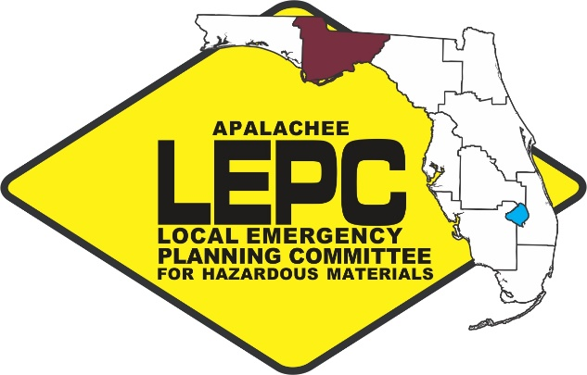

Funded by the US Department of Transportation through the
Florida State Emergency Response Commission for Hazardous Materials

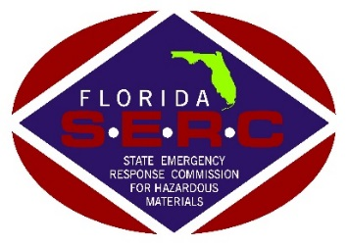

Apalachee Local Emergency Planning Committee
Hazardous Materials Commodity Flow Study

In February of 2016, the Apalachee Local Emergency Planning Committee (LEPC) began a transportation flow study of the hazardous materials shipped through the nine-county district. The Apalachee LEPC District includes Calhoun, Franklin, Gadsden, Survey data collection occurred over a six-month period. Although the original Hazardous Materials Emergency Preparedness (HMEP) scope of work for the project called only for a highway placard survey, the Apalachee LEPC included an analysis of CSX Transportation rail data.

Highway Placard Survey
For the highway placard survey, data was collected and analyzed from nearly 800 vehicles carrying hazardous materials on Interstate 10, US 98 and US-90 (east-west routes), and US-19, US-319, US 27 and US-231 (north-south routes). During the data collection, it was observed that Interstate 10 is the major road corridor of hazardous materials transport within the Apalachee District. Although hazardous materials are transported on almost all major roads within the District, the bulk of the hazardous materials were observed on Interstate 10. However, the majority of the gasoline and diesel fuel was observed coming into the District on US 27, assumedly from Bainbridge, Georgia.

It is important to note that the survey represents approximately 75% accuracy of the hazardous materials moving on highways throughout the Apalachee District region. Beyond general recording error and survey limitations, there are two reasons for this lack of accuracy. Firstly, trucks are only required to display placards if the hazardous materials meet or exceed the established transport thresholds. A truck carrying hazardous materials cargo may not necessarily display a placard when the cargo is below the federal threshold.

Secondly, trucks are only required to display the placard for the most dangerous hazardous material on board. In these instances, the survey does not reflect the entire hazardous materials inventory for the truck. Although there may be a variety of hazardous materials loaded together, they are regulated for compatibility under CFR 49, § 177.848 and they generally meet all the packaging criteria in § 172.101

Thirdly, the placard does not always reveal specific information about the corresponding hazardous material. For example, one placard (1993) indicates any of the following: combustible liquid, cleaning liquid compound, tree/weed killing compound, diesel fuel, flammable liquid not otherwise specified, fuel oil, etc. Unfortunately, there is no way to confirm the actual hazardous material cargo other than reviewing the shipping papers. To compensate for this uncertainty, the survey results were aggregated by the U.S. Department of Transportation’s 2012 Emergency Response Guidebook (ERG) general hazards categories. Table 1 provides a summary of the percentages of hazardous materials surveyed in descending order as categorized by the 2012 ERG.

Table 1: 2016 Highway Placard Survey Summary

General Hazards Category  from 2012 ERG | Hazardous  Material Commodity | Placard # | %
Flammable Liquids (Non-Polar/Water-Immiscible) - Guide 128 | Gasoline, Gasohol and Motor spirit | 1203 | 60.6
Flammable Liquids (Non-Polar/Water-Immiscible) - Guide 128 | Elevated Temperature Liquid, n.o.s., at or above 100°C (212°F), and below its flash point | 3257 | 6.9
Flammable Liquids (Non-Polar/Water-Immiscible) – Guide 128 | Diesel Fuel, See ERG | 1993 | 6.2
Gasses – Flammable (Including Refrigerated Liquids) – Guide 115 | Propane, See ERG | 1075 | 4.1
Substances (Low to Moderate Hazard) – Guide 171 | Hazardous Waste, liquid, n.o.s. | 3082 | 2.7
Substances – Toxic and/or Corrosive (Non-Combustible) – Guide 154 | Caustic Alkali Liquid, n.o.s. | 1719 | 2.3
Gasses – Inert (Including Refrigerated Liquids) – Guide 120 | Carbon Dioxide, refrigerated liquid | 2187 | 1.3
Gasses – Oxidizing (Including Refrigerated Liquids) – Guide 122 | Oxygen, refrigerated liquid (cryogenic liquid) | 1073 | 1.1
Substances – Toxic and/or Corrosive (Non-Combustible) – Guide 154 | Caustic soda/Sodium hydroxide | 1824 | 0.9
Flammable Liquids (Polar/Water-Miscible) – Guide 127 | Resin solution | 1866 | 0.8
Flammable Liquids (Non-Polar/Water-Immiscible) - Guide 128 | Fuel, activation, turbine engine | 1863 | 0.8
Gasses – Flammable (Including Refrigerated Liquids) – Guide 115 | Hydrogen, refrigerated liquid | 1966 | 0.8
Flammable Liquids (Non-Polar/Water-Immiscible) - Guide 128 | Petroleum products, See ERG | 1268 | 0.6
Substances – Toxic and/or Corrosive (Non-Combustible) – Guide 154 | Hypochlorite Solution | 1791 | 0.6
Flammable Liquids (Polar/Water-Miscible) – Guide 127 | Alcohols, n.o.s. | 1987 | 0.6
Gasses – Inert (Including Refrigerated Liquids) – Guide 120 | Helium, refrigerated liquid | 1963 | 0.5
Flammable Liquids (Polar/Water-Miscible/Noxious) – Guide 129 | Isopropyl | 1219 | 0.4
Oxidizers – Guide 140 | Ammonium nitrate, with not more than 0.2% | 1942 | 0.4
Substances – Toxic and/or Corrosive (Non-Combustible) – Guide 154 | Ammonia, See ERG | 2672 | 0.4

Table 1 Summary
As can be seen in the table above and chart below, the majority (75.1%) of the hazardous materials being transported throughout the District are Flammable Liquids (Non-Polar/Water-Immiscible). This category includes petroleum products such as gasoline, gasohol and motor spirits. The second most abundant category, far behind that of the top grossing category is Gases - Flammable (Including Refrigerated Liquids). This category also includes petroleum products, such as propane, LPG and hydrogen. Overall, petroleum-based hazardous materials account for the overwhelming majority of surveyed hazardous materials placards within the region traveling on the highway. In addition, it may be important to note that some of the Flammable Liquids (Polar/Water-Miscible) category may include petroleum products such as resin solution.

Beyond petroleum products, the survey revealed nineteen other general hazard categories as found in the 2012 ERG ranging from 2.7% to less than 1% of the total number of surveyed trucks. These survey results show the wide diversity of hazardous materials traveling through the Apalachee District.

Analysis of the Transportation of Hazardous Materials by Rail
Three active railroads operate in the Apalachee District,. These railways are illustrated on the map provided on this document’s cover page.

Apalachicola Northern Railroad (AN), is a Class III railroad that operates 96 miles from Port St. Joe to Chattahoochee and is operated by Genesee and Wyoming, Inc. (GWI). Upon communication with this entity, it was discovered that no hazardous commodities are shipped on this line. AN primarily carries scrap metal and forest products. At its terminus in Chattahoochee, AN connects with CSX Transportation (CSXT). AN runs through Gulf, Franklin, Liberty and Gadsden counties in the Apalachee District.

Bay Line Railroad, L.L.C., (BAYL) also owned by GWI, is another Class III railroad. This line operates from Panama City to Dothan, Alabama. Sixty-three miles of BAYL’s 110-mile track is found in Florida. BAYL meets with CSXT in Cottondale, Florida on its route to its final destination in Dothan. BAYL primarily ships paper products, lumber, chemicals, and others1. BAYL runs through Jackson County in the Apalachee District. Upon communication with BAYL, staff was informed that no hazardous commodities are transported on this railway.

The largest, CSXT, maintains records of the quantity and type of commodities moving through the District. CSXT is the only one of the three rail lines that carries hazardous commodities. CSXT is a Class I railroad that is the largest operator in the State of Florida, owning over 53-percent of the statewide track mileage1. CSXT is a division of CSX Corporation and runs through Jackson, Gadsden, Leon, and Jefferson counties in the Apalachee District.

A hazardous materials density study was performed by CSX Transportation to identify the hazardous materials most frequently transported through the District. The study excludes intermodal shipments (trailer or container on flat cars). Intermodal hazardous materials shipments are non-bulk and less than 55 gallon/package formats.

Table 2 displays the average amounts of hazardous materials transported by rail through the Apalachee District region in 2015 in descending order. As CSX can accurately track the amounts of hazardous materials cargo by computer, the results are displayed in descending order by average carload. For general estimating purposes, a carload is approximately 20,000 gallons of product.

Table 2: 2015 CSX Hazardous Materials Commodity Summary

Average  Carloads 2015 | General Hazards Category  from 2012 ERG | Hazardous Material Commodity | Placard # | %
2,498 | Flammable Solids – Guide 133 | Sulfur, Molten | 2448 | 16.34
2,223 | Substances (Low to Moderate Hazard) – Guide 171 | Environmentally Hazardous Substances, Liquid, N.O.S. | 3082 | 14.54
1,540 | Substances - Toxic and/or Corrosive (Non-Combustible) - Guide 154 | Sodium Hydroxide Solution | 1824 | 10.08
1,093 | Gases - Flammable (Including Refrigerated Liquids) – Guide 115 | Liquefied Petroleum Gas | 1075 | 7.15
905 | Oxidizers – Guide 140 | Ammonium Nitrate | 1942 | 5.92
824 | Oxidizers – Guide 140 | Ammonium Nitrate, Liquid | 2426 | 5.39
721 | Flammable Liquids (Non-Polar/Water-Immiscible) – Guide 128 | Fuel Oil | 1202 | 4.72
566 | Substances - Toxic and/or Corrosive (Non-Combustible) – Guide 154 | Phosphoric Acid, Liquid | 1805 | 3.70
495 | Flammable Liquids (Non-Polar/Water-Immiscible) – Guide 128 | Elevated Temperature Liquid, N.O.S. | 3256 | 3.24
401 | Substances – Toxic and/or Corrosive (Non-Combustible/Water-Sensitive) – Guide 157 | Hydrochloric Acid | 1789 | 2.62
316 | Flammable Liquids – Corrosive – Guide 132 | 2-Dimethylaminoethanol | 2051 | 2.07
283 | Oxidizers – Unstable – Guide 143 | Hydrogen Peroxide, Stabilized | 2015 | 1.85
276 | Flammable Liquids (Polar/Water-Miscible/Noxious) – Guide 129P | Methyl Acrylate, Stabilized | 1919 | 1.81
275 | Flammable Liquids (Non-Polar/Water-Immiscible) – Guide 128P | Styrene Monomer, Stabilized | 2055 | 1.80
251 | Gasses – Inert (Including Refrigerated Liquids) – Guide 120 | Carbon Dioxide, Refrigerated Liquid | 2187 | 1.64
236 | Flammable Liquids – Corrosive – Guide 132 | Acetic Acid, Glacial | 2789 | 1.54
199 | Substances - Toxic and/or Corrosive (Non-Combustible) - Guide 154 | Potassium Hydroxide, Solution | 1814 | 1.30
188 | Substances – Water-Reactive – Corrosive – Guide 137 | Sulfuric Acid | 1830 | 1.23
173 | Gases - Flammable (Including Refrigerated Liquids) – Guide 115 | Methyl Chloride | 1063 | 1.13
107 | Substances – Toxic and/or Corrosive (Combustible) – Guide 153 | Phenol, Molten | 2312 | 0.70
43 | Substances (Low to Moderate Hazard) – Guide 171 | Other Regulated Substances, Liquid, N.O.S. | 3082 | 0.28

Table 2 Summary
Molten sulfur, environmentally hazardous substances, sodium hydroxide solution, liquefied petroleum gases and ammonium nitrate were the five most frequently shipped hazardous materials commodities in 2015 by rail by CSX Transportation. The top four commodities have stayed the same since the last study in 2007. The fifth most common commodity, ammonium nitrate, was previously refrigerated liquid carbon dioxide.

Top Five Commodity Comparison
Table 3 is a ‘Top 5’ comparison between Table 1 (Highway Placard Survey) and Table 2 (CSX Density Study). This table allows for a comparison of the most commonly transported hazardous materials by rail and highway and includes the corresponding 2012 ERG Guide Number.

Table 3: Top 5 Highway & Rail Comparison Summary

Rank | General Hazards Category (Highway Placard Survey) | ERG Guide # | % | General Hazards Category  (CSX Density Study) | ERG Guide # | %
1. | Flammable Liquids (Non-Polar/Water-Immiscible) | 128 | 75.1 | Flammable Solids | 133 | 16.34
2. | Gases - Flammable (Including Refrigerated Liquids) | 115 | 4.9 | Substances - Toxic and/or Corrosive (Non-Combustible) | 154 | 15.08
3. | Substances – Toxic and/or Corrosive (Non-Combustible) | 154 | 4.2 | Substances (Low to Moderate Hazard) | 171 | 14.83
4. | Substances (Low to Moderate Hazard) | 171 | 2.7 | Oxidizers | 140 | 11.31
5. | Gasses – Inert (Including Refrigerated Liquids) | 120 | 1.8 | Flammable Liquids (Non-Polar/Water-Immiscible) | 128 | 9.75
The matching shaded areas denote shared general hazard categories for both the Highway Placard Survey and the CSX Density Study.

Table 3 Summary
The comparison reveals that both Flammable Liquids (Non-Polar/Water-Immiscible),
Substances – Toxic and/or Corrosive (Non-Combustible), and Substances (Low to Moderate Hazard) are listed in the ‘Top 5’ for the Highway Placard Survey and the CSX Density Study. Based on this analysis, first responders may consider focusing their hazardous materials training these commodities, especially Flammable Liquids and Flammable Solids considering their overwhelming presence in this study.

For additional information on this Hazardous Materials Commodity Flow Study, please contact Zachary Annett, Apalachee LEPC Coordinator at (850) 488-6211 ext. 107 or zannett@thearpc.com.

Appendix D

MEDIA RELEASE FORMS

Figures 6-1 through 6-7

Figure 6-1

MEDIA RELEASE A: Alert - No Protective Action

The ________________ County Emergency Management Director received a report that

has occurred. It has been determined that no protective actions are required to ensure and maintain public health and safety.

The County Emergency Management Division will continuously monitor and assess the situation to confirm earlier reports. As monitoring results become available, protective actions may be recommended as needed.

NOTE TO CORRESPONDENTS:

This message has been issued by authority of the ________________ County Board of Commissioners. Additional information may be obtained from

Date/Time of issue:_____________________________________________

Issued by:_____________________________________________________
Figure 6-2

MEDIA RELEASE B: Shelter-In-Place Notice

The _____________ County Board of Commissioners has declared an emergency situation in the vicinity of _________________________. This is a warning to all residents within a __________ mile radius of the _______________. You are advised to seek shelter immediately; go indoors... close windows and doors... turn off air conditioners and fans. Stay inside until you receive further instructions. There has been a release of hazardous materials. To avoid exposure, seek shelter immediately indoors... close windows and doors... turn off air conditioners and fans. Evacuation has not been recommended at this time. Keep your radios and television sets turned on for additional information.

NOTE TO CORRESPONDENTS:

This message has been issued by authority of the ________________ County Board of Commissioners. Additional information may be obtained from

Date/Time of Issue:______________________________________________

Issued by:______________________________________________________

Figure 6-3

MEDIA RELEASE C: Evacuation Preparation

The _______________ County Board of Commissioners has declared an emergency situation in the vicinity of _________________________. Should the decision be made to evacuate your area, you should plan to be away from your home for __________ or less. You should now begin thinking about where you would stay and the necessities you may wish to take with you. You should review any evacuation instructions on hand which may have previously been supplied by local officials. This station will broadcast instructions if evacuation is ordered. The following items are recommended as evacuation supplies:

1. Two (2) blankets per person, or a sleeping bag.

2. Change of clothing.

3. Important papers (checkbook, etc.)

4. Medicine, particularly special medication.

5. Toiletries.

We repeat that evacuation has not yet been recommended. These are only preparatory instructions.

NOTE TO CORRESPONDENTS:

This message has been issued by authority of the ______________ County Board of Commissioners. Additional information may be obtained from

Date/Time of Issue:_____________________________________________

Issued by:_____________________________________________________

Figure 6-4

MEDIA RELEASE D: Evacuation Notice

The County Board of Commissioners has issued an order directing the immediate evacuation of . Local emergency management authorities have begun the evacuation of this area. This evacuation order was issued in response to the reported release of hazardous materials by ______________. Persons living in the affected area should follow the instructions given below:

1. Take the following items with you:

a. Two (2) blankets per person, or a sleeping bag.
b. Change of clothing.
c. Important papers (checkbook, etc.)
d. Medicine, particularly special medication.
e. Toiletries.

2. Lock your home. Turn off electricity, gas and water.

      - Go to _________________________________. Follow the evacuation route nearest you. Do not move against traffic.

4. Time is important, but move safely.

5. Persons not having transportation should notify the __________________________.

6. Persons immediately outside of the affected area are not subject to a direct hazard; however, these persons should remain alert to any possible changes in instructions resulting from changes in wind direction or accident conditions. Stay by your radio or TV. Persons outside the affected area are also asked not to travel on or near routes being used for evacuation. These routes are:

NOTE TO CORRESPONDENTS:

This message has been issued by authority of the ______________ County Board of Commissioners. Additional information may be obtained from

Date/Time of Issue:________________ _____________________________

Issued by:________________________ _____________________________

Figure 6-5

MEDIA RELEASE E: Evacuation Follow-Up

During the period of evacuation, law enforcement officers will patrol the perimeter of the evacuated areas to ensure protection of homes and businesses. No unauthorized persons will be allowed in the evacuated areas. County officials will monitor the affected areas continuously. When conditions are determined safe, you will be notified to return home. Transportation will again be provided for those in need.

NOTE TO CORRESPONDENTS:

This message has been issued by authority of the ________________ County Board of Commissioners. Additional information may be obtained from

Date/Time of Issue:_____________________________________________

Issued by:_____________________________________________________

Figure 6-6

MEDIA RELEASE F: All Clear

The _______________ County Board of Commissioners has announced that the emergency conditions at ______________________________ have ended. It is now safe to return to your residence and/or business. Repeating... the emergency conditions in the area of ____________________________ have now ended. You may return home and resume normal activities. There is no longer any threat to persons in the area. If you need additional information, you may contact ________________________________.

NOTE TO CORRESPONDENTS:

This message has been issued by authority of the ______________ County Board of Commissioners. Additional information may be obtained from

Date/Time of Issue:_____________________________________________

Issued by:_____________________________________________________

Figure 6-7

MEDIA RELEASE G: School Evacuation

The Superintendent of Public Instruction, ______________ County School Board has issued an order directing the immediate evacuation of ____________________ School. School authorities have begun the evacuation of children to _______________________. Parents of children attending ___________________ School are advised to pick up their children at _______________________. If you need additional information, you may contact

NOTE TO CORRESPONDENTS:

This message has been issued by authority of the Superintendent of Public Instruction, ________________ County School Board. Additional information may be obtained from

Date/Time of Issue:_____________________________________________

Issued by:_____________________________________________________

http://www.dot.state.fl.us/rail/PlanDevel/Documents/FinalInvestmentElement/G-Chapter2-FreightRail.pdf

