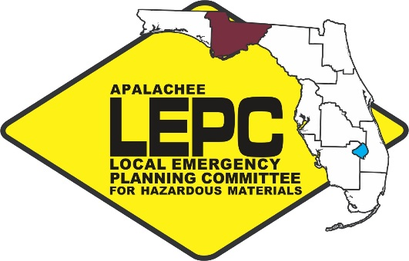
APALACHEE LOCAL EMERGENCY

PLANNING COMMITTEE
2507 Callaway Road, Suite 200, Tallahassee, Florida 32303
Office (850) 488-6211 ext. 102 Fax: (850) 488-1616

Chairman: Kevin Peters
Vice Chairwoman: Gail Stewart
Training Task Force Member: Vacant

Staff to the Committee: Apalachee Regional Planning Council

Apalachee Local Emergency Planning Committee Meeting
Thursday, November 10, 2016
10:00 AM Eastern

***Tallahassee Fire Department Training Division***
2964 Municipal Way
Tallahassee, FL 32311

AGENDA

- Call to Order, Roll Call, and Introductions

- Approval of Minutes

- Chairman’s Report – Kevin Peters

  - Recap of State Emergency Response Commission (SERC); LEPC Chairs and Staff; and SERC Training Task Force (TTF) meetings

  - Domestic Security Update: North Florida Regional Domestic Security Task Force (NFRDSTF)

- Staff Updates – Chris Rietow

  - 2016 Emergency Response Guidebooks (ERGs)

  - Hazardous Materials Training

  - HMEP Planning Project – HazMat Commodity Flow Study

  - County Hazards Analysis Summary Presentation (Franklin & Liberty)

- Other Business

- Public Comment

- Next Meeting Date and Location – To Be Determined

Capital Area Chapter of the American Red Cross
1115 Easterwood Drive
Tallahassee, FL 32311

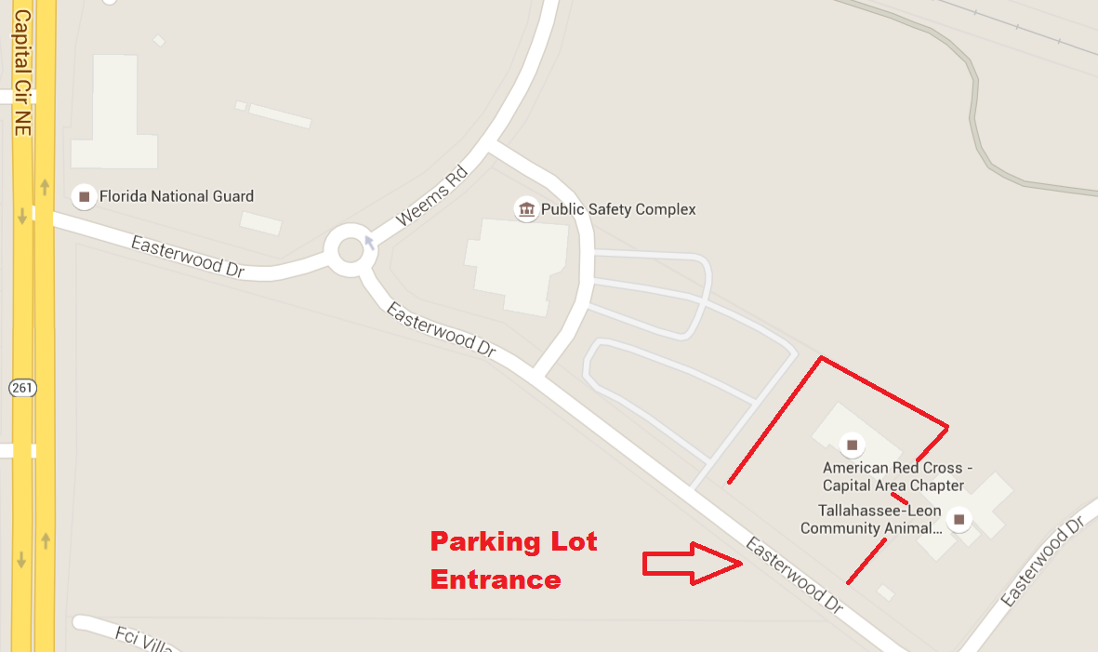

The Capital Area Chapter of the American Red Cross is located adjacent to the Tallahassee/Leon Public Safety Complex. The parking lot entrance is on Easterwood Drive. You are not required to sign in upon entering the facility.

Apalachee Local Emergency Planning Committee
Capital Area Chapter of the American Red Cross
1115 Easterwood Drive
Tallahassee, FL 32311

February 16, 2016 – 10:00 AM Eastern

Meeting Minutes

- Call to Order, Roll Call and Introductions

Chairman Kevin Peters called the meeting to order, welcomed those in attendance, thanked those that traveled to the meeting at the Capital Area Chapter of the American Red Cross and asked for self-introductions from those individuals present. Chairman Peters also thanked the Nicole King for hosting the meeting. Staff indicated that a quorum was present. He reminded all present to sign the attendance roster that had been passed out. The following members were present:

Members and Alternates
Duncan, William Florida Dept. of Transportation
Ellerbe, Carol Jefferson County Emergency Management
Hall, Darryl Leon County EMS
King, Nicole American Red Cross
Lara, Jonathan FL Department of Environmental Protection
Laursen, Jason Tallahassee Police Department
Leiva Krause, Nancy Florida Dept. of Health
Rhonda Lewis Liberty County EM
Lupton, GW Tallahassee Community College
Nagy, Jennifer Leon County Division of Emergency Management
Peters, Kevin Leon County Division of Emergency Management/Chair
Rainey, Eve Florida Emergency Preparedness Association
Stewart, Gail FL Dept. of Health/Leon
Taylor, Brad Wakulla County Sheriff’s Office – EM
Woehle, Melissa FL Department of Environmental Protection
Younger, Michael Tallahassee Community College

Guests
Anderson, Steve Chipola College
Clark, Ashton Florida Department of Law Enforcement
Corbin, Steve Florida Dept. of Transportation
Crozier, Joe Apalachee Regional Planning Council
Futch, James FDOH – Bureau of Radiation Control
Gay, George Chipola College
Hofmeister, Austin FL Department of Environmental Protection
Joyner, Bridget Wakulla County Sheriff’s Office – EM
McAllister, Jamie Chipola College
Shuler, Lisa Liberty County EM
Tammisetti, S’ri City of Tallahassee

Staff
Rietow, Chris Apalachee Regional Planning Council

2. Approval of Minutes
A motion to approve the minutes of the October 20, 2016 Apalachee Local Emergency Planning Committee meeting was made by Gail Stewart and seconded by Nancy Leiva-Krause. The vote was unanimous.

A. SERC Training Task Force (TTF) & LEPC Chairs/Staff Meeting Recap

Daytona Beach, FL – January 19, 2016

Training Task Force Meeting Summary Update

Chris Rietow reported that Captain Tom Pescatore with the Tallahassee Fire Department could no longer serve as the Apalachee LEPC’s Training Task Force representative and noted that he was looking into potential replacements. He noted that TFD didn’t currently have any candidates, but that DEP’s Melissa Woehle was being considered.
- Melissa Woehle announced that she was working with her superiors to determine if this was a possibility.

HazMat Symposium 2016 Update - Jonathan Lamm
- 51 presenters total (38 local) this year
- Estimated 300 total (100 more than last year)
- Jonathan Lamb moving from one LEPC to another, but will continue to assist with the HazMat Symposium
- Have received great support from FFCA on the HazMat Symposium after overcoming some initial challenges in the first several years
- Moving forward with planning for 2017 HazMat Symposium

FL East Coast Railway (Scheduled Speaker backed out)
- Diesel and modified LNG hybrid trains rolling out
- Will fill up in Jax and can make 3 trips to Miami and back on one tank
- They are working on outreach with east coast hazmat teams
- LNG use continues to grow in ports and rails in FL
  - Training for LNG fires should in increase accordingly (on east coast)

HazMat FOG Update - Frank DeFrancesco
- Subcommittee has been working on update
- Draft update will be available for review at the April TTF meeting

Florida State Fire College - Scott Chappell
- FSFC is moving forward with implementation of more online training
- Will help alleviate costs for the 160-hr hazmat Tech course training
- So far, efforts have received positive feedback

LEPC Chairs and Staff Meeting

HA Workgroup Update - Dwayne Mundy
- Jan. 11th Conference Call Summary
  - DEM a bit behind on HA reviews
  - Status on submission of site plans through E-Plan
  - User Defined Fields
    - How is it shipped? Check a box for truck, rail, etc.
  - Progress with respect to GATOR and CAMEO work
- Counties can upload their HA data onto the SharePoint Portal
- Discussion on HA Training
  - Folks that prepare HAs vs. People that use the HA data
- Opportunities for Improvement
  - Status on 302 search using E-Plan (very close to completion on this by E-Plan)
  - Email Rob Dietrich for wish list changes on E-Plan
- Still a disconnect from data in E-Plan to corrected date entered into CAMEO

LEPC Name and Logo Discussion
- New logos and names brought to closure
- District 2 LEPC is now the Apalachee LEPC

HMEP Funding Plan
- Application data needed to DEM by March 1st (only the planning project as DEM will submit a comprehensive list of classes to US DOT for approval)
- Moving to 3-yr contract
- No longer training vs. planning, just HMEP eligible activities
- Planning project optional (need cost estimate)
- $787K coming down from US DOT and passed through to RPCs
  - Subject to sequestration (could end next year)
- Could include purchase of LEPC training trailer for the region

PHMSA Pipeline Discussion - Arthur Buff, US DOT
- See PowerPoint
- Explosion de Gas en Reynosa video (26 people killed)
- Transportation of Crude by Rail
  - 2008 - 9,500 tanker car loads
  - 2014 - 493,146
  - Mostly due to fracking and Bakken crude (no pipelines in place where crude is being extracted)
  - NTSB - deems the increase "an unacceptable risk"
- Most incidents come from excavation activities
  - There's an incident every 6 minutes
  - Call before you dig 811

Review of the FL SERC Policies for LEPCs
- Policies updated to changing times
- Including occupational categories, membership size, members per category, attendance policy

State Emergency Response Commission (SERC) Meeting Recap
January 20, 2016 – Daytona Beach, FL

New Primary Member & Alternate LEPC Appointments were approved (see agenda pg. 6)
- New primary - Mike Phillips, FDOH
  - New Alternate - James Futch, FDOH

Thomas Yatabe Award Winner Presentations
- Mac Kemp of Leon EMS accepted on behalf of Chief Quillin who could not attend
- Certificates of Appreciation for Tanker Trouble Planning Team Members
  - Chairman Peters distributed the certificates to those present

- Domestic Security Update: North Florida Regional Domestic Security Task Force Update
- FDLE Domestic Security Planner Ashton Clark announced that the North Florida RDSTF Meetings will now be held biannually
  - The next meeting will be held on June 2, 2016
- Chris Rietow reported that FDEM has requested that the ARPC begin planning a full scale terrorism exercise for the Region 2 RDSTF specialty teams
  - The exercise will be held on May 16, 2016 and will serve as the kickoff to the 2016 Statewide COOP Exercise
  - The first planning meeting will be held in approximately one week

4. Staff Update
A. Regional Hazardous Material Response Training

Training Summary
Date | Course | Location | Hours | Participants
10/30/15 | 8-hr OSHA Technician Level Refresher | TFD Training Division | 8 | 16
12/11/15 | 4-hr Awareness | Tallahassee Community College | 4 | 7
1/20-22/16 | 2016 HazMat Symposium | Daytona |  | 6
1/23/16 | 8-hr Operations Refresher | Jefferson Co. EOC | 8 | 24
2/1-5/16 | 40-hr OSHA HAZWOPER | TFD Training Division | 40
2/6/16 | 8-hr Operations Refresher | Jefferson Co. EOC | 8 | 16
5/3-5/16 | 24-hr OSHA HazMat Operations | TFD Training Division | 24
6/8/16 | 8-hr HazMat Technician Level Refresher | TFD Training Division | 8

Upcoming Training
- See page 9 for upcoming 8-hr OSHA HazMat Tech Refresher Course being held on June 8th at the TFD Training Division
- Working with TFD to identify training needs
- Please send hazmat training needs in ASAP

B. HMEP Planning Project Update
- Selected HazMat Commodity Flow Study for 2015-16 Planning Project (last completed in 2009)
- Data collection began this month
- March 1st Deadline to propose 2016-17 Planning Project
  - Training Needs Assessment Survey of Public Sector HazMat First Responders
  - LEPC Plan Exercise
  - HazMat Commodity Flow Study
  - On-site Assessment of or Needs Assessment Survey for HazMat Rapid Response Teams
  - Develop District Response Procedures (SOPs) For Incidents Involving The Transportation of Flammable Liquids, Chlorine and Anhydrous Ammonia To Include In County CEMP and District Response Plan
    - Based on the initial feedback on this project from the membership, Chris Rietow reported that he would contact the additional EM offices within the region to gauge interest in this project
      - If there was a general consensus among the EM offices, he would move forward with submitting a proposal to DEM for this project
  - Other projects within grant guidance

- County Hazards Analysis Summary Presentation
- LEPC staff will provide HA summary for the region’s counties’ throughout the year
- Franklin and Liberty County summaries were postponed until the next meeting due to time constraints

Other Business – James Futch, FDOH, Radiation and the Bureau of Radiation Control Presentation: Mr. Futch provided a thorough PowerPoint presentation on the BRC and expanded on current capabilities and training opportunities. Radiation samples were on display for a question and answer session after the meeting.

George Gay, Overview on the Chipola Fire College Training Program: Mr. Gay provided a brief summary on the Chipola Fire College and its current efforts to become more involved with hazardous materials training. Chris Rietow noted that this was a resource that was unknown to him and that we would like to collaborate with the college with respect to a potential hazmat training trailer.

Gail Stewart reported that there was great representation from the region at the recent FEPA Annual Meeting.
- Ms. Stewart also announced that a Chlorine Responder 3-day Class in Gainesville was being held April 19-21, 2016
  - Staff noted that he would forward out the information on the course

Eve Rainey announced that FEPA Mid-Year is scheduled for August 1-5, 2016 in Sarasota; Governor’s Hurricane Conference in Orlando is May 8-13, 2016; Intermediate Training Academy May 9-13, 2016 at Camp Blanding; FEPA recently eclipsed its 60th year of existence.

Public Comment – No public comments given.

Next Meeting – Staff noted that he would work with Chairman Peters to schedule the next meeting during the last week in April. Nicole King and GW Lupton offered the Red Cross and TCC, respectively as potential locations.

Meeting Adjournment
Chairman Peters thanked everyone for their attendance and participation. There being no further business, the meeting adjourned at Noon Eastern Time.

SIGNED: ATTEST:

____________________________ ____________________________
KEVIN PETERS CHRIS RIETOW
KEVIN PETERS CHRIS RIETOW

