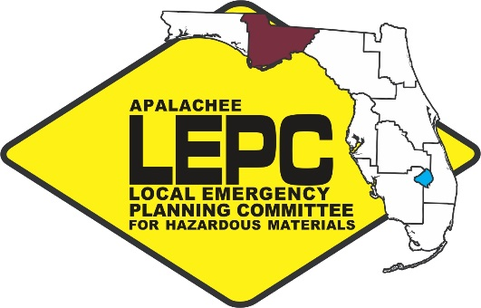
APALACHEE LOCAL EMERGENCY

PLANNING COMMITTEE
2507 Callaway Road, Suite 200, Tallahassee, Florida 32303
Office (850) 488-6211 ext. 102 Fax: (850) 488-1616

Chairman: Kevin Peters
Vice Chairwoman: Gail Stewart
Training Task Force Member: Melissa Woehle

Staff to the Committee: Apalachee Regional Planning Council

Apalachee Local Emergency Planning Committee Meeting
Monday, June 19, 2017
10:00 AM Eastern

***Capital Area Chapter of the American Red Cross***
1115 Easterwood Drive
Tallahassee, FL 32311

AGENDA

- Call to Order, Roll Call, and Introductions
- Approval of Minutes
- Chairman’s Report – Kevin Peters
  - Recap of State Emergency Response Commission (SERC); LEPC Chairs and Staff; and SERC Training Task Force (TTF) Meetings

  - Domestic Security Update: North Florida Regional Domestic Security Task Force (NFRDSTF)

- Staff Updates – Gina Mendicino
  - NASTTPO Update
  - HMEP Planning Project – Updating SOPs for Hazardous Materials

  - HMEP Training

    - 8-hour Tech class on June 29th (Full)
    - 8-hour Tech class September 13th (Seats Available)
    - 24- hour and 40- hour classes being set up for September/November

- Other Business
- Public Comment
- Next Meeting Date – Tentatively scheduled for May 23, 2017
- Adjournment

Capital Area Chapter of the American Red Cross
1115 Easterwood Drive
Tallahassee, FL 32311

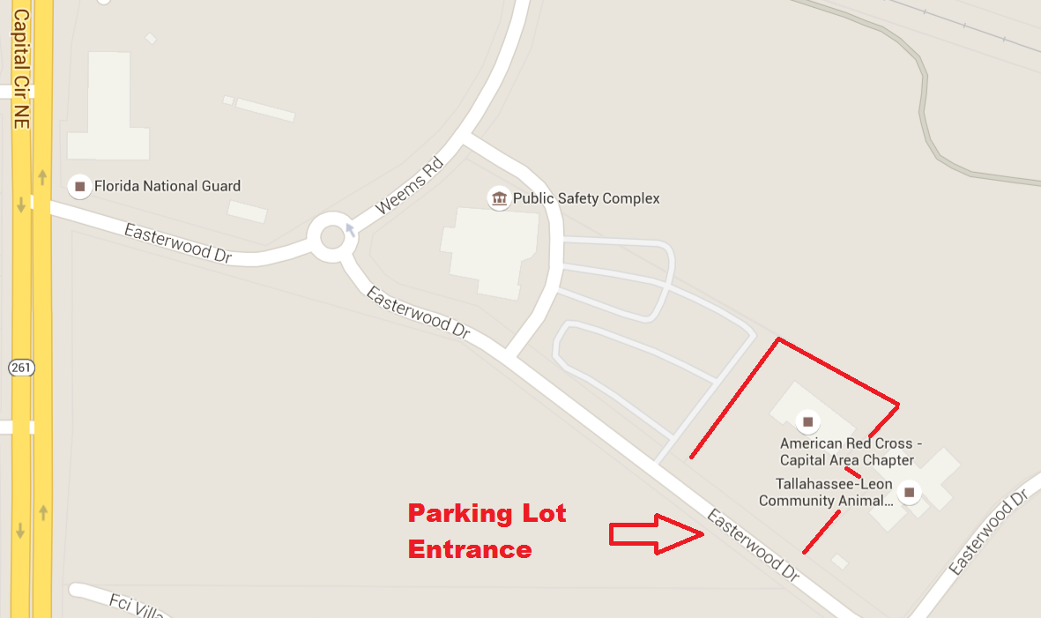

The Capital Area Chapter of the American Red Cross is located adjacent to the Tallahassee/Leon Public Safety Complex. The parking lot entrance is on Easterwood Drive. You are not required to sign in upon entering the facility.
Apalachee Local Emergency Planning Committee
Capital Area Chapter of the American Red Cross
1115 Easterwood Drive
Tallahassee, FL 32311
February 14 – 10:00 AM Eastern
Meeting Minutes

- Call to Order, Roll Call, and Introductions
Chairman Peters called the meeting to order, welcomed those in attendance, thanked those that traveled to the meeting at the Capital Area Chapter of the American Red Cross, and asked for self-introductions from those individuals present. Staff indicated that a quorum was present. Chairman Peters reminded all present to sign the attendance roster that had been passed out. The following members were present:
Members and Alternates
Ellerbe, Carol Jefferson County Emergency Management
Gay, John Leon County Emergency Medical Services
Gray, Laymon Florida State University
Lupton, GW Tallahassee Community College
Nagy, Jennifer Leon County Division of Emergency Management
Peters, Kevin Leon County Emergency Management
Powers, Robby City of Tallahassee
Rainey, Eve Florida Emergency Preparedness Association
Stewart, Gail Department of Health – Leon
Woehle, Melissa Florida Department of Environmental Protection

Guests
Bats, Howell Department of Health Region 2
Dietrich, Rob Florida Division of Emergency Management
Furlong, Michael Leon Division of Emergency Management
Holliday, Kristina Florida Department of Law Enforcement
Imbler, Denise Apalachee Regional Planning Council
Johnson, Natalie Department of Health – Liberty
Johnson, Nicole City of Tallahassee
Shuler, Jesse Department of Health – Gulf/Franklin
Steel-Claridge, Sue North Florida Fusion Exchange
Wotherspoon, Paul Florida Division of Emergency Management

Staff
Mendiino, Gina Apalachee Regional Planning Council

- Approval of Minutes
Eve Rainey motioned to approve the minutes of the November 10, 2016 Apalachee Local Emergency Planning Committee meeting. Gale Stewart seconded the motion and the minutes were passed unanimously.

- Chairman’s Report
  - SERC Training Task Force (TTF) and LEPC Chairs and Staff Meeting Recap
Daytona Beach, FL – January 10, 2016

    - Training Task Force Meeting Summary
- HazMat Symposium
      - The Apalachee LEPC was able to sponsor 6 individuals from the region to attend the HazMat Symposium. This included 4 members of the Tallahassee Fire Department HazMat Team, one member from Jefferson County Fire Rescue, and one member of Florida Department of Environmental Protection.
      - Feedback from those who attended the HazMat Symposium was overall very positive, and the Symposium itself saw a massive increase in attendance and vendors this year.
- HazMat Team Assessments
      - Scott Chappell has sent out self-assessment forms to all HazMat teams in Florida. The LEPCs will then follow up with each HazMat team in their region. The goal is to have replies from each team by June 1, 2017.
      - Assessments will take place on a 3-4 year rotation. This is not as pertinent to the Apalachee Region, as we only have one HazMat team, and we will likely asses the TFD HazMat team every 2-3 years.
      - Matt Marshall and Scott Chappell are available to assist with the assessments.
      - Scott Chappell has asked that all assessments be completed by the October SERC meeting.
- Offshore HazMat Response
      - The MOU is being rewritten to allow for the American Salvage Association to pay for offshore HazMat responses and allow the US Coast Guard and local HazMat teams to train together at no cost for the hazmat team.

    - LEPC Chairs and Staff Meeting
- HA Working Group
      - A sample survey has been drafted and will be sent to those using HA’s as well as to LEPCs.
- Tier II Non-Filers and LEPC Responsibilities
      - A new database has been created for tracking information on non-filers. It is the LEPC’s responsibility to report non-filing facilities if necessary.
- RMP Rule
      - This rule is currently on a 90 day hold and will require level 2 and 3 self-responding facilities to hold a tabletop exercise every 2-3 years, and a full scale exercise every ten years in coordination with the LEPCs.
- Notification Rule
      - DEP is currently notifying the public in the event of a release, rather than the facilities themselves.
      - Paul Wotherspoon expressed concerns that too much information could lead to complacency among the public.

  - SERC Meeting
Daytona Beach, FL – January 10, 2016
- Updates
      - Updates were given regarding the HazMat Symposium, TTF Meeting, and LEPC Chairs and Staff Meeting.
- Offshore HazMat Response
      - The MOU is being rewritten to allow for the American Salvage Association to pay for offshore HazMat responses and allow the US Coast Guard and local HazMat teams to train together at no cost for the hazmat team.
  - Yatabe Award
    - The Yatabe Award was presented to GW Lupton for his service to the Apalachee LEPC.

  - Domestic Security Update
- The NFRDSTF is undergoing changes in their task force meeting schedule and structure. The LEPC will be updated as these changes take place.
- The next NFRDSTF will be in June, 2017.

- Staff Updates
  - HMEP Planning Project
    - This year’s planning project is to update each county’s SOPs to include an annex for hazardous materials response.
    - Meetings will be taking place between the LEPC Coordinator and each county’s EM director.

  - HMEP Training
    - The LEPC has received several requests for HAZWOPER refresher training, including a 24-hour course, a 40-hour course, and several Awareness courses.
    - Any other training needs should be forwarded to the LEPC Coordinator.

  - HazMat Releases
    - An update was provided regarding the recent notable HazMat releases in the Apalachee region. This included an instance of chemical suicide as well as an overturned tanker resulting in a jet fuel spill.

- Other Business
  - FEPA Update
    - Eve Rainey provided an update of the FEPA annual meeting, which had occurred 2 weeks prior to the LEPC meeting. The mass care scenario was well received and included a “no powerpoint rule” in order to create a more realistic environment.
    - The FEPA Intermediate Academy will take place February 26 – March 3, 2017 at Camp Blanding. This academy is primarily for those with less than 3 years of experience in the emergency management field to gain additional experience and training, as well as an opportunity to practice vital skills outside of an actual emergency scenario.
    - April 20, 2017 is the FEPA Intern Day, which will be streamed through Facebook Live, and will discuss the value of internships in the field of emergency management.

  - Airport Exercise
    - The Tallahassee International Airport completed their full-scale exercise, providing Leon County EMS with the opportunity to work with a large number of patients and test their mass casualty procedures. The scenario involved simulated treatment for around 70 patients and allowed EMS to observe items in the Airport’s plan that would EMS would need to accomplish in a real event.
    - Big Bend Health Care Coalition and the North Florida Medical Reserve Corps were able to simulate moving resources and assisting in the reunification center and the City of Tallahassee was able to act as the liaison with the EOC to aid in coordinating resources and information

  - Active Bystander Training
    - Two upcoming Active Bystander Training sessions.
- Leon County – March 17, 2017 at FDOH, 8:00 am – 12:00 pm.
- Gadsden County – April 28 at Gadsden Center, 1:00 pm – 5:00 pm.

  - Apalachee Regional Planning Council Update
    - APRC has been asked to help coordinate and plan this year’s Statewide Hurricane Exercise. ARPC staff will also be serving as evaluators again this year for the exercise

- Adjournment
  - Gale Stewart motioned to adjourn the meeting. GW Lupton seconded the motion. The meeting was adjourned at 11:10 am.

SIGNED: ATTEST:

_______________________________ _____________________________
KEVIN PETERS GINA MENDICINO

